WORK INSTRUCTION 2: SCREENING OF PROJECTS, SPONSORS, CONTRACTOR AND COLLABORATORS FOR COMPLIANCE WITH EXPORT REGULATIONS– U.S. DENIAL LISTS

ATTACHMENT 2: GENERAL PROHIBITIONS - SCREENING AGAISNT U.S. DENIAL LISTS

Objective
To ensure that Smithsonian activities (i.e., services such as training, any transactions involving non-US persons or organizations, or the export items) do not involve persons or organizations restricted by U.S. government denial lists. This is particularly important if we are involved in countries or with governments related to a trade sanction: Burma, Cuba, Iran, North Korea, Sudan and Syria. Listed parties are also related to the Balkans, Belarus, Congo, Ivory Coast, Iraq, Lebanon, Liberia, Zimbabwe and where there is military conflict or UN actions. Countries that support narcotics trafficking and terrorism activities such as Columbia, Mexico, Afghanistan and Iraq also have many parties that are located world-wide. The Export Compliance Website has a link to the Office of Foreign Assets Control which is the agency that administers the US government sanctions program.

Responsibilities
Grants and Contracts Specialists
Export Compliance Officer
Financial Management
Human Resources
Fellowship Coordinator
Program Managers
Principal Investigators
Persons receiving foreign visitors
Visa Coordinator
Units providing financial assistance to foreign persons
Shipping Personnel

Questions
- Request an instruction sheet with information from export@si.edu.
MK Denial-screenshot.doc A sample screen shot is at the end of this instruction.

References
The export control agencies maintain their own denial lists:
The four lists to screen are:
- Denied Persons List (DPL) – Supplement No. 1 Part 764 of the EAR. A list of individuals and entities that have been denied export privileges. Any dealings with a party on this list that would violate the terms of its denial order are prohibited.
- Entity List - The Entity List identifies foreign parties that are prohibited from receiving some or all items subject to the EAR unless the exporter secures a license. Those persons present a greater risk of diversion to weapons of mass destruction (WMD) programs, terrorism, or other activities contrary to U.S. national security or foreign policy interests. By publicly listing such persons, the Entity List is an important tool to prevent unauthorized trade in items subject to the EAR.
BIS can add a foreign party, such as an individual, business, research institution, or government organization, for engaging in activities contrary to U.S. national security and/or foreign policy interests to the Entity List. In most instances, license exceptions are unavailable for the export, reexport, or transfer (in-country) to a party on the Entity List of items subject to the EAR. Rather, a license approval is required, and these applications are usually subject to a policy of denial.
For guidance concerning the prohibitions and license application review policy applicable to a particular party, the user must review that specific party's entry on the list. Contact the ECO for any interpretation. Procedures for removal from the Entity List appear in section 744.16 of the EAR. General Orders also may restrict exports to named individuals or entities.
- Unverified List - A list of parties where BIS has been unable to verify the end-user in prior transactions. The presence of a party on this list in a transaction is a “Red Flag”. Accordingly, we have amended the UVL to instruct exporters how to address UVL-designated parties. For transactions normally subject to a license exception, where a UVL party is involved, the exporter must seek a license from BIS. For all other transactions not subject to a license requirement, the exporter must obtain a statement from the UVL party certifying compliance with the EAR and agreeing to host an end-use check. That will assist BIS to determine the bona fides of the party. that should be resolved before proceeding with the transaction.
- List of Specially Designated Nationals (SDN), Foreign Assets Control Regulations. These persons/ companies are foreign nationals of, or companies owned or controlled by countries under US trade embargo. The Treasury Department maintains a list of terrorist, government official who violate human rights, drug kingpins, etc. Check all foreign government organizations and persons against this list before proceeding with contracts and sponsorships. See note about more than 50% ownership.
- Debarred List U.S. Dept. of State. These parties are debarred for violation of the Arms Export Control Act. These are listed on the DDTC website www.pmddtc.state.gov

We have a subscription to an on-line tool at www.mkdenial.com that consolidates the list of parties, sanctioned countries, terrorists, and drug kingpins and allows quick searches.
15 CFR Part 764 of the Export Administration Regulations (EAR)
22 CFR Part 127 of the International Traffic in Arms Regulations (ITAR)
31 CFR Appendices to Chapter V of Title 31, Code of Federal Regulations Foreign Assets Control Regulations (FACR)
The Treasury Department’s Office of Foreign Assets Control has updated its 2008 guidance on entities owned by persons whose property and interests in property are blocked to establish new guidance (set forth below) with respect to entities owned 50 percent or more in the aggregate by more than one blocked person. OFAC states that it will incorporate this guidance as regulations implementing new sanctions programs are issued and that it expects to amend regulations implementing existing sanctions programs to reflect this guidance.
Property blocked pursuant to an executive order or regulations administered by OFAC is broadly defined to include any property or interest in property, tangible or intangible, including present, future or contingent interests. A property interest subject to blocking includes interests of any nature whatsoever, direct or indirect.
Blocked persons are considered to have an interest in all property and interests in property of an entity in which such blocked persons own, whether individually or in the aggregate, directly or indirectly, a 50 percent or greater interest. Consequently, any entity owned in the aggregate, directly or indirectly, 50 percent or more by one or more blocked persons is itself considered to be a blocked person. The property and interests in property of such an entity are blocked, regardless of whether the entity itself is listed in the annex to an executive order or otherwise placed on OFAC’s list of specially designated nationals. Accordingly, a U.S. person generally may not engage in any transactions with such an entity unless authorized by OFAC. In certain OFAC sanctions programs (e.g., Cuba and Sudan) there is a broader category of entities whose property and interests in property are blocked based on, for example, ownership or control.

Instruction
1. Denial List Prohibition
Per the sections of the regulations listed above, it is prohibited for SI to engage with parties on government denial lists. “Engage” can mean a financial transaction, and activity, or facilitating an export of items, software technology, or currency. Therefore, all parties and organizations that we deal with that are not U.S. government agencies must be screened against the government lists (i.e., banks, freight forwarders, brokers, purchasing agents, end-users and those involved with payment mechanisms.)

Screening of collaborators, subcontractors, visitors, organizations and sponsors
The SI website provides a link to our consolidated denial list screening tool – www.mkdenial.com. Log on and provide the credentials below:
ID 70891 PW smithsonian
The web screening tool allows you to enter the name of a person or organization, (i.e., a student, post doc, researcher, etc.), their address and country.
The tool will show a result of “not found” and date should be recorded and saved as and image. The tools will save the screening in an internal log, but the user can opt to save the report. If desired, the user should create an export compliance directory and name each DPL result files as “DPL_name_date”.

INSTRUCTIONS FOR DENIED PERSONS SCREENING OF VISITORS, COLLABORATORS AND SPONSORS
1. GO TO WWW.MKDENIAL.COM. CLICK ON MEMBER ACCESS
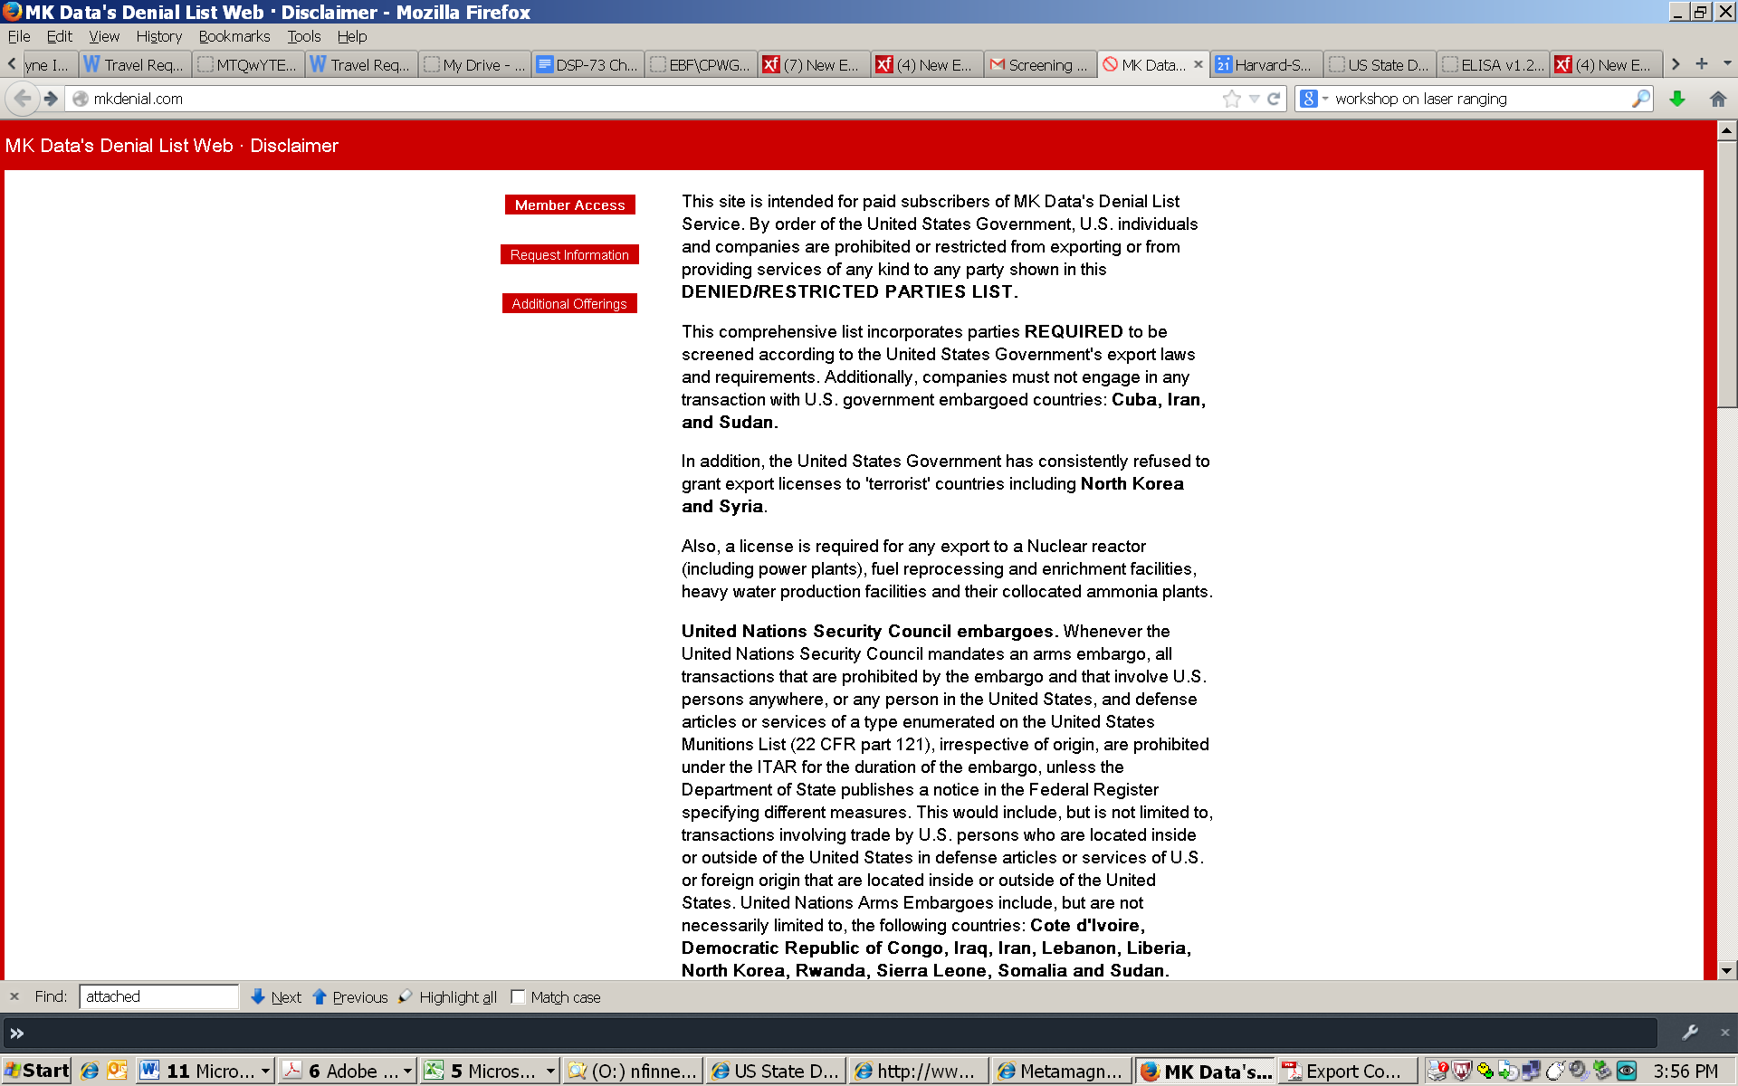

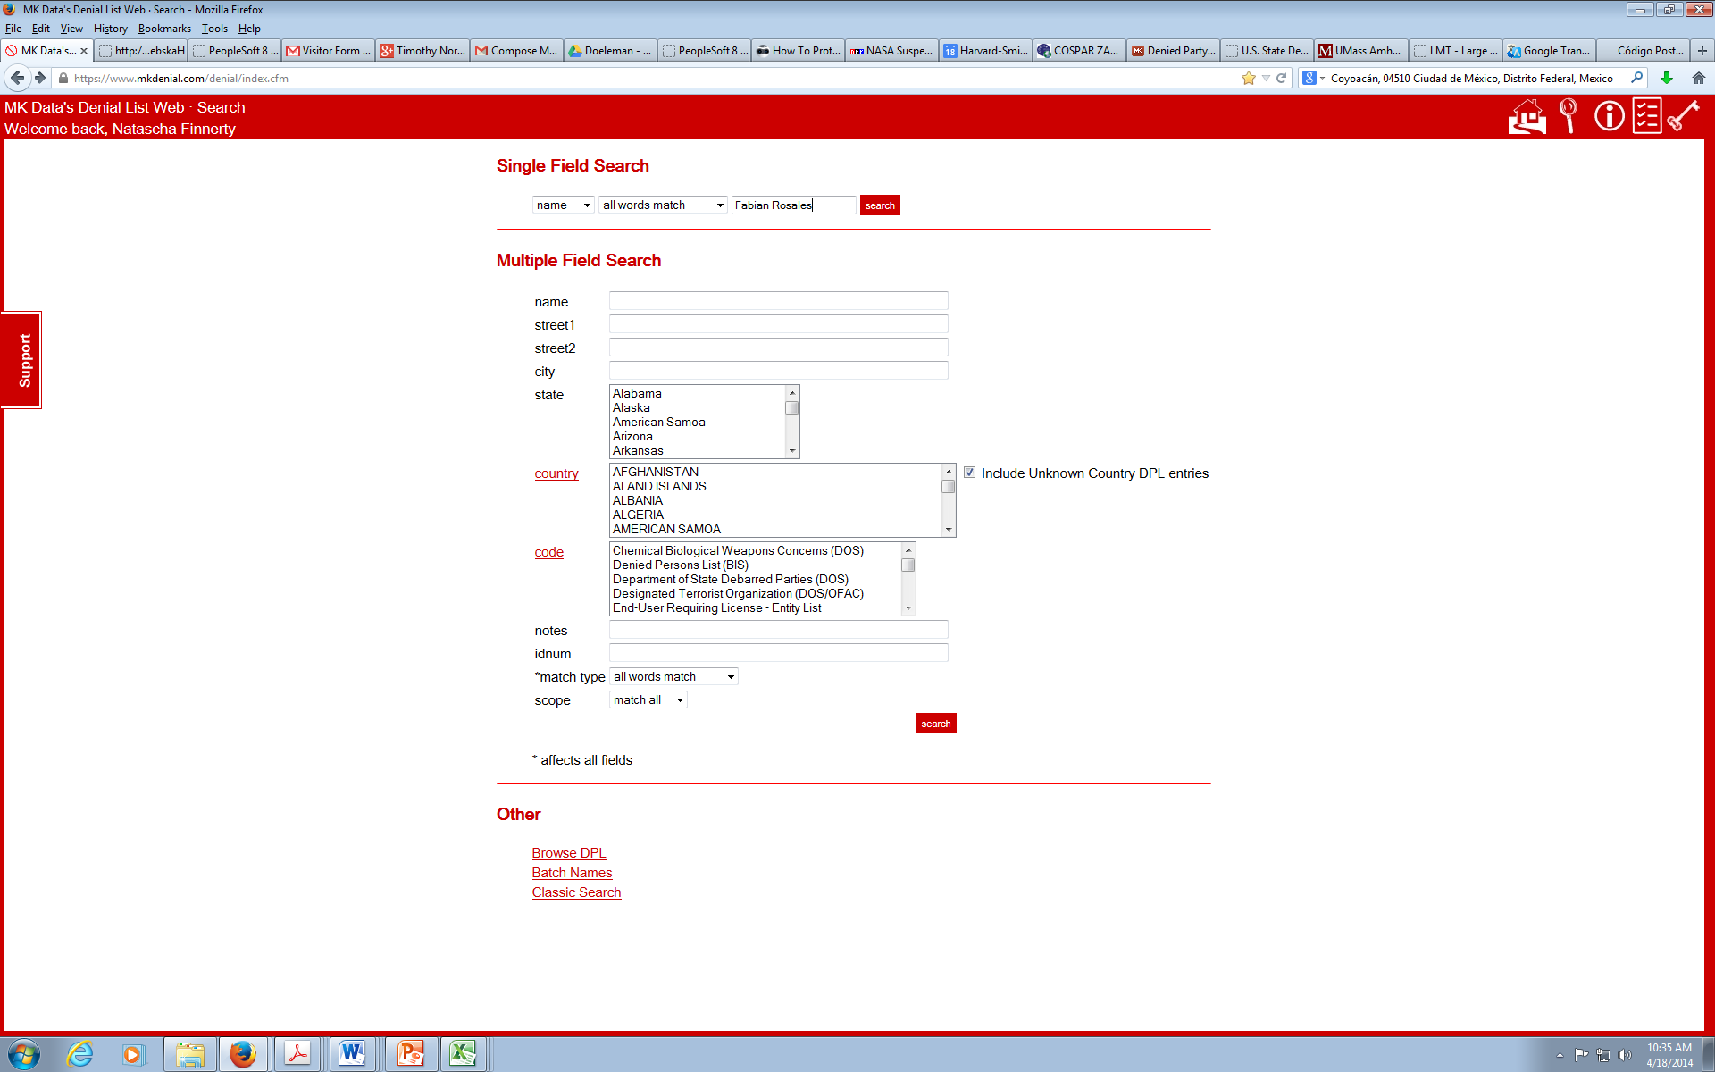
Enter name
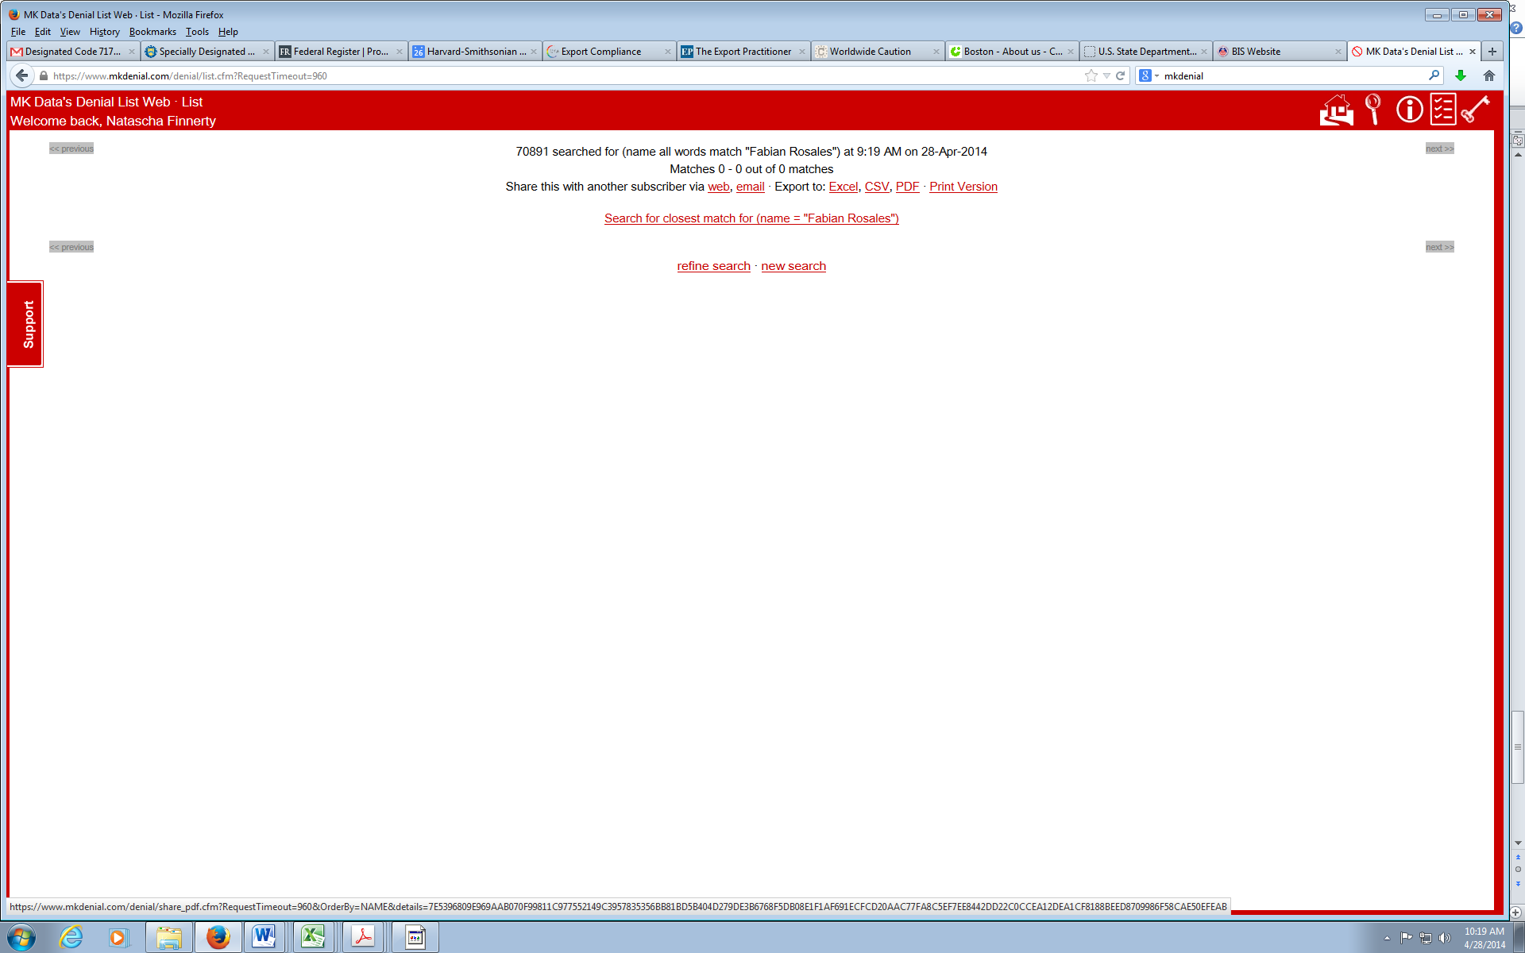
Name is not on the list. You may proceed.

