Preparing documents for
International Federal Express Shipments of an
Export Controlled (Commerce (EAR), State (ITAR) item or Treasury (OFAC)-controlled Shipment and
Filing the Electronic Export Information

August 14, 2017

Note: Fed Ex has tutorials on international shipping

Before exporting, you will need to gather information about the proposed transaction.

Refer to SI’s export clearance procedures and the export checklist (form SAO-ECO1)
- Use SI’s FedEx account number - do not open your own account. (0021-2618-4.)
- Determine how quickly you need your item to arrive. The weight and speed will determine price and service. Packages (under 150 lbs) - International Next Flight, International First, International Priority, International Economy. Flat Rate Pack or FedEx Ground for Canada and Mexico. Over 150 lbs – similar services for Freight.
- Want to know more about restrictions related to the country you are shipping going to? Specific country profiles can be found at Country Snapshots

2. Contact export@si.edu when you know the information below. In some cases, your item may require an export license or other permits.

While international shipping is not as hard as some make it seem, you will need to know most of the following information to complete the checklist and Federal Express screens:
- Where is it going? (Cuba, Iran, North Korea, Russia, Sudan and Syria require approval.)
- With address, contact name of the person who handles imports, zip code and tax ID number, if possible. If you will ship to this address again, you can save it in your address book or make a profile.
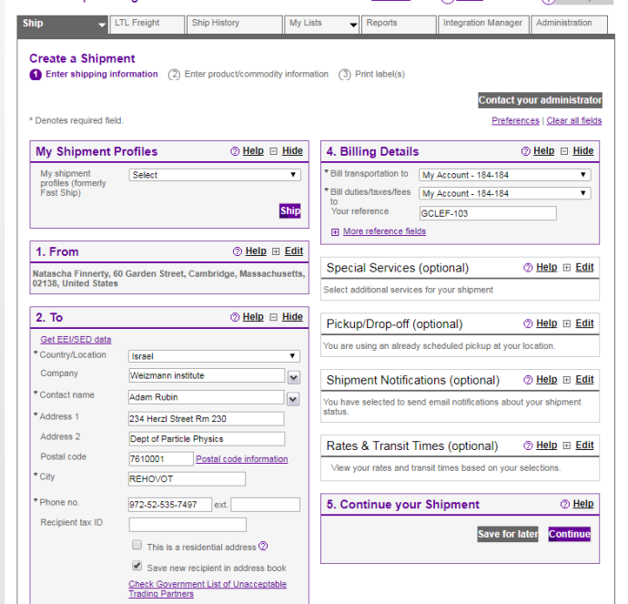
- You can screen your consignee against the Government Denial Lists here.
- When does it need to be there? Check if it is export controlled.
- What is the equipment/specimen to be exported?
- Is it on the US Munitions List or Commerce Control List? (Infrared, pathogen, virus?)
- If yes, what is the Category or Export Control Classification Number? The ECO will determine if a license is required.
- What is the value?
- Include serial numbers, if possible
- What is the origin of manufacture –US or foreign?
- Who owns it and who is shipping it (what location it is leaving from in the US)?
- How long it is staying and is it coming back? If so, when?
- What is the weight – package for small items. It is “freight” if item is over 150 lbs. or very large – get a price for Fedex Heavyweight Freight - 866-393-4585 and provide our account number) You should book the freight in advance and get a booking number from them. Intl -800-247-4747.
- Does it need a government bill of lading?

Creating the Commercial Invoice –

Export documents can be prepared using our templates on the www.cfa.harvard.edu/SPP/export compliance website, or the ECO can prepare it for you, or the invoice can be created in the Federal Express program. If you use SI’s invoice, print out 3 copies and include the invoice in the pouch with the shipping label. Our invoice tends to be more detailed than the Fed Ex-generated one. Log in and ship with FedEx Ship Manager® at fedex.com. It will take you through the required documentation step-by-step to make sure the process runs as smoothly as possible.

Remember to explore FedEx Global Trade Manager for additional tools to help with documentation. Explore Fed Ex international document assistance information to learn best practices. International The International Air Waybill is the primary shipping document for most international shipments. You can fill it out online using FedEx Ship Manager at fedex.com.

For SI invoice:
- The “ship to” address with contact person, cell number and email.
- Make, model number, description and country of origin of the item. Indicate the serial number if there is one.
- The currency of transaction. (This is the currency in which you’ll be entering the value and charges related to this shipment.)
- The purpose of the shipment (e.g. commercial, testing, gift, sample, research, )
- The name and description of the product to find its Harmonized Code. (Harmonized Codes are used internationally to catalog and describe products for tariff and regulatory purposes.) Fed Ex has a look up function for these. Or you can call the international/Shipping department of the manufacturer. (SAO - Our equipment tends to be in Chapter 85 or in a Chapter in the 90s, so start looking there.) In the code, it tells you the duty rate for countries that are not a participant in a Free Trade Agreement. There are also Value Added Taxes that need to be paid.
- The INCO term – who is responsible for paying for transportation, duties and taxes – like” Ex Works” (named place) or “Free Carrier” – FCA (named place) or DDP (named place). You can google “INCO term” and select the one based on who will be paying for transportation, loading, duty and taxes
- The product’s value for customs. (Enter the selling price or fair market value if used [even if not sold or for resale] of your shipment contents.) If it used equipment, you can depreciate it over its useful life or enter the fair market value.
- Go to the Commercial Invoice interactive form.
- http://intldocs.fernohost.com/commercial-invoice/

Other required documents will vary by shipment. Examples of commonly required forms include: • Commercial Invoice • Certificate of Origin • Pro Forma Invoice • Packing List • Electronic Export Information (EEI) - if your shipment value is > $2,500 USD or qualifies under the authority of an export license, per EEI guidelines.

4. Clear customs.

Getting a shipment through customs in any country can seem complicated, but if you stick to these best practices, you can minimize delays and maximize efficiency. Best practices:

Declare the accurate value of your item, even if it’s being provided at no charge (i.e. sample or not for resale). The value will be used to assess duties and taxes.

Keep multi-piece shipments together, and label each piece of the shipment individually.

Correctly complete all necessary documents. Keep your answers specific, accurate, and free of spelling errors.

Make sure information is consistent across all documents.

List each commodity separately, and provide a detailed, accurate description of each one, including what it’s made of and how it will be used.

Legibly print the commodity’s country of origin/manufacturer to indicate where your commodity was manufactured, grown, or produced.

If you’re using your own broker, please include their complete contact information.

Provide the tracking number and invoice to the foreign consignee and the broker before shipment is exported. Indicate phone number or fax information for both the sender and the consignee.

Some countries allow research equipment duty free or if the professional equipment is not staying, we can get a carnet or temporary import bond.) Federal Express also can help identify the international documentation needed for a specific country in addition to the Commercial Invoice:
On the invoice, state:
  - The Fed Ex platform will let you check the names on the Denied Parties List using Fed Ex air waybill tool. (see screenshot A)
  - The Fed Ex platform will allow you to ask them to file the Electronic Export Information (EEI) if a single harmonized code is of the shipment is more than $2500 (See Screenshot B)
- Toxic or hazardous? - Understanding if what you want to ship is regulated for hazardous material, i.e., radio, x-ray or magnetic emission, explosive, medical). Are there special packaging or inspection requirements? – i.e., Philippines) Check the Fed Ex site for the country and with the manufacturer, if it is a purchased product. Include a Material Safety Sheet if the item has hazardous material issues.
- Do you want to nominate a specific broker? – ask the overseas party about how they clear imports or the Export Compliance Officer will help you find one. (FedEx will not clear shipments over $1000 and might not process temporary import bonds). Designate your broker on the shipping platform. Indicate their Tax ID number and any duty free information that they provide on the documents.
.
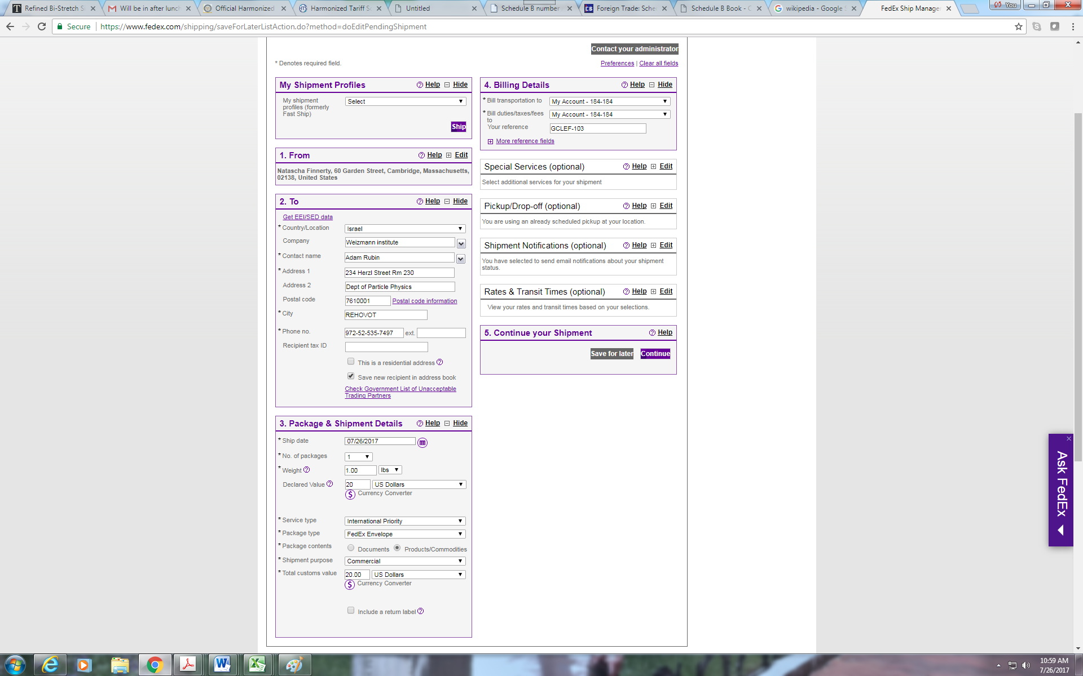
Enter our account number here. Create a reference number

Ask for tax-free number from your collaborator

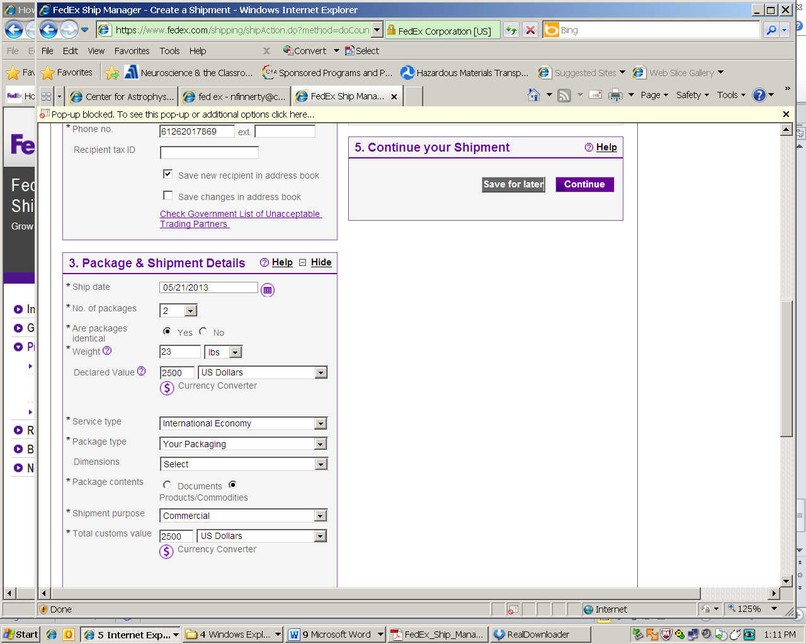

Indicate the service type. If your packaging, provide the dimensions and weight.

#6
Commodity description – it should include model numbers. The description also should be similar and generic like the description of the harmonized tariff number (HTSUS) (import code) or Schedule B number (export code). In either list, it indicates the unit of measure “no.” for “number so indicate “each”, meters (for cable), kg for compounds, etc.
Value – cannot be $0. The value must represent a fair market value if it is not being bought/sold because it is used, gifted or a prototype.
Harmonized code – google the harmonized code and look for the closest number. Have a qualified engineer approve it, if it is a technical item. Add it to the dictionary.
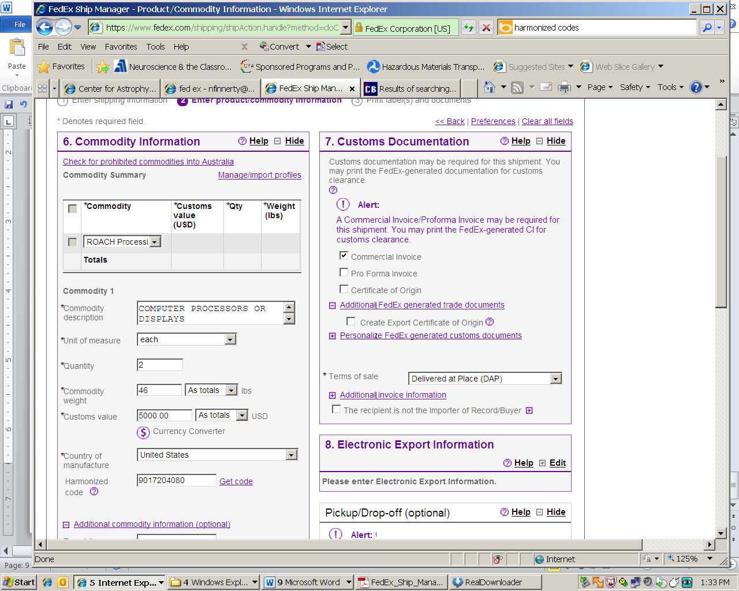

C. EEI Filing to Bureau of Census - When it's required
The EEI must be filed with shipments from the U.S., Puerto Rico or the U.S. Virgin Islands to foreign destinations; between the U.S. and Puerto Rico; and from the U.S. or Puerto Rico to the U.S. Virgin Islands, if any of the following applies:
- Shipment of merchandise under the same Schedule B/Harmonized commodity number is valued at more than US$2,500 and is sent from the same exporter to the same recipient on the same day. (Note: Shipments from the U.S. to Canada are exempt from this requirement.)
- The shipment contains merchandise, regardless of value, that requires an export license or permit. (To determine if your shipment requires a license, go to the U.S. Department of Commerce: Bureau of Industry and Security.)
- The merchandise is subject to the International Traffic in Arms Regulations (ITAR), regardless of value. (For more information about ITAR, go to the U.S. Department of State.)
- The shipment, regardless of value, is being sent to Cuba, Iran, North Korea, Sudan or Syria.
- The shipment contains rough diamonds, regardless of value (7102.10, 7102.21 and 7102.31).
2. When it's not required
The EEI is not required for:
- Shipments from the U.S. to Canada (unless the merchandise is subject to ITAR, require an export license or permit, or are rough diamonds.)
- Shipments from the U.S. to the following U.S. territories: American Samoa, Commonwealth of the Northern Mariana Islands, Guam, Howland Islands and Wake Island.
- Shipments from the U.S. Virgin Islands to the U.S. or Puerto Rico.

- Shipments where all items under a schedule B number is under $2500 and the item is not export controlled (No License Required).

- Tools of the trade that are not export controlled.
Don’t forget, you can use the FedEx Document Preparation Center on FedEx® Global Trade Manager to complete, save and reuse Commercial Invoices for both your FedEx Express and FedEx Ground international shipments.

When you activate the EEI filing, you will leave the Fed Ex program. So remember to SAVE THE SHIPMENT FILE! You will have to select “save for later”.
When the filing has been accepted, you need to check your email.
You will receive 2 emails from FedEx – First with the shipment reference number and a second one with the AES filing number. You will have to get back into the shipping program under – “create a shipment” and click on “Edit a shipment”.
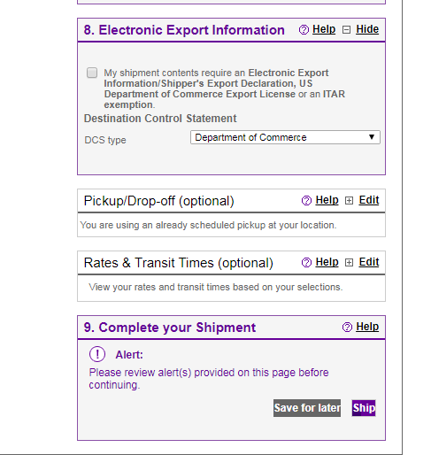
XX
then 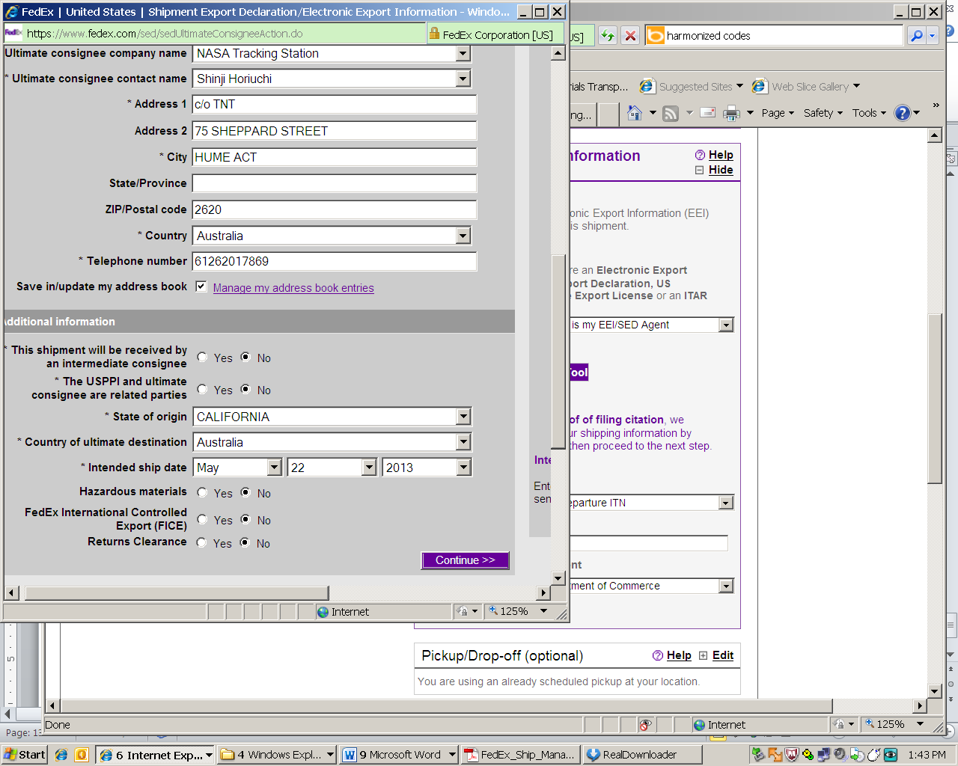
The EEI will ask certain questions, such as if the parties are related, if the package is hazardous, and if it is a Dept. of Commerce shipment, which is a commercial shipment. Unless you have an ITAR license or OFAC shipment, indicate yes.

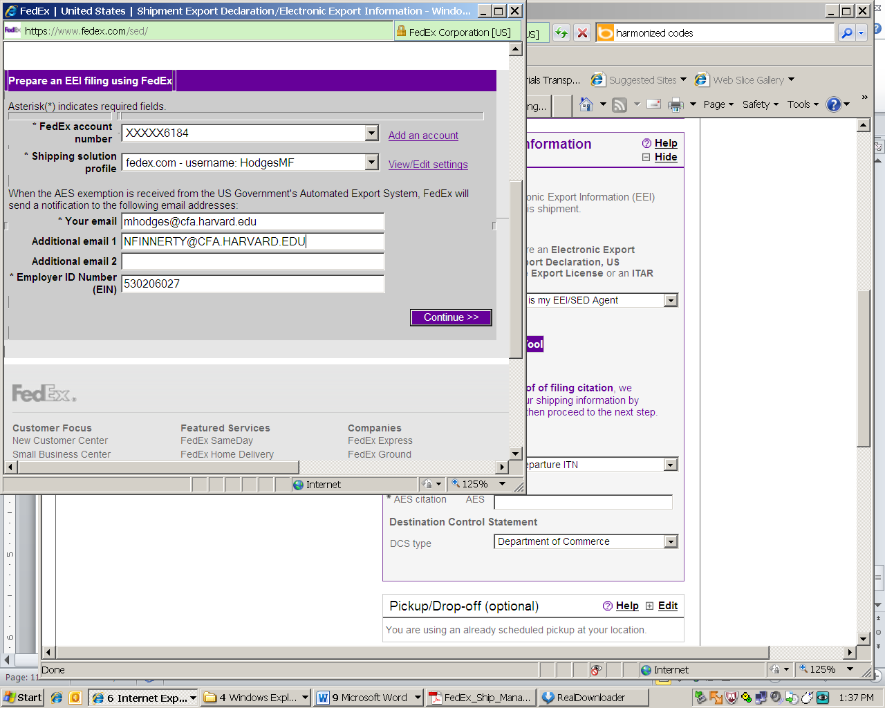
You can add a second name in the email. Add export@si.edu.

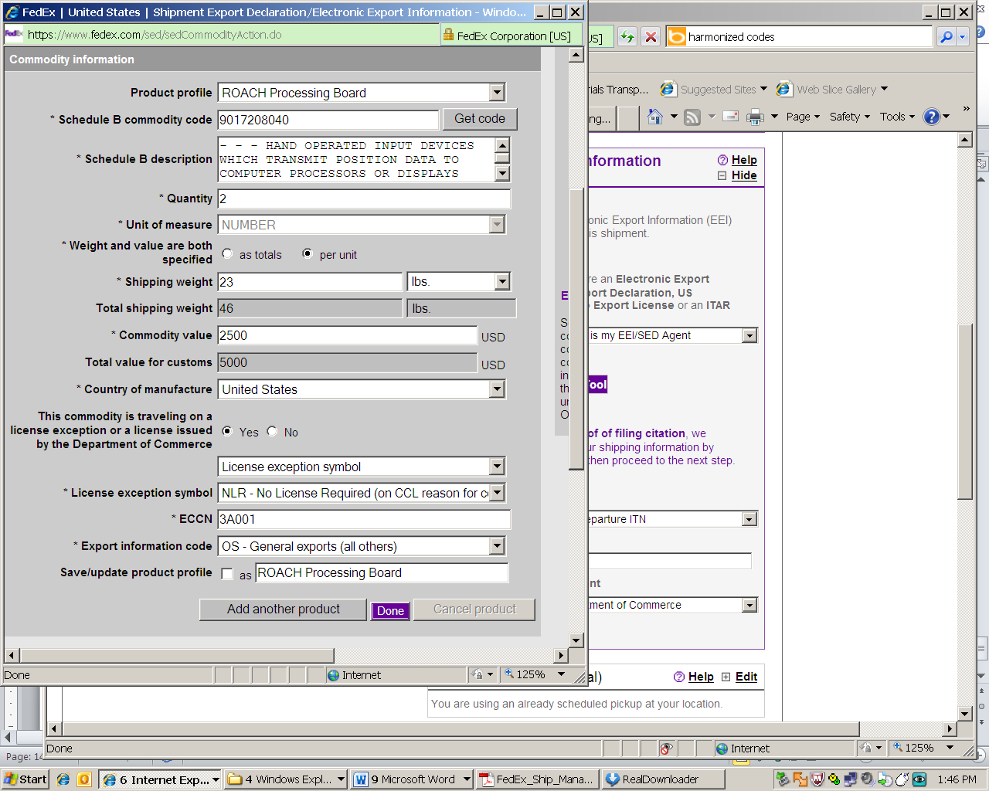
NOTE – FED EX ASKED FOR A PART NUMBER FOR THIS BOARD. MAKE SURE ALL DESCRIPTIONS INCLUDE A PART NUMBER
This screen will ask the type of shipment – Commerce, State or OFAC, if the shipment is EAR99/NLR, then you click license exception. This should be indicated on your checklist.

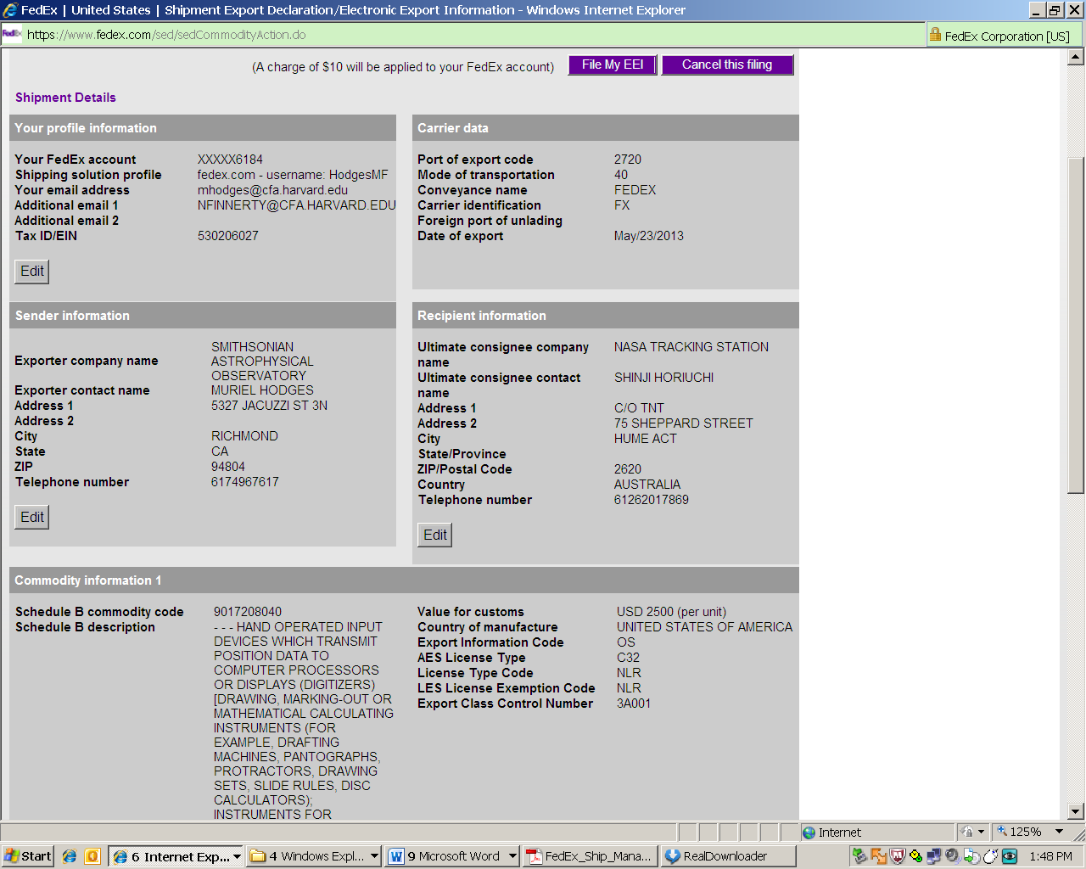

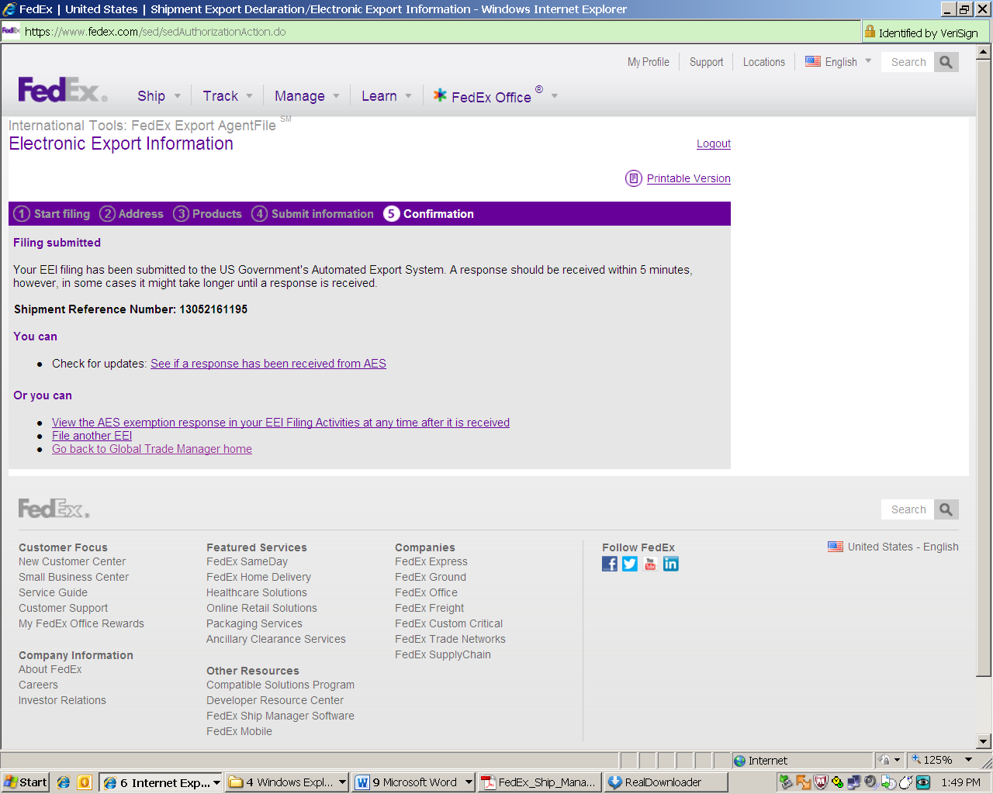

Fwd: Your EEI Filing has been Assigned a Shipment Reference Number.
Inbox

Shipper Name
From: sed_filing@fedex.com
Subject: Your EEI Filing has been Assigned a Shipment Reference Number.
Date: May 21, 2013 1:49:08 PM EDT
To: FinitialLName@cfa.harvard.edu
Reply-To: donotreply@fedex.com
Dear FedEx Customer,
A FedEx Shipment Reference Number has been generated for the filing you have submitted using the FedEx Electronic Export Information (EEI) agent filing tool at http://www.fedex.com/eei/
For shipment to: SHINJI HORIUCHI, AU
Shipment Reference #: 13052161195
NOTE: This is a FedEx reference number only. If your filing requires EEI, you will receive a separate e-mail with an Internal Transaction Number (ITN) issued by the U.S. government's Automated Export System (AES).
If you have any questions, please call FedEx International Customer Service at 1.800.GoFedEx 1.800.463.3339 (say "international services").
Thank you,
The FedEx International Shipping Team

