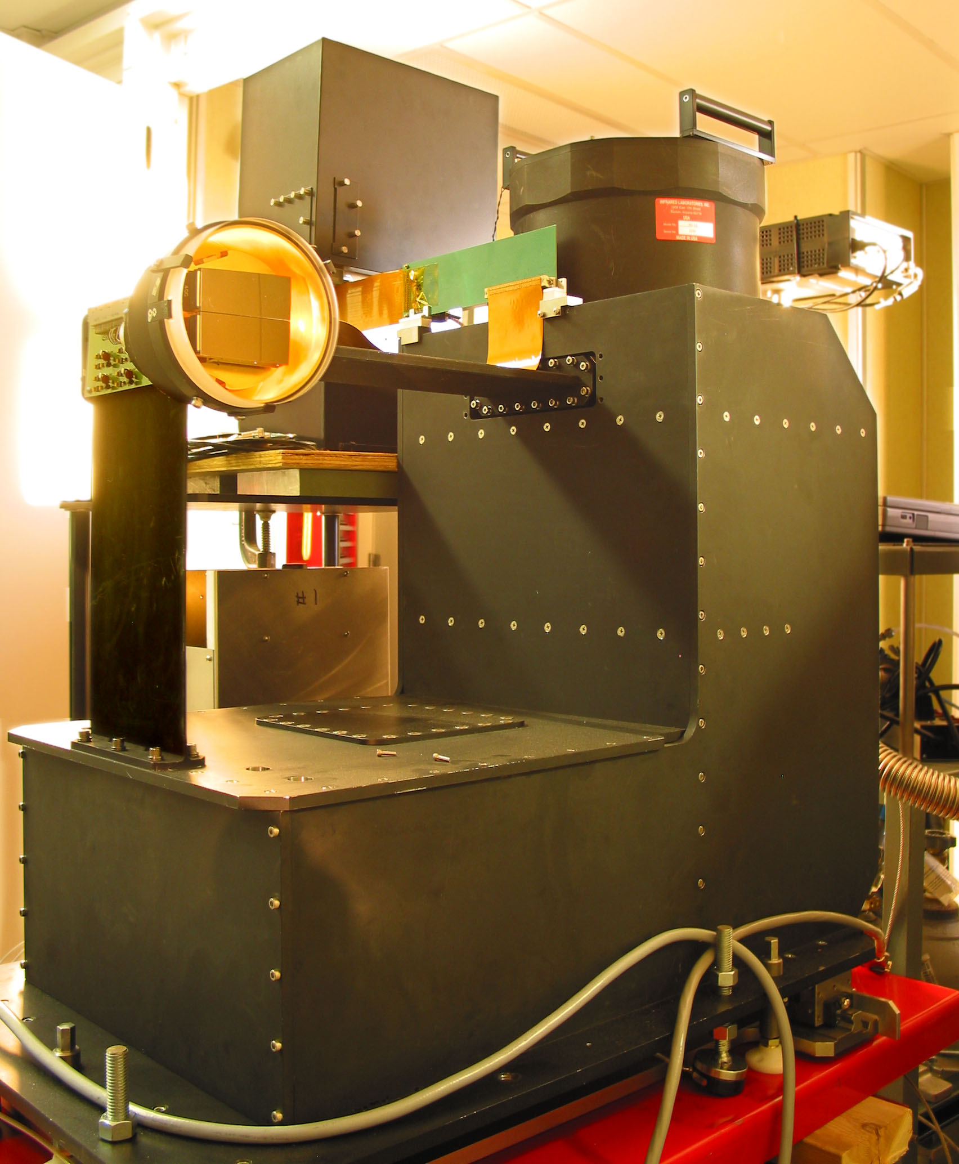

Hectochelle Observers Guide

Andrew Szentgyorgyi, Maureen Conroy, Gabor Furesz, & Nelson Caldwell
Optical and Infrared Division/Smithsonian Astrophysical Observatory
Issued: 1 Apr 2006 / Revision Date 12 Sept 2023

Contact Information

Andrew Szentgyorgyi – saint@cfa.harvard.edu/617-495-7397
Maureen Conroy – mconroy@cfa.harvard.edu
Gabor Furesz
Nelson Caldwell – caldwell@cfa.harvard.edu

OIR Division M/S 20
Smithsonian Astrophysical Observatory
60 Garden St.
Cambridge, MA 02138

Table of Contents
Table of Figures IV
Table of Tables IV
Introduction 1
A brief description of the Hectochelle 1
Outline of Hectochelle Operations 4
Allocation of Responsibilities 5
Science Team Responsibilities: 5
Startup/Shutdown Scientist Responsibilities: 5
Queue Observer Responsibilities: 5
Queue Scientist Responsibilities: 6
Robot Operator Responsibilities: 6
Automatic Functions: 6
Controls Available to Queue Observer/Spectrograph Operator 7
Hectochelle Spice Windows 9
The Status Region 10
Bench Servers 11
CCD Servers 12
Facility 12
CCD temp 12
Dome lamps 12
Field 13
Exposure 13
Img Type 13
ExpStatus 13
Sequence 13
QueStatus 13
Filter 13
Binning 13
The Startup Panel 14
Start Pulizzi 15
Start Bench 15
Bench Power 15
Home Bench 15
Start CCD 15
Note on Hung status 15
The Configuration Panel 16
TELNAME 17
INSTRNAME 17
DETNAME 17
OBSVRS 17
P.I. 17
PROPID 17
BINNING 17
FILTER 17
Config Bench 17
Note on Configuration panel button color coding 18
Shoe! 18
Configuration Target/Current status indicators 18
Clear 18
Standard Ops Panel 19
Data Taking Modes 20
Taking Data 21
Aborting an Exposure or Sequence of Exposures 21
Title 21
The AutoOps Panel 22
The Focus Panel 23
The SequenceTool Panel 24
The Start/Stop Panel 25
The Shutdown Panel 27
The Commentchelle Window 29
Other User Windows 30
Exposure Display Window 30
Mount Display Window 32
Focusing Procedure 33
Calibration Protocols 35
Calibration Resources 35
Calibration configuration 38
Observing Protocols/Modes? 43
Appendices 44
A. FAQ 44
What action does one take if the CCD temperatures deviate from nominal? 44
Under what circumstances should the queue observer deviate form the queue schedule? 44
B. Order Separating Filter Properties 45
C. Signal to Noise of Example Observations 58
D. Hectochelle cheat sheet 62
E. Spectrograph Optical Parameters 65
F. Error! Bookmark not defined.

Table of Figures
Figure 1: The optical train of the Hectochelle 2
Figure 2: An isometric view of the Hectochelle. 3
Figure 3:Diagram showing how the Hectochelle order separating filter changer operates. 4
Figure 4: Introductory warning window 9
Figure 5: Status window 11
Figure 6: Startup control panel 14
Figure 7: Configuration control panel. 16
Figure 8: Standard Operations panel 19
Figure 9: Automatic Operations panel 22
Figure 10: The Focus panel 23
Figure 11: Sequence Tool panel 24
Figure 12: Start/Stop window 25
Figure 13: Shutdown window 27
Figure 14: The Commentchelle Window 29
Figure 15: Exposure Display window 30
Figure 16: Mount Display window 32
Figure 17: Focusing in the StandardOps panel 33
Figure 18: Comparison of focused and unfocused spots 34
Figure 19: The partially assembled Hectochelle cal lamps system. 37
Figure 20: The calibration lamp system mounted on the MMT. 38
Figure 21: The diffractive orders of the Hectochelle. The dotted line indicates the extent of the CCD format when the grating is operated on blaze. The grating may be rotated, thus moving wavelengths that were lost onto the CCD format. 46
Figure 22: Ca 19 filter Transmission. 49
Figure 23: OB 21 filter transmission. 49
Figure 24: OB 24 filter tranmsission. 50
Figure 25: OB 25 filter transmission. 51
Figure 26: OB 26 filter transmission. 52
Figure 27: Na 28 filter transmission. 53
Figure 28: RV31 filter transmission. 54
Figure 29: OB 32 filter transmission. 55
Figure 30: OB33 filter tranmission. 55
Figure 31: OB 37 filter transmission. 56
Figure 32: Ca 41 filter transmission. 56
Figure 33: CJ 46 filter transmission. 56

Table of Tables

Table 1: Exposure times for domeflat and ThAr calibration. 41
Table 2: Solstice sunrise/set and twilights at the MMT 41
Table 3: Typical timeline for Hectochelle calibrations 43
Table 4: Order separating filter properties 47
Table 5: Hectochelle Optical Parameters 65

Introduction

A brief description of the Hectochelle

The Hectochelle is a fiber-fed, bench mounted echelle spectrograph that operates at the post-conversion MMT. The MMT is a 6.5m Cassegrain telescope and the Hectochelle is designed to operate with the MMT in its f/5, wide field mode. In this mode, a triplet wide field corrector and atmospheric dispersion compensator delivers a 1º field of view between zenith and two air masses (60º zenith distance). The robot positioner and fiber system can be operated both with Hectochelle, and Hectospec,, a moderate dispersion spectrograph designed primarily for galactic red shift surveys and studies of large scale structure. The robot positioner places all 300 fiber buttons for an observation in five minutes with an accuracy of 25μm or better. Hectochelle only utilizes 240 of the 300 fibers in the robot positioner. The 24 inch diameter focal plane(1º on the sky) is hyperbolic, so the positioner must tilt to the local surface normal to pick and place the fiber buttons. The fiber buttons are held to the focal surface magnetically, and each fiber button contains a turning prism to direct the vertical telescope beam into the horizontally aligned optical fibers. The fiber core diameter is 250μm, or 1.5" at the MMT f/5 plate scale.

The optical design of the Hectochelle, by Harland Epps, is shown in Figure 1. Both the slit and the CCD detector head are internal to the beam, which introduces only slight vignetting when proper attention is paid to the cross section of the obscuring members. The doublet corrector is fused silica and all surfaces are spherical. Hectochelle is a single order instrument, where a single diffractive order is isolated with selectable order-sorting filters.The filter changer is shown in Figure 3. The width of each order is approximately 150 Ǻ (see Figure 21 in Appendix B.) The resolution of the Hectochelle is ~34,000 and the the efficiency is peak 5-6%, depending on which diffractive order it is operating in.

Because the Hectochelle and Hectospec both use the same fiber feed,but have different magnifications, only 240 fiber images fall on the Hectochelle focal plane format, while Hectospec exploits all 300 available fibers. The order sorting filter changer erects filters with a cam follower immediately in front of the pseudoslit. Eleven filters are currently available for Hectochelle observations, covering diffractive orders with astrophysically interesting spectral features (Hα, [O III], Ca H&K, etc.). Details may be found on page 45, et seq.

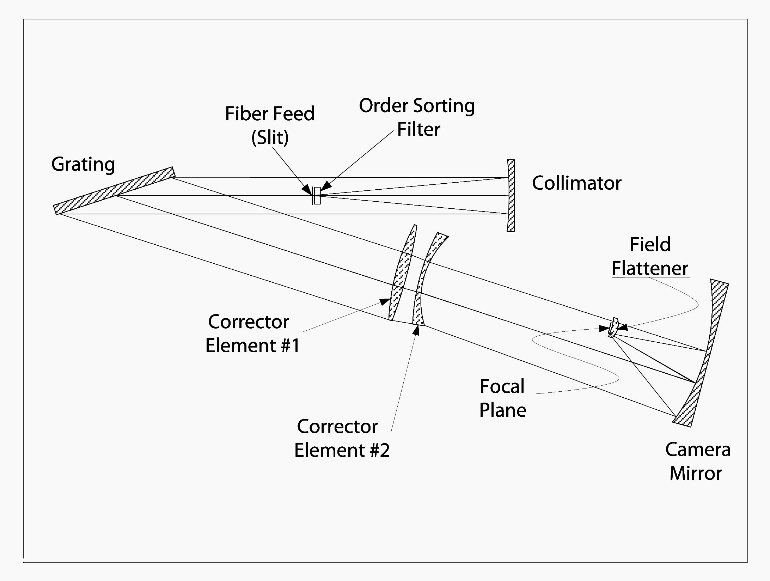
Figure 1: The optical train of the Hectochelle
The collimator is a spherical mirror with a Lawrence Livermore durable multilayer coating on a Zerodur substrate. The diffraction grating system consists of a pair of 300 mm x 400 mm Richardson Grating Laboratory aluminum coated reflection gratings ruled at 110 lpm and blazed for R2 (64.5º). The gratings are co-registered on a precision bonded Zerodur metering structure which matches the coefficient of thermal expansion of the Zerodur grating substrates. The angle between the incident and diffracted beams
is 15º.

The Hectochelle employs a spherical doublet refractive corrector made of fused silica and anti-refection coated with Sol Gel to maximize throughput. The camera mirror is a 43 inch diameter Zerodur sphere that is f/0.6 and coated with enhanced aluminum by the Flabeg Corporation.

The field flattener, an all spherical fused silica lens, also serves as a vacuum window for the cryostat. The focal plane is cooled with liquid nitrogen and the CCDs themselves are a pair of E2V 2k x 4.5k devices with 13.5$\mu$m pixels. The readout system is an extremely flexible, high speed architecture developed at SAO and now in use for virtually all its new ground-based optical and infrared instrumentation. The Hectochelle can be operated in a Precise Radial Velocity Mode (PRV) mode when a iodine vapour system is installed in the instrument. At present this feature of Hectochelle is under development, however it is expected to provide radial velocity precision of 30-50 m/s.

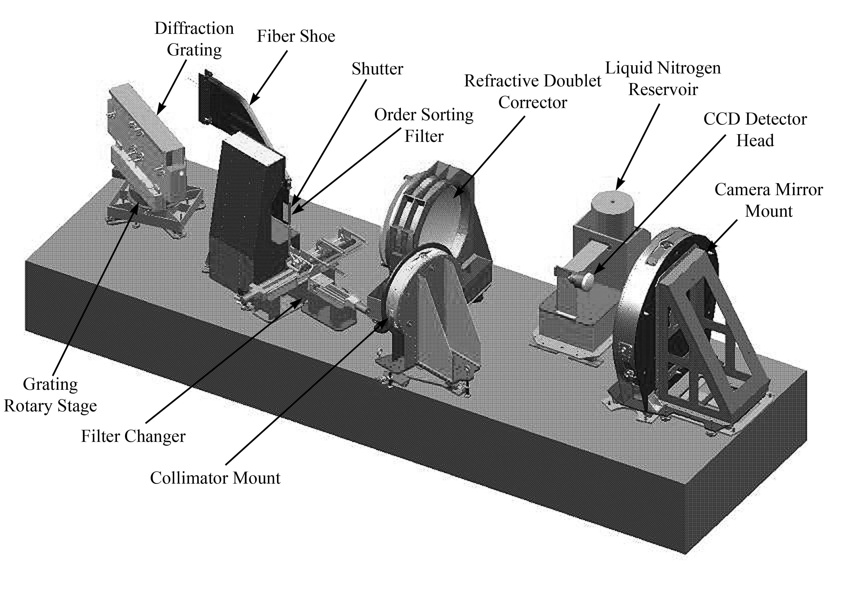
Figure 2: An isometric view of the Hectochelle.

There are several motion axes in the Hectochelle that are operated by the observer:
- Selection of the desired order separating filter.
- Focus of the camera mirror to compensate thermal growth and shrinkage of the optical bench and to parfocalize each order separating filter.
- Focus of the collimator to parfocalize the order separating filters.
- Rotation of the diffraction grating to optimize the location of spectral features on the CCD format.
Many of these parameters are preset; when a new order sorting filter is selected the camera and collimator are parfocalized automatically. Similarly the grating moves to its optimal position automatically. The observer is, however, required to focus the Hectochelle at a single wavelength at the start of each evening. The observer also controls the calibration lamp system and CCD data acquisition system.

The spectra are imaged onto two thinned E2V CCDS. As stated above, only 240 of the 300 fibers fall completely on the focal plane. These CCDs have readout noise of 2.7 e,
and are operated at a gain of 1 e/ADU.

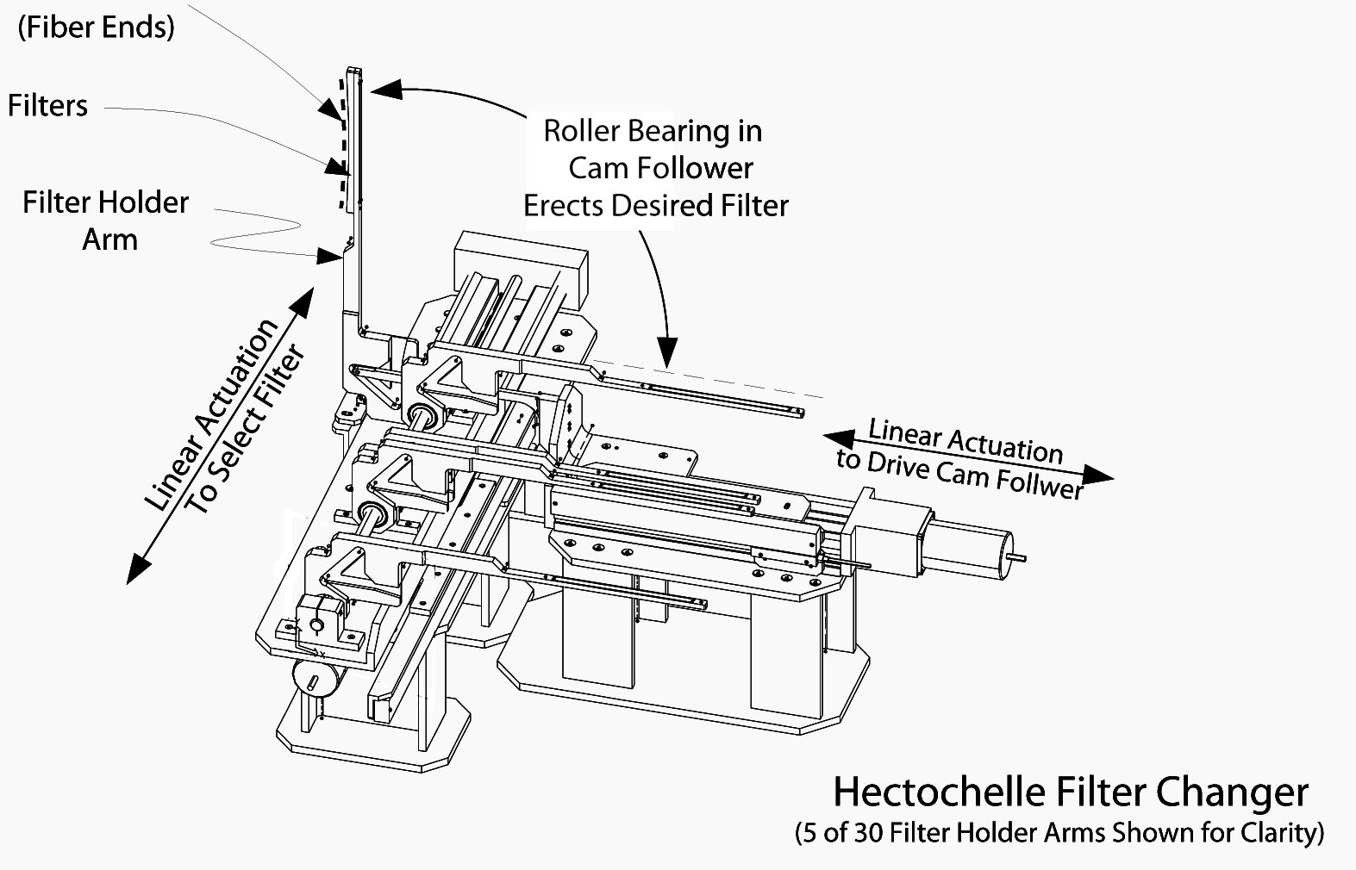
Figure 3:Diagram showing how the Hectochelle order separating filter changer operates.

Outline of Hectochelle Operations

The Hectochelle spectrograph is operated by the queue observer and the robot positioner is operated by the robot operator. The spectrograph and ancillary systems is controlled with a software package called Spice (Spectroscopic ICE), based on ICE an IRAF CCD control software system.

All Hectochelle observations are queued, i.e., any observation may be taken at at any time within Chelle run on a given trimester. A number of factors including observability, weather conditions and how much a given program has been completed compared to other TAC approved programs determine when an individual observation is made.

When observations commence, the queue observer will be provided with a queue schedule for the night. Within reason, the queue observer should attempt to adhere to that schedule, but pragmatic considerations may force departures from the nominal queue.

Each science team must prepare all configurations for a given observing run well in advance of the date of the run so the queue scientist can review the configurations and send them to the robot operator. Please read the relevant chapters on queue operation and fiber configuration in the Hectospec manual (http://www.cfa.harvard.edu/mmti/hectospec/hecto_software_manual.htm). No observations will be made that have not been reviewed by the Queue Scientist. The robot configurations are made with Xfitifibs. Xfitfibs performs fiber allocation and optimization for input science target catalogues, allocation of sky fibers and preliminary determination of guide star candidate, transformation of guide and science target to unified coordinate system. The queue observer and robot operator have access to all run configurations at the start of the observing.

It is extremely important for the queue observer to become familiar with the observability of all fields in the queue well before observing commences every night. Skycalc (which may be accessed at several websites is extremely useful in this regard. A summary of team responsibilities is listed below.

Allocation of Responsibilities

Science Team Responsibilities:
The science team is responsible for originating and executing the scientific program for which the Hectochelle observations are made. It is a requirement for that some members of the science team to serve a queue observers to develop an understanding of Hectochelle operations and share in the burden of collecting data. Because of the queue nature of Hectochelle observing these science team members may not be present when their data is acquired.
- Preparation of viable robot positioner configurations and guide star catalogues on an acceptable coordinate system with < 0.2” relative positional accuracy. Configuration files must contain correct exposure times, binning and filter selections to configure both the robot and Hectochelle correctly.
- Evaluation of observability on nights allocated for Hectochelle observations (moon position, transit time, time above 2 airmasses on potential observation date).

Startup/Shutdown Scientist Responsibilities:
Several days before Hectochelle observations, the Hectochelle must be prepared for observation. If the first observer of a run is experienced in these operation, the observer will arrive a day early to prep the Hectochelle. Otherwise the PI can arrange for someone stationed in Arizona to prep the Hectochelle.

One or two days before start of Hectochelle observing run the Startup/Shutdown Scientist must: :
- Pump down and initial cool down of CCD camera
- Removal/replacement of spectrograph covers
- Checkout of spectrograph operations and testing of all software updates since last Hectochelle operation.
- Check for availability of consumable – high purity nitrogen for optical bench vibration isolation system and liquid nitrogen for science camera cooling.
- Ensure consumable available well enough in advance of run so they are available in time for startup

Queue Observer Responsibilities:
The Queue Observer operates the spectrograph itself and is responsible for successful acquisition of all data needed by the Science Teams. The Queue Observer’s duties include:
- Knowledge of spectrograph operating principals
- Operation of Hectochelle spectrograph
- Optimization of observing queue in response to local conditions and opportunities
- Acquisition of requisite calibration products for each night of observation
- Cross check of program observability, esp. moon position on given night
- Focusing spectrograph every night
- Logbook maintenance and performance tracking of Hectochelle

Queue Scientist Responsibilities:
The Queue Scientist is custodian of the observing queue. The Queue Scientist performs his/her duties remotely, and is not present at the MMT during observations. The Queue Scientist must:
- Receive configuration files from all approved Hectochelle observers. Configuration files must be submitted 10 days in advance of the first run of any given trimester.
- Check adequacy of configurations
- Submit valid configurations to observation database at MMT
- Prepare the observation queue extending several days in to the future for queue observer
- Perform transit crossing checking
- Update daily queue to reflect actual observations on previous night and balance allocation of observing time among approved programs.

Robot Operator Responsibilities:
The robot operators are specially qualified observers who have exclusive control of the robot and local authority over all robot operations. Their responsibilities include:
- Operation of robot position
- Establishing and maintaining guide
- Technical oversight of robot positioner
- Loading configuration (config) files
- Filling dewar
- File nightly performance report to PI teams
- Transit crossing checking (w/queue observer)
- Provide information and support to queue observers within reasonable limits.

Automatic Functions:
- Data is archived to CfA computer every night
- Notification to observers of availability of data and information sufficient to access/down data.
Telescope Operator Responsibilities: The MMT is operated by MMT staff members who have control and authority over the telescope itself. Their responsibilities are:
- Control & pointing of telescope, including thermal balance of telescope primary
- Wavefront sensor operation and correction of primary figure
- Adjudication of conditions for safe operation of the telescope.

Sequence of Operation on an Observing Night

A brief summary of the sequence of operation for the Queue Observer follows. An expanded description of these activities forms the substance of this document. Each evening the Queue Observer is expected to do the perform the following task approximately in the order in which they are listed.

- As early as possible check that the Camera servers are running and the temperature of the focal plane is -120ºC. If the server has stopped, the temperature is too low. It will take several hours to equilibrate.
- Check for latest queue schedule.
- Check for software updates.
- Cross check observability of queue that night (e.g with Skycalc).
- Start SPICE if it is not already running- see section of Hectochelle Spice Windows.
- Startup Hectochelle if not already running – see section on Startup panel.
- Configure Hectochelle – see section on Config panel.
- Take preliminary calibration data – see sections on StandardOps & AutoOps Calibration Protocols.
- Telescope operator removes MMT mirror cover.
- Focus the Hectochelle – see sections on StandardOps &Focus.
- Take long duration wavelength calibration/flat field for all filters and binning modes to be used that night - see sections on StandardOps, AutoOps and Calibration Protocols.
- Take twilight sky exposures in all filters and binning modes - see sections on StandardOps, AutoOps and Calibration Protocols.
- Setup first configuration of night - see sections on StandardOps & AutoOps.
- Take long duration wavelength calibration - see sections on StandardOps, AutoOps and Calibration Protocols.
- Perform science observations and calibrations throughout the night – see sections on StandardOps & AutoOps. The robot operator must enable calibration lamp turn on. The telescope operator updates the wavefront correction at the start of each new science exposure sequence.
- Take dawn sky exposures when possible – see sections on StandardOps & AutoOps.
- Robot operators fill dewars.
- Set up automated Bias & Dark acquisition – see section on AutoOps

Controls Available to Queue Observer/Spectrograph Operator
There are several controls available to the queue observer. Most of these controls are quite automatic – e.g., when a filter is changed the grating tilts to the correct diffraction angle and the camera & collimator parfocalize themselves – however the queue observer can, in consultation with the PI and science team, odify the configuration of the spectrograph. As such it is important for any spectrograph operator to have a good working model of how the spectrograph functions and what is happening.

The Hectochelle control axes are:
- Grating tilt – When selecting a filter, the grating is automatically tilted to a preset diffraction angle that optimizes the location of scientifically interesting spectral feature on the CCD format. In special circumstances, it is possible to reset this angle, however it should only be done in consultation with the PI.
- Camera focus – Before observing begins, the queue observer is required to focus the Hectochelle camera. This procedure is described later in the section on Focusing Procedure. Focusing is required because of thermal expansion of the of the Hectochelle optical bench face sheets, so this is particularly important when the temperature has changed significantly from the previous night.
- Collimator & camera parfocalization – Since the optical path distance through the order sorting filters is different filter to filter,it is necessary to adjust the focus of both the collimator and camera for each filter selection. After determination of the base focal location in a single filter, this parfocalization is automatic whenever a new filter is selected.
- Data collection mode – Data can be collected in a number of modes – wavelength calibration, bias, &c. The correct mode is selected by the queue observer. This is discussed in the section on the Standard Ops Panel.
- Initialization and shutdown of Hectochelle There is a prescribed sequence for starting the Hectochelle. Shutdown is less critical because the queue observer typically sets up a number of calibration integrations before going to bed. The robot operators often take responsibility for shutdown. This is discussed in the sections on The Startup Panel and The Shutdown Panel
- Control of the calibration lamp system in concert with the robot operator – Calibration lamps are controlled by the queue observer, but their operation is interlocked and requires the concurrence of the robot operator before they can be turned on. This because the calibration lamps also illuminate the guide system fiber ends and turning even the faint ThAr on when the guide camera is on could lead to a catastrophic failure of the robot positioner.
- Binning mode: This is set automatically during science observation, but it must be explicitly set during calibration. There are four modes available – unbinned (1 x 1, 2 x 1, 2x2, and 2 x 3). Science teams need calibration products in their binning mode and in the filters they use.

Hectochelle Spice Windows

The Hectochelle spectrograph is operated on the computer LEWIS in the MMT control room. To operate the Hectochelle, one logs onto LEWIS as user chelle. The password associated with chelle may be found the desk drawer next to the robot operator console.

The Spice software system is started in a xterm window with the command:

>dospice

Spice then pops up a warning window seen in Figure 4 which is a reminder that no Hectochelle data may be taken without selecting a filter and configuring the bench.
Configuring the bench consists of erecting an order separating filter, tilting the diffraction grating to the correct angle of incidence and parfocalizing both the camera and collimator mirrors.

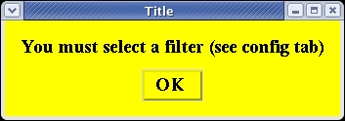
Figure 4: Introductory warning window

The Spice window (Figure 5) is divided into three regions: an upper Status region, a lower Command region and a bottommost orange strip that display information and abbreviated help messages about buttons and statuses boxes. The Status region is highlighted in Figure 5. The lower Command panel has a number of tab-selectable panels that organize forms of control of the Hectochelle and associated hardware, e.g. the calibration lamp system.

The Command regions consists of eight tab-selectable:
- Startup: This panel starts the various Hectochelle servers and fiducializes the spectrograph control axes.
- Config: This panel configures the spectrograph for observation in a particular diffractive order. Current and target status variables are displayed for relevant axes.
- StandardOps: The Standard Operations panel is used to execute one-by-one observations.
- AutoOps: In the Automatic Operations panel, one may load catalogues of preprogrammed exposures, for automated execution of a sequence of exposures. AutoOps is only for automatic sequencing of darks and biases.
- Focus: This panel displays parameters relevant to parfocalization of the spectrograph in each of the order separating filters. The base focus is set in this window. Note: focus frames are actually collected in the StandardOps panel by choosing “Focus.”.
- SequenceTool: Enable creation of preprogrammed observation catalogues. This feature is still indevelopment.
- Start/Stop: This panel is used to monitor and start, stop or restart all the servers relevant to the Hectochelle.
- Shutdown: This panel is used to shutdown the main Hectochelle servers in an orderly manner.
The sequence of operation of the Command regions tabs in a typical evening is roughly as follows.
  - Startup – Start the server
  - Config – Configure the bench
  - StandardOps/AutoOps – Darks, biases
  - StandardOps – Determine best focus.
  - Focus – Set base focus position.
  - StandardOps/AutoOps – Wavelength calibration/twilight skies
  - StandardOps/AutoOps – rest of night.

The rest of the windows are used for status and control of spectrograph function.

The Status Region

The status variables displayed in the Status region are color coded and on some cases contain quantitative information. The color coding, used throughout Spice is as follows:
- Red, Yellow, Green – Off, Indeterminate/Warning, On
- Orange background, Black/grey type – Informational panel either active/inactive.

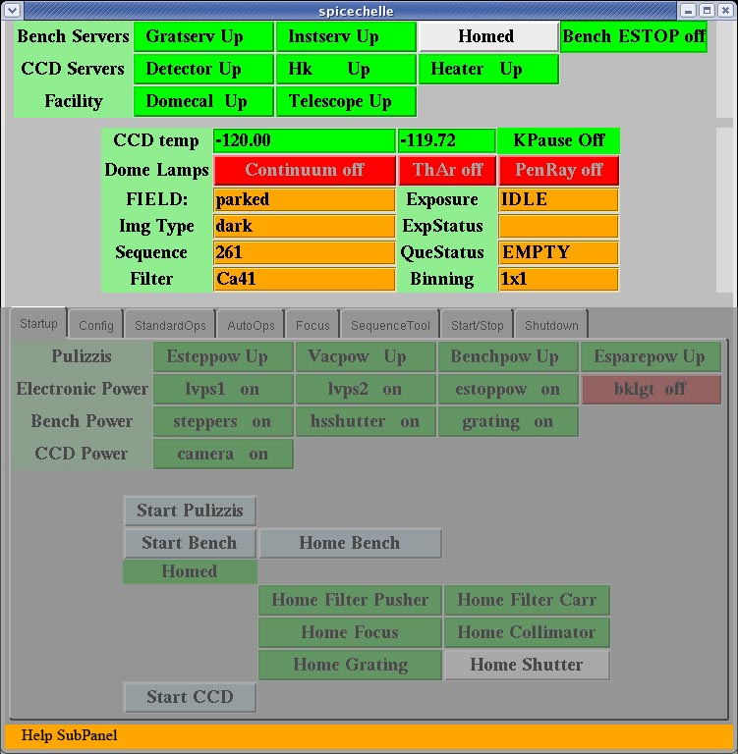
Figure 5: Status window

A description of the status region is as follows:

Bench Servers - These are servers control the axes of motion on the Hectochelle optical bench and must be on for any Hectochelle operations. The buttons in this group are described below:
- Gratserv: the server that controls the grating rotary stage. This server centers the passband of a given filter on the spectrograph focal plane.
- Instserv: the server that controls all the axes of motion on the spectrograph bench, especially the shutter and the focus mechanisms of the camera & collimator mirrors.
- Homed: All control axes must be fiducialized or homed before they work accurately. If the “Homed” light is green, all axes have been homed and in a ready state.
- Bench ESTOP off: The Hectochelle/Hectospec system has a number of emergency stops (ESTOPs). If a subsystem’s ESTOP is engaged or “on”, it will immobilize that subsystem. A green “Bench ESTOP off” indicates the spectrograph bench is enabled.

CCD Servers – These are a family of servers that control and monitor the CCD and CCD data acquisition system. Their functions are as follows:

- Detector Up/Down: This indicates whether or not the CCD data acquisition system is enabled to take data.
- Hk Up/Down: Indicates whether CCD camera Housekeeping (Hk) is running.
- Heater Up/Down: The CCDs must operate with in few degrees Kelvin of -120ºC. The focal plane is chilled to ~ -140ºC (with the heating system off) and then heated to operating temperature. The temperature of each of the two CCDs constituting the focal plane mosaic appear below in the CCD temp section of the Status panel.
Facility – Indicates the status or connectivity of systems related to the Hectochelle
- Domecal Up/Down: Indicates whether the calibration lamp system server is running.
- Telescope Up/Down: Indicates the status of the telescope server, which is part of the MMT software system and communicates telescope information to the Hectorobot and the Hectochelle data acquisition system.
CCD temp – Provides information about the CCD focal thermal control system.
- The two numerical values are the centigrade temperatures of each of the two CCD that constitute the Hectochelle focal plane. They are thermally controlled with heater resistors which hold these temperatures to -120º±0.3ºC. When the thermal control system is off, the focal plane will drop to ~ -140ºC, which is well out of operational range. Furthermore, when the temperature is not stable, thermal gradients in the focal plane support structure will cause time dependent pixel shifts, especially in the spatial direction. The amplitude of these shifts over few minute time scales can be as large as several pixels, which can make aperture extraction very difficult. If you notice these temperatures changing more than a 0.1ºC during an observation, you should alert the robot operator.
- KPause off : The temperature sensor, which servos the thermal control loop is read by a Keithley controller which is Paused during readout. During nominal operation, KPause should turn red during readout and green otherwise. If it is not green, the thermal control loop is not operating and the focal plane is probably outside its operating temperature range and flexing.
Dome lamps – Indicators of the status if the various calibration lamps systems. Red indicates off and green indicates on.
- Continuum – Indicates the state of the incandescent bulb continuum lamp system.
- ThAR – Indicates the state of the sixteen Thorium Argon hollow cathode wavelength calibration system.
- PenRay – There are four sets of PenRay emission lamps mounted on the dome walls. These are used by Hectospec and are not currently available to Hectochelle observers, although we may add them in the future.

Field – Displays name of configuration file that has been used to set up the fiber configuration. If no configuration has been implemented, the fibers are “parked”.

Exposure – Shows that state of the CCD data acquisition system.

Img Type – Type of exposure in progress or to be taken next. See Standard Ops section for more details.

ExpStatus – Shows the current exposure count and the total number of exposures requested.

Sequence – Each exposure is written to a fits file with a sequence number and an identifier indicating the exposure type. See Standard Ops section for more details.

QueStatus - Shows the status of the exposure queue.

Filter – Indicates order separating filter for current/next exposure.

Binning – Indicates binning mode for current/next exposure. Binning is displayed as s x d,where s is the binning along the spatial direction and d is the binning along the dispersion direction. At present, only 1 x 1, 2 x 1, 2 x 2, and 2 x 3 are permitted.

Help SubPanel – At the bottom of the Status Panel there is a orange subpanel that will display help information when the cursor is held over buttons, etc. in the SPICE window.

The Startup Panel

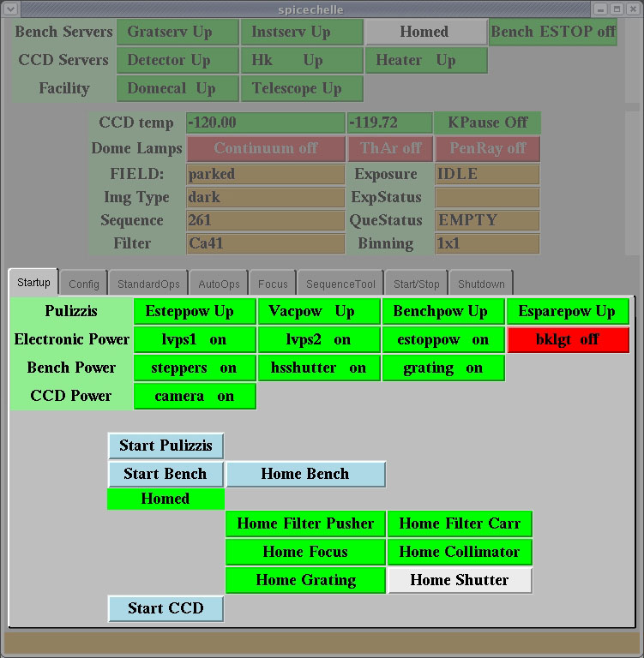
Figure 6: Startup control panel

The Startup panel, not surprisingly, is used to start the various servers that run the Hectochelle and home the control axes on the spectrograph bench. Here the color coding of the status variables follow the Spice standard (see Status Panel section). The clickable buttons are color coded light blue in Figure 6, a color coding that is used throughout the Spice Command panels. The color coding of these clickable buttons is as follows:
- Light blue – ready to click
- Green – executing
- Grey – Done.

The servers and homing operations must be initiated in a specific order, proceeding in the same order as text, i.e. left to right and top to bottom. Each button activates a group of subsystems. The status of each subsystem is grouped in rows at the top of the Startup panel.
One should not proceed to the next button until each status in the current panel has turned green. This may take several minutes.

The Startup buttons are listed in the order they should be activated.

Start Pulizzi – Pulizzis are Ethernet controllable powerstrips that supply power to various bench electronics. The meaning of the status indicators is as follows:
- Esteppow: Indicates status of power to focus stages, filter changer and shutter.
- Vacpow: Indicates status of power to the CCD camera vacuum gauge.
- Benchpow: Indicates status of AC power to several bench electronics, especially the CCD data acquisition and control system.
- Esparpow:

Start Bench – The meaning of the associated staus indicators is as follows:
- lvps1: Status of low voltage power for bench control
- lvps2: Same
- estoppow:
- bklgt: Not currently used – should be red.

Bench Power – Controls activation of stepper amplifier and the grating rotary stage system.
- steppers: Indicates status of stepper amplifiers.
- hhshutter: Indicates status of high speed (hs) shutter amplifier.
- grating: Indicates status of and communication with diffraction grating rotary stage.

Home Bench – This button fiducializes the various motion axes to their home position. The homing state of each axis is shown in a block of indicators just below the Home Bench button. Homing is not complete until all axes are homed. The grating axis is usually slowest and may take several minutes.

Start CCD – This button starts the CCD server. The status of the CCD power is indicated by the camera on indicator above.

When the startup sequence is complete, all of the status indicators in the Status panel should be green. The CCD temp numbers should be black and if they are not close to the control temperature of -120º, they should change slowly, approaching the control temperature. All the Dome Lamps indicators should be red.

Note on Hung status: Occasionaly a status indicator will briefly turn yellow and indicate a Hung status. This is particularly likely after a button has been clicked. Generally this is a transitory state, and is no cause for concern if the indicator returns to its expected red or green state. If this condition persists for more than a minute, consult the robt operator.

The Configuration Panel

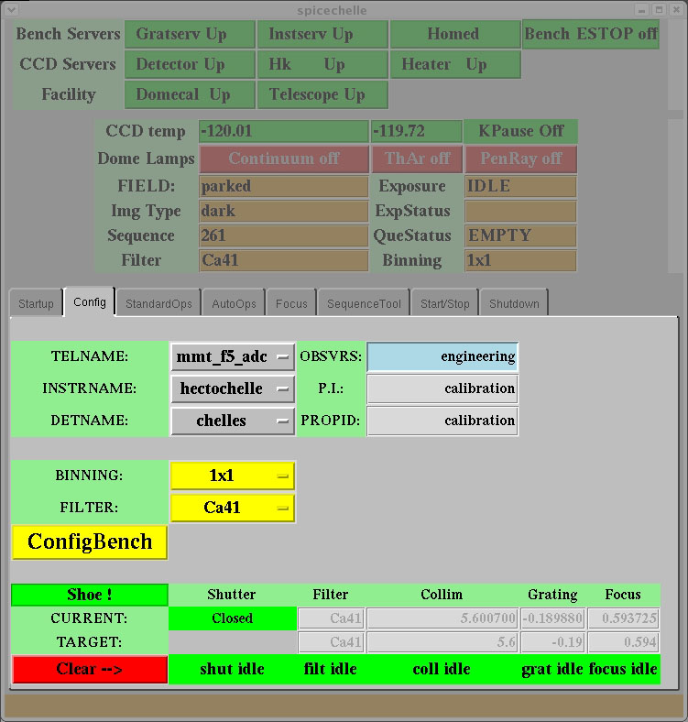

Figure 7: Configuration control panel.

Before taking any data, the configuration of the bench must be selected and the bench must be configured to match this selection. Configuration consists principally of selecting a binning mode and an order separating filter. It is also possible to enter several test modes when one is operating the Hectochelle when the telescope server is not on (e,g. taking darks when the telescope operator is not present.

The various controls that may be activated in the Configuration panel are as follow:

TELNAME - This is a pulldown menu that is used to select:
- mmt_f5_adc: This selection is used when the telescope server is enabled and the MMT is operating. If this mode is selected and the telescope is not operational, an error will result.
- Test: This selection is used for operations when the telescope is not operating, e.g. pre-observation checkout, taking calibration that does not require telescope support, etc.

INSTRNAME: This is a pulldown that allows one to operate the Spice software whether the Hectochelle is operational or not:
- hectochelle: Used for standard Hectochelle operations. In this mode Spice requires that the Hectochelle be fully operational and all servers be up.
- test: In this mode Hectochelle does not need to be operational to exercise Spice.

DETNAME:
- chelles: The usual operating mode, with the fiber shoe mounted on the Hectochelle (it can be moved to Hectospec) .
- chellen: No shoe present. This is used to run Hectochelle when the fiber shoe is on Hectospec.

OBSVRS: The observers’ names should be typed into this window.

P.I.: The name of the PI from the robot configuration file appears here. This is set automatically and cannot be modified unless the configuration file is modified and loaded into the positioner software.

PROPID: The proposal identifier, again automatically set by the configuration file.

BINNING: A pull-down menu. Either 1x1, 2x1, 2x2, or 2x3 binning may be selected. See Status panel/Binning section for details.

FILTER: Pull-down menu to select order-separating filter. The properties of the Hectochelle order separating filters appears in Appendix A.

Config Bench: Clicking this button configures the Hectochelle for the binning modes and filter selected. Configuring the bench consists primarily of putting the selected order separating filter in the spectrograph beam, tilting the diffraction grating to the center of the passband of the filter and parfocalizing the collimator and camera for the optical path difference introduced by the selected filter.

Note on Configuration panel button color coding: The pull downs and Config Bench button are colored yellow until the spectrograph is configured. When the spectrograph is configured, these turn green.

Several status variables appear on the Config panel:

Shoe!: Since the fiber shoe can be moved between the Hectochelle and Hectospec, there is a sensor which detects whether the fiber shoe is installed on the Hectochelle. When it is mounted on the Hectochelle is green.

Configuration Target/Current status indicators: A block of indicators at the bottom of thr Config panel show the target and current values for the axes that are actuated during a configuration. At the end of a configuration, the target and current values should be thes same. The numerical values are in millimeters with respect to a home position.

Clear: The bottommost row of indicators show whether the axes moved during a reconfiguration are idle (green) or in motion (red). The Clear indicator show the …

Standard Ops Panel

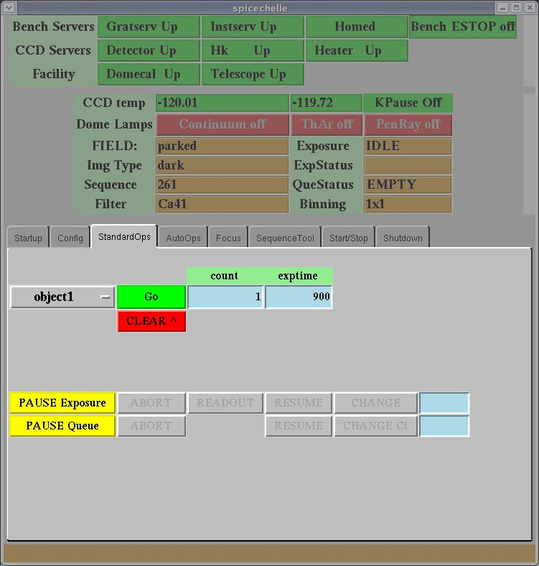Figure 8: Standard Operations panel

Data taking with the Hectochelle is done in the Standard Operations (Ops) panel. Several pre-programmed types of data can be taken with Hectochelle. The data taking mode is selected with the pull-down menu that is activated by the button labeled object1 in Figure 8. The observing modes are described below:
Data Taking Modes:

Filename | Data Type
object1 | Science frame
object2 | Another way to take a science frame (obsolete).
skyobject | Telescope offset frame for direct sky subtraction.
skyflat | Twilight sky frame
comp | Dome ThAr frame
Domeflat | Dome incan frame
Dark | Dark frame
Bias | Bias frame
Qfocus | Only used for Hectospec.
Focus | Focus frame

Taking Data: The number of integrations is typed into the blue window labeled count. The duration of the exposure or exposures, in seconds, is type into the blue window labeled exptime. Data taking is initiated by the green Go button.

The Clear Button:

Aborting an Exposure or Sequence of Exposures: To abort a single exposure, click the PAUSE Exposure button. When the ABORT button next to it turns ???, click it. When the go button turns green, the exposure has been successfully aborted and data taking may resume.

To abort a sequence or queue of exposures …..

Title:

The AutoOps Panel

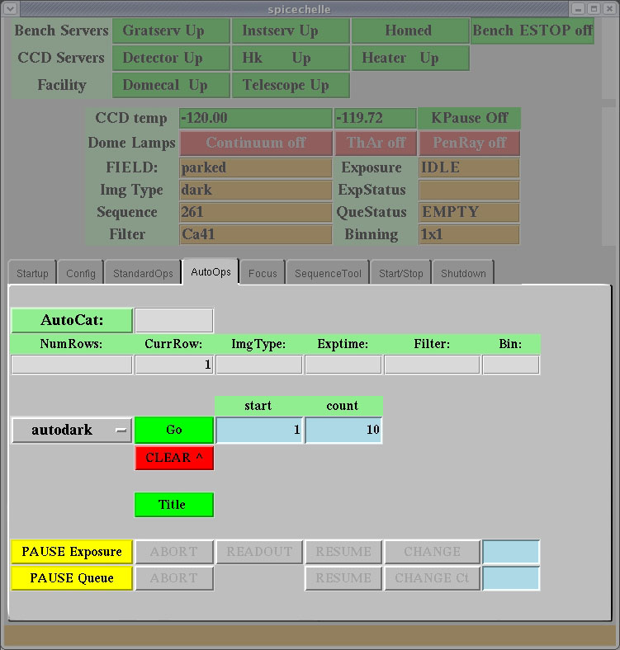
Figure 9: Automatic Operations panel

The AutoOps panel may be used to automate or script sequences of calibration observations. These are divide into categories: calibration involving lamp (comps and domeflats) and calibrations that do not require lamps (darks and biases).

The Focus Panel

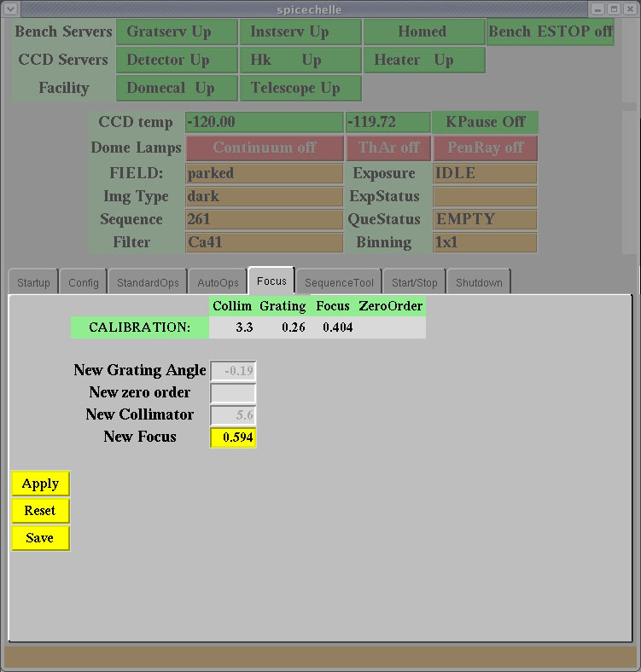
Figure 10: The Focus panel

The Focus panel is used to set the base focus value after the correct focal position has been determined in a sequence of focus frames through the RV31 filter with the focus command in the StandardOps panel. This value is typed in to the New Focus box, and load by clinking the Apply button. The Reset button may be used to restore the original focus value. The Save button may be used to ________. The Calibration values are the Collimator, Grating and Focus, only adjusted by the PI team.

The SequenceTool Panel

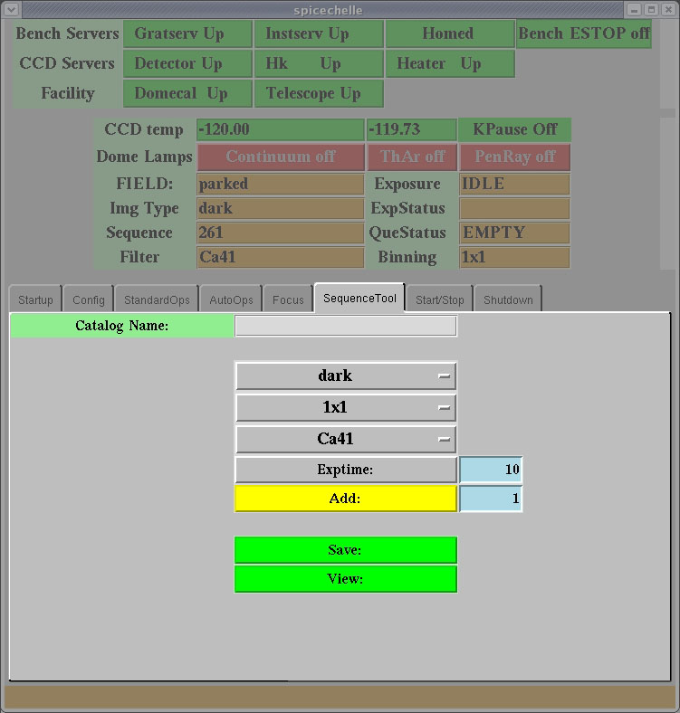
Figure 11: Sequence Tool panel

SequenceTool is under development.

The Start/Stop Panel

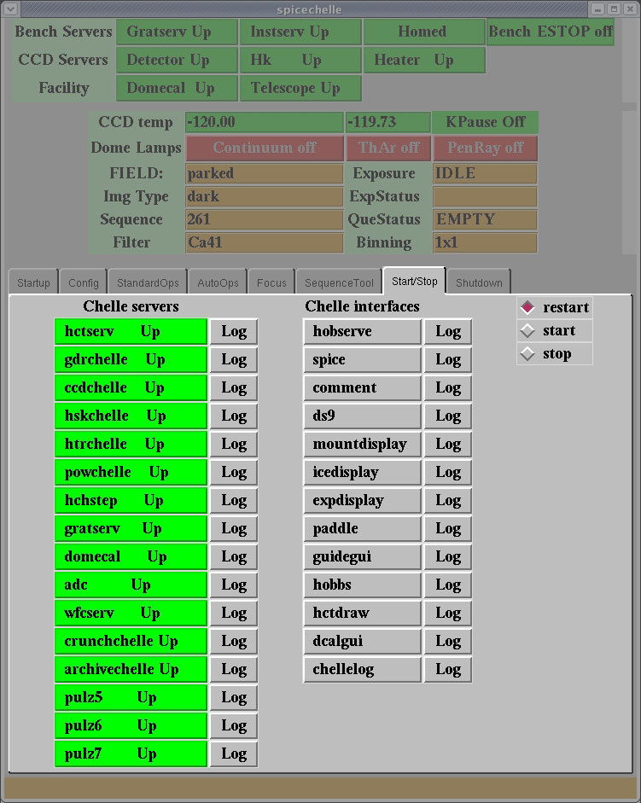
Figure 12: Start/Stop window

The Start/Stop panel is used to start, stop and restart servers. All buttons should be green. It is this lattermost function that it is most commonly used for, since most servers are started elsewhere and rarely stopped. Most of the important servers have been discussed in the Startup Panel section. The other servers are discussed in other documents.

Sometimes servers are observed to either hang ( the corresponding button turns yellow) or stops (the button turns red). If red or yellow condition persists for more than a minute, make sure restart have been selected in the upper right hand corner of the window and click on the yellow or red button. It should return to an Up (green state within 30 second or so. If it does not, consult with the telescope operator. If it persistently hangs or stops, consult the telescope operator.

It can also be used to start a number of Hectochelle interfaces. The more useful interfaces are discussed in later sections of this document.

The Shutdown Panel

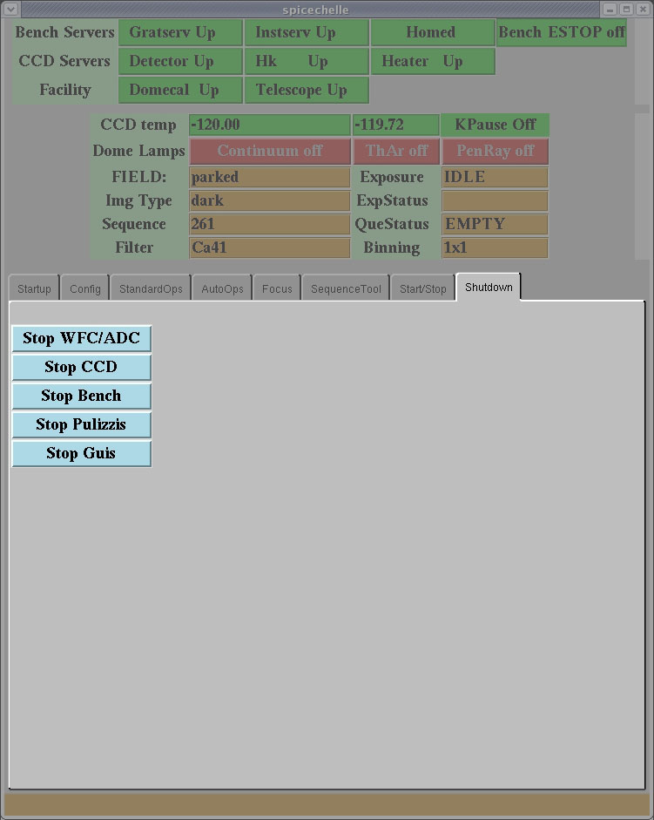
Figure 13: Shutdown window

The shutdown panel permits a clean shutdown, usually at the end of a run. It also be used to shut the spectrograph down at the end of the night, although this is unnecessary Shutdown is performed by clicking the buttons top to bottom

The Commentchelle Window

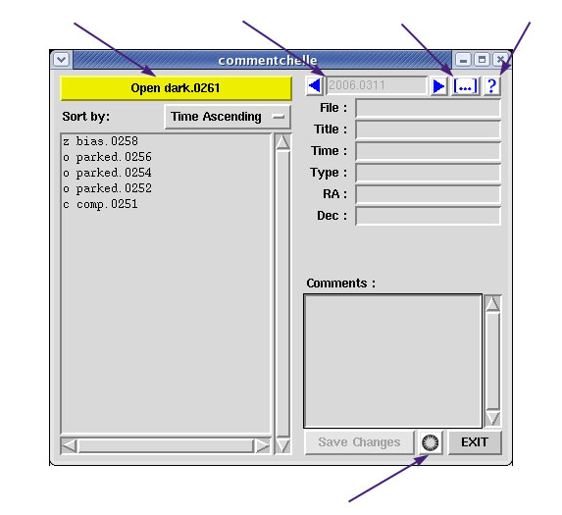
Figure 14: The Commentchelle Window

The commentchelle window is used as a database and logging tool.

Other User Windows

Exposure Display Window

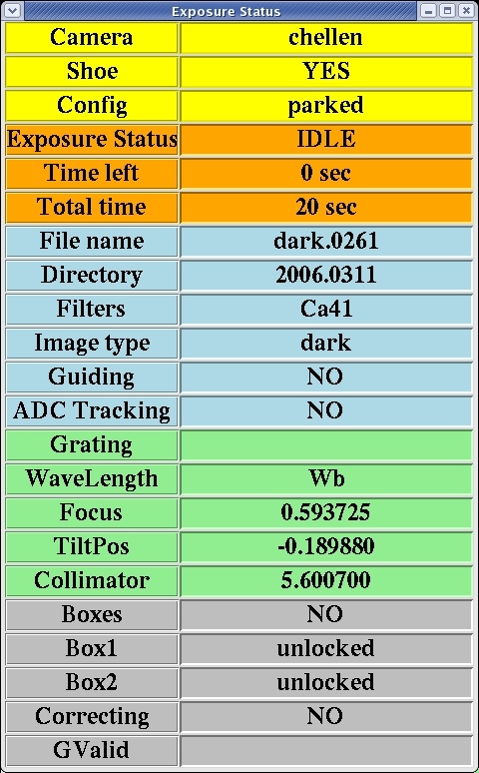
Figure 15: Exposure Display window
The Exposure Display window displays information about the Hectochelle and its interaction with the telescope. Most of this information is self-explanatory. We offer the following supplementary information for the less obvious entries:
- Camera: Chelles indicates the fiber shoe is mounted on Hectochelle rather than Hectospec and the spectrograph is ready to take data. If the fiber shoe is on the Hectospec, if is possible to take test data if Hectochelle is put in Chellen mode in the Configuration control panel.
- Config: Displays the name of the configuration file that has been used to deploy the fiber button.. If this entry is parked, the buttons have not be deployed.
- Filename: The file the data will be written to.
- Directory: The subdirectory in /data/ccd/CHELLE/ where the data will be written.
- Guiding: Is the guide server on?
- ADC Tracking: During science observations, it is essential that the ADCs be on, indicated by a YES here.
- Grating: Not use dby Hectochelle
- Wavelength: Not used by Hectochelle
- Focus: The focus position of the camera (actually the CCD dewar is moved to focus the camera, not the mirror.)
- TiltPos: The tilt angle of the diffraction grating.
- Collimator: The focus position of the collimator mirror.
- Boxes: TBD
- Box1: Guide box 1 locked on star?
- Box2: Guide box 2 locked on a star?
- Correcting: Is the guide server sending corrections to the telescope
- GValid: For MegaCam

Mount Display Window

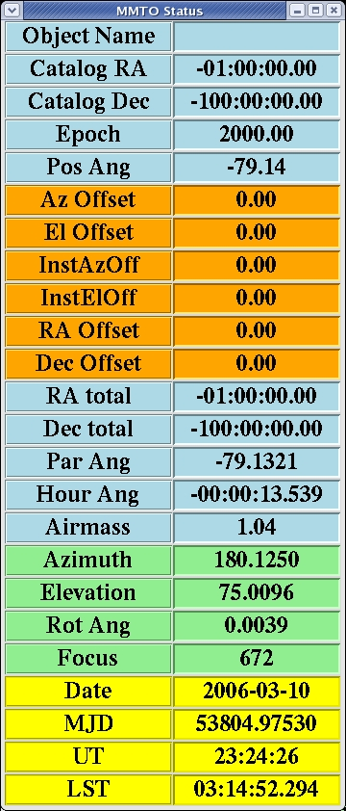
Figure 16: Mount Display window
The Mount Displpay window provides information about the status of the MMT itself. This information is self-explanatory.

Focusing Procedure

Focusing is perform by automatically taking a series of focus frames with the focus mode if the StandardOps window (see section in StandardOps.) . Each focus step is read out into an individual fits file.

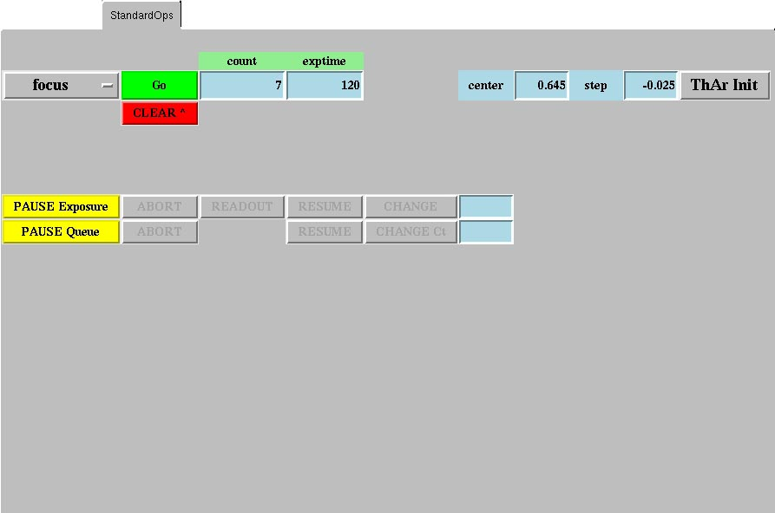
Figure 17: Focusing in the StandardOps panel

Focusing is done in the RV31 filter and binning should be 1x1, for maximum resolution of defocus errors.

The focus frames are taken about a center focal position that may be typed into the blue box labeled center. This defaults to the previous focus. A good starting value is last night’s bets focus or the default. Changes in focus are the result of thermal expansion of the spectrograph optical bench, so if the ambient temperature is stable night to night, changes in focal position should be small The size of each step, in millimeters,is typed into the blue box labeled step. A good starting value, the default, is 0.023 mm.

The number of focal steps typed into the blue box labeled count. In general, a sequence of 7 focus exposures is a reasonable number.The exposure time is typed into the exptime box. With the current calibration lamps system (18 ThAr bulbs mounted on the secondary), a 120 sec exposure time is reasonable.

The ThAr Init botton turns the ThAr lamps on and off. The state of the ThAr lamps is indicated in the Dome Lamp section of the Status panel. There is a 10-20 second latency between clicking this button and lamps turning on/off, so do not click impatiently.

Title, PAUSE Exposure and PAUSE Queue are discussed in the StandardOps section.

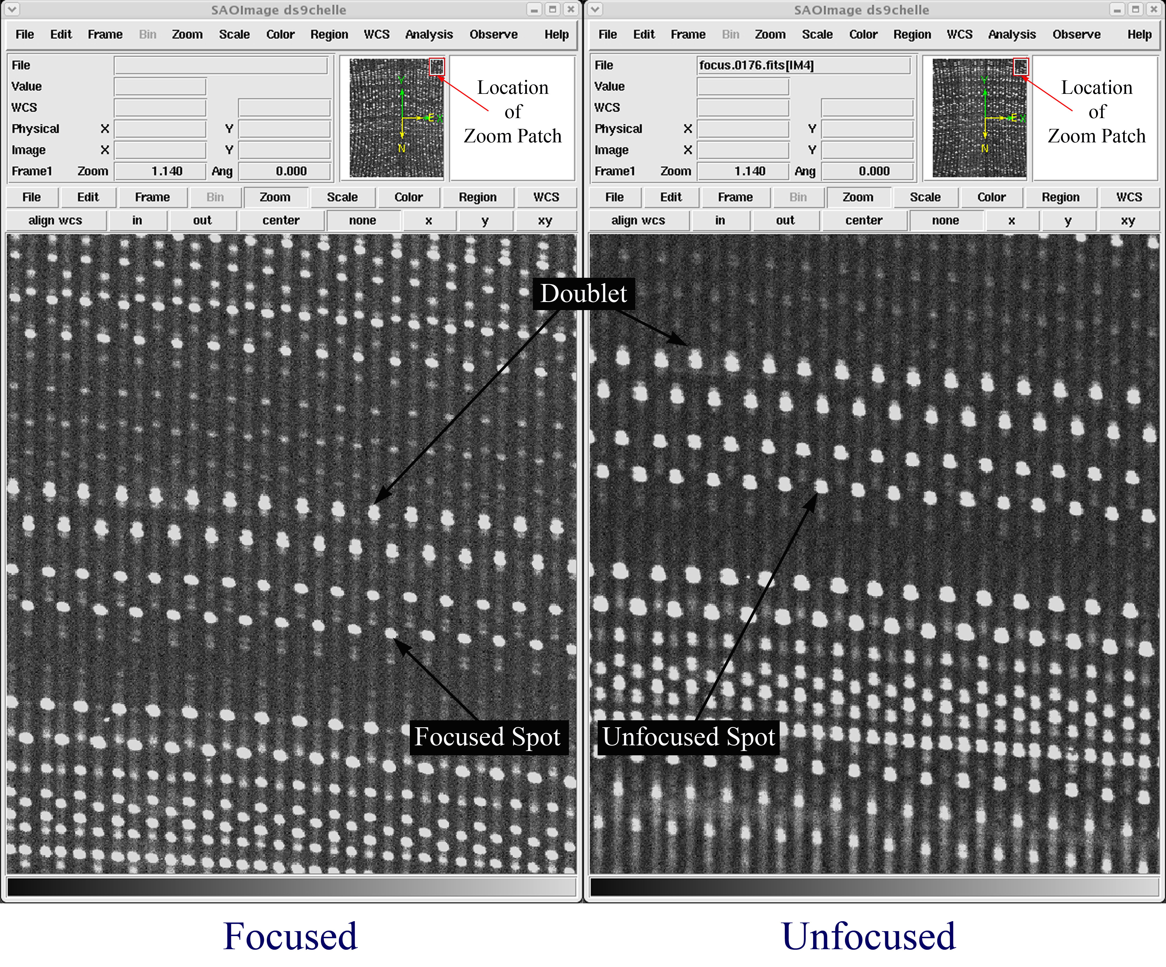
Figure 18: Comparison of focused and unfocused spots

Figure 18 shows how to determine good focus. Defocus is best seen at the corners of the CCD format; at most reasonable focal positions, the spots will be well formed at the center of the focal plane. Defocus manifests itself primarily as “doubling” of the fiber images, this doubling due to a failure to parfocalize the images from the two halves of the grating mosaic. The right panel of Figure 18 shows a defocused image in the upper left corner of the CCD format. In this image, all the spots are doubled. This doubling is to be compared with a focused image in the left panel of Figure 18. It is important to differentiate doubled images and spectral doublet (again see Figure 18). In the focused image, some spots are doublet and some are singlets. In the unfocused image all of the spots are double.

It is essential to examine all four corners of the focal plane and the center at all focal positions. It is possible to tighten the focus in one corner at the expense of other corners -- the focus must be good everywhere for Hectochelle properly.

Once a good focal position has been determined, it must be set for further observations. This is done by going to the Focus panel in the Command region and typing the best focus position into the New Focus box and clicking the Apply and Save buttons. One may note the focal position by watching the Current/Focus value in the Config panel during the focus exposures, but it is best obtained from the header of the best focus file. This is done by examining the fits header with DS9. The focal position is the INSFOCUS parameter in the fits header.’

Calibration Protocols

Calibration Resources

The following resources are available for the calibration of Hectochelle data;

- Thorium-argon (ThAR) hollow cathode lamps – These are nine (18) lamps that provide the primary wavelength calibration standard (see Figure 19. To make wavelength calibration exposure tractably short, they are mounted on a spider immediately in front of the secondary mirror and directly illuminate the focal plane. These bulbs are mounted on-axis and illuminate the focal plane relatively uniformly, irrespective of fiber position. Since these lamps point directly at the focal plane, they can be illuminated without closing the slit & it is recommended that a ThAr lamp be taken after every science frame or before and after each group of science frames. The guide cameras must have their gains reduced when the ThAr system is turned on, however this procedure, implemented by the HectoRobot operator, is routine. It is also essential to offpoint the telescope somewhat from the target stars during calibration, since it is undesirable to have stellar spectra superposed on the calibration data.
- Dome flat (Continuum) lamps] – This is a quartz halogen lamps mounted at the center of the cluster of ThAr bulbs. These provide a continuum light source with a ~3200ºK color temperature. They can used when the slit is open. It is recommend that one continuum be taken with robot configuration to optimize aperture tracing of the ThAr and science frames.
- Twilight sky – These data can be taken, weather conditions permitting, just after sunset. While these calibration frames can only be taken once a night, they fill the pupil more perfectly than the ThAr system and serve as a cross check of ThAr calibration taken contemporaneously. On the shorter nights of the year, it is possible to request the operator to support the acquisition of twilights at dawn, but this is an extra burden on the staff and should only be requested special circumstances.
- Internal calibrator – The internal calibrator is a set of three optical fiber pairs mounted on the side of the fiber shoe (the science pseudo-slit) which is fed from a remote light box with a lamp system that is fixed. The pairs produce images that are at the top, middle and bottom of the focal plane. Each pair consists of a 250μ and 100μ fiber. The larger fiber is the same size as the Hectochelle science fiber and the smaller fiber is included to make it easier to assess focus and alignment. This system is very close to the pupil illumination at the focal plane of the F/5 MMT for sources at infinite conjugate – i.e. it is similar to the real telescope illumination and does not suffer from the pupil illumination issues that may be present with the ThAr system. It is significantly offset in the dispersion direction from the science fibers, so it is only useful as a measure of motion of the fiber shoe during the night. It is not used much since the ThAr was deployed, however it has the advantage that is direct measure of system drifts.
- Sky fibers - Xfitfibs, the fiber configuration planning software tool, will allocate unused fibers for sky subtraction measurements. Better sky subtraction clearly requires better sampling of the sky across the focal plane, however this requirement has not been quantified yet. We note there is a reasonably bright sky emission feature in the RV31 filter (and probably other filters too – we simply have the most experience with the RV31 filter at this time) which may be exploited to register wavelength solutions.
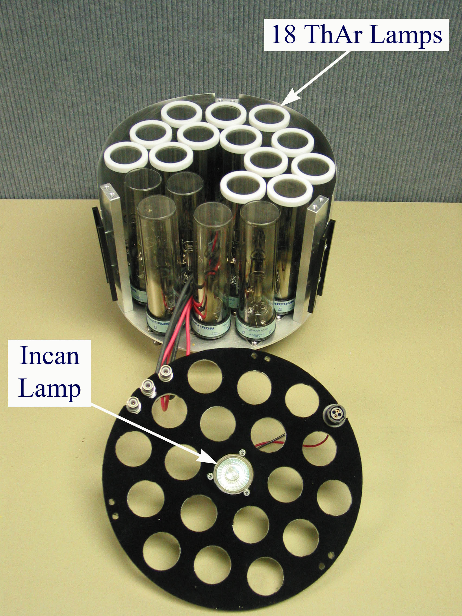
Figure 19: The partially assembled Hectochelle cal lamps system.

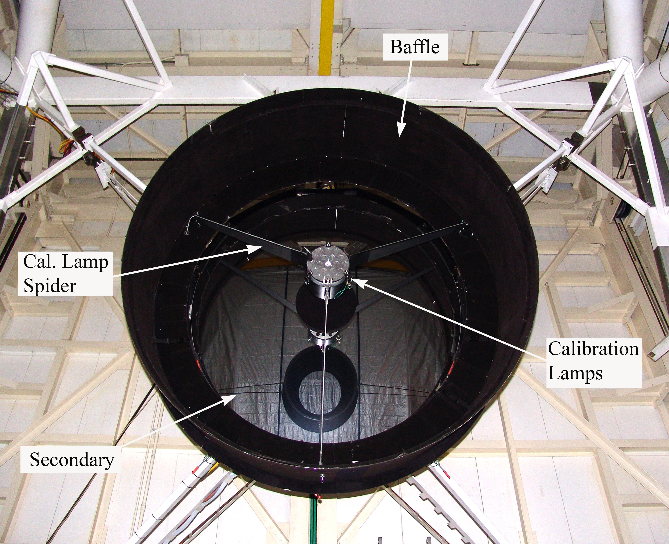
Figure 20: The calibration lamp system mounted on the MMT.

Calibration configuration

Observations with the Hectochelle are queued, so it is necessary to collect a sufficient set of calibration for the reduction of all data taken in a given night. However, the number of possible Hectochelle configurations is large, so it is only possible to calibrate those configurations that will be employed in a given night.

Hectochelle has the following configurational degrees of freedom:

- Binning modes – the Hectochelle CCD spectra can be binned arbitrarily to minimize the loss of signal-to-noise to read noise of the CCD with a slight loss of resolution. Values are 1x1, 2x1, 2x2, and 2x3.
- Filter configurations – Hectochelle is equipped with several order-separating filters to isolate individual diffractive orders. Hectochelle automatically parfocalizes the optics and optimizes the tilt of the diffraction grating for each order. The various filters are enumerated and described in Appendix B.
- Exposure duration – the duration of Hectochelle exposures varies widely between programs, so as short as 10 minutes and others as long as an hour. As exposures stretch beyond 30 minutes, dark current and unavoidable light contamination may need careful attention, especially for faint data.

Filters are selected with the Config panel in the Command region. It is essential to click the ConfigBench button whenever the filter is changed. This button actually implements the filter change, parfocalizes the camera and collimator and adjusts the grating tilt. Failure to toggle this switch will result in an error message. The current filter is displayed in the Status region and logged to the fits header each exposure.

Binning is independently selectable in the spatial and dispersion directions through the SPATBIN and DISPBIN entries in the SPICE window. While many combinations are possible, only 1 x 1, 2 x 1, 2 x 2, and 2 x 3 are supported at present.

It is necessary to log each different form of science and calibration data to the correct file type, selected in the StandardOps panel, e.g., one should make sure that “comp” is selected as the data type when the ThAr lamps are used.

Calibration protocols for the Hectochelle

We require the following data for the reduction of the Hectochelle data.

Bias Frames – 10 bias frames at whatever binnings are being used for the night.

Dark Frames – Dark frames are taken as a diagnostic took to detect light leaks in the spectrograph room, but are also used in the spectral extraction. After the dewar has first been cooled, or the room has been illuminated for inspection, the dark rate will be high for up to 24 hours. It is essential to take dark exposures right after illumination to drain off the excess dark. However, there is detectable dark even days after room illumination, so dark exposures are needed to properly reduce the data.

Twilight Frames – For approximately 20 minutes before sunset, it is possible to collect high signal-to-noise solar reference spectra from the twilight sky. These spectra should have ~10-20,000 continuum counts/pixel. It is recommended that these spectra are collected for each filter/binning combination to be used in a given night in the Ring 200 configuration. The PI team request whenever possible that this data be taken in the RV31 filter.

Dome flats – Most “domeflats” are taken using lights located at the telescope secondary mirror. These are used for spectrum extraction. For “throughput correction”, the more uniform illumination provided by the building lights are preferred. These are called “boxdomeflats”. They are essential for good skysubtraction, and for removing the CCD fringing that occurs for wavelengths beyond 7500A. Domeflats should have ~10,000 counts/pixel. At table of exposure times for each filter appears in Table 1, but exptimes are set automatically in Spice.

Wavelength Calibration (Comps) – ThAr exposures are required to fiducialize the spectrograph wavelength scale. These are taken before observations commence for comparison with twilight frames and before & after all science exposures, or for shorter exposures times, sequences of exposures. Domeflat and Comp exposure times are set in automatically in Spice.

Sky Offset Frames - If the science targets are brighter than V=12, they will contaminate the reference spectra. Contamination may also occur when observing crowded fields (e.g. globulars) or fields with bright nebular emission. In these circumstances, the telescope should be offset by 5” to the North by the telescope operator, at the request if the observer for these calibration exposures. Typical exposure time is 5 min in 1x1 binning mode in the RV31 filter.

 | Exposure Times
 | 1 x 1 Binning |  |  | 2 x 3 Binning
Filter | Contin. | Short ThAr | Long ThAr | Contin. | Short ThAr | Long ThAr
Ca 19 | 24 | 240 | 900 | 4 | 90 | 300
OB21 | 24 | 240 | 900 | 4 | 90 | 300
OB24 | 24 | 240 | 900 | 4 | 90 | 300
OB25 | 24 | 240 | 900 | 4 | 90 | 300
OB26 | 24 | 240 | 900 | 4 | 90 | 300
CJ26 | Same
Na28 | 24 | 240 | 900 | 4 | 90 | 300
Cu28 | Same
RV31 | 24 | 240 | 900 | 4 | 90 | 300
OB32 | 24 | 240 | 900 | 4 | 90 | 300
OB33 | 48 | 240 | 900 | 8 | 90 | 300
OB37 | 48 | 240 | 900 | 8 | 90 | 300
Ca41 | 240 | 240 | 900 | 40 | 90 | 300
Table 1: Exposure times for domeflat and ThAr calibration.

Calibration timeline

On weekdays the day crew turns operation of the telescope to the observers at 4:00 p.m. The telescope operator is generally available to assist with operations at this time, e.g. to remove the mirror cover, tip the telescope, etc. The timing of calibration is regulated by the time of twilight – time to obtain twilight skies - and 12º twilight the beginning of observations.

I have compiled a table of sunset/sunrise times & 12º twilights for the solstices and equinoxes (Table 2). As a general rule, the dawn twilight frames are not taken, since it places an unreasonable on the telescope operator to support calibration activities this late in the morning. However, the long dark frames can be set up in the morning for automatic execution. It is important to set the SPICE parameter “TELNAME” value to “test”, which makes it possible to continue taking Hectochelle data when the telescope server is shut down the operator at the end of the night.

 | Summer  Solstice | Winter  Solstice
Sunset | 19:36 | 17:28
12º twilight | 20:35 | 18:22
12º twilight | 04:16 | 06:23
Sunrise | 05:15 | 07:16
Table 2: Solstice sunrise/set and twilights at the MMT

In Table 3, I show a typical timeline for calibration. This can clearly be modified to suit an actual night’s plan, but is illustrative of what is required. Since the 1 hour dark frames are essential but onerous, it is reasonable to defer most of them until the end of observations. However, it is best to try to include at least one before observations Observers of specialized configurations (very long exposures, rarely used filters) are free to adjust the number of repetitions up or down as long as they do not impose an significant extra burden on observers. For example, programs involving very long integrations, may set up 3-5 long darks at the end of the night that may run until 11a.m., recognizing there is some risk that it may be necessary to enter the spectrograph room to service one of the spectrographs. In the case of queued observations for other observers the number of calibration frames may not be reduced.

It should be noted that, in general, darks can be taken when the dome is illuminated. Also, since 3 repetitions is the minimum useful number of dark frames for cosmic ray removal, although five repetitions is vastly preferable.

Frame Type | Time of  Exposure† | Binning | Fiber setup | Number Taken | Exposure  Duration  [min] | Total  Duration††  [min] | Total All Exp. [min]
Bias | -2:00 | 1x1 | any | 10 | 0 | 2 | 20
Bias | -1:40 | 2x3 | any | 10 | 0 | 1 | 10
Open Mirror Cover/Zenith Point | -01:30 |  |  |  |  | 10
Configure to Ring 250 | -01:20
Focus | -01:00 | 1x1 | Ring 200 | 7 | 1.5 | 3.5 | 25
Open dome | -00:30 |  |  |  |  | 5
Twilight | -00:20 | 1x1 | Ring 200 | Each Filter | 0.5-1.1 | 2.5 | 10
Twilight | -0:10 | 2x3 | Ring 200 | Each Filter | 0.16-0.5 | 1.1 | 5
Sunset | 00:00 | M | M | M | M | M | M
Twilight |  | 1x1 |  | Each Filter | 1/60-1/15 | 2 | 8
Twilight |  | 2x3 |  | Each Filter | 1/60-1/15 | 1 | 5
Configure fibers |  |  |  |  |  | 10
Close dome
ThAr Lamp | 00:25 | Setup 1* | Setup 1* | 1 | 15 | 17 | 17
Continuum Lamp | 01:15 | Setup 1* | Setup 1* | 3 | 10 | 11 | 33
12º Twilight –Start Obs. | 01:15
12º Twilight – End Obs | n/a
Dark A | n/a | TBD | Parked | 5 | TBD | TBD | TBD
Dark B | n/a | TBD | Parked | 5 | TBD | TBD | TBD
Done | n/a
Table 3: Typical timeline for Hectochelle calibrations
*Setup 1 is the first fiber setup of the night † Times are referenced to local sunset
††We assume a 2 minute read time for integration in binning 1x1, <1min for binning 2x3

Observing Protocols/Modes
For a given configuration is essential to take a short ThAr and continuum (see Table 1) at that configuration (grating tilt, binning, fiber config. focus.) It is not adequate to take these calibration data in the afternoon, since there a slight inaccuracies in the different mechanisms that might affect wavelength scale. For this reason, ThAr and continuum lamps were installed at the secondary mirror. As noted above, for accurate throughput corrections, either boxdome flats or twlight sky flats must be observed, and for adequate removal of CCD fringing in red orders (e.g., Ca19 at 8500A), boxdome flats must be observed.

The minimum protocol is to take a short continuum and ThAr before observation in a given configuration. It may be desirable to retake these at the end of the exposure sequence. For very long exposures (~ 1 hour) it may be desirable to take a pair of calibration frames between each exposure.

The calibration frames should taken with the telescope off-pointed from the science pointing, since it is undesirable to have your object spectra overlapping you rcalibration spectra. This can be done efficiently right after wavefront sensing and before moving to the science field.

For binning considerations, unbinned data is the most accurate. However, the other three binnings are also used, depending on the faintness of the targets and the spectral resolution needed.

Setup/wavefront/pointing/guidelock take 20 minutes. An additional 5 minutes is needed for calibration exposures, and each exposure takes a further 1.5 minutes.

To properly protect the optical fiber chain, observations are suspended if the telescope approaches within a few degrees of zenith, since the Cassegrain derotator can spin quite rapidly near zenith. Proper account of the constraint should also be made when deciding when to start and stop exposure.

Appendices

A. FAQ

What action does one take if the CCD temperatures deviate from nominal?

The CCD temperatures displayed in the Status region should be within 0.3 ºC of their nominal setpoint temperature of 120 ºC. These temperatures should not fluctuate more that ±0.01º over ten minute intervals, except immediately after CCD readout. During readout, thermal control is suspended, and there may be some recovery after a readout. If the temperature drops significantly below 120 ºC, CCD performance will be affected. Deviations from the setpoint temperature, especially rapid fluctuation will cause thermal gradients in the focal plane structure and induce shifts in the position of the spectra. These shift are principally in the spatial direction. If the temperature starts to drift or fluctuate unreasonably, the probable culprit is a hung server. Check the status window to see if all the servers are running properly. If the Hk (housekeeping) or Heater servers are down, they may be restarted in the Start/Stop panel. Alternatively, clicking the Start CCD button in the Startup panel will also restart all the CCD related servers.

Under what circumstances should the queue observer deviate form the queue schedule?

Queue observer should follow the queue schedule whenever it is possible.
However, several common circumstances are cause for deviating from the queue schedule:
- The configuration file is unobservable because the guide stars are inadequate or quick-look checking on the first exposure indicated light is not going into fibers.
- There is light cirrus making it impossible to do faint objects, but possible to do bright objects.
- The moon is too close to the object. This is a slightly qualitative call since some program are more sensitive to moonshine than others.
- Delays have made a scheduled extremely unfavourable – e.g. there is no point in going to a field that will go below 2 airmasses in 45 minutes.

Where’s my data?

Hectochelle data is logged to:

/data/crunch/CHELLE

in subdirectories with the format (year).(month+day), i.e. 2006.1023
The directory is incremented to a new day at noon every day.

How do I get it home?

All data is immediately transferred back to CfA and archived in Cambridge. Email notices are sent to the PI in the afternoon with instructions on how to retrieve the data.

B. Order Separating Filter Properties

The Hectochelle is, at present, a single order, multiobject spectrograph where overlapping orders are separated with narrow band filters. These filters have, in general, been designed with a full width, half maximum (FWHM) passband equal to the free spectral range (FSR) of each diffractive order. The center wavelength (CWL) of the pass is not that of the CWL at blaze, since this inevitably leads to some important wavelengths lying at the margins of the FSR. Instead, we have tried to center as many astrophysically interesting wavelength within the filter passbands, The diffraction grating is mounted on a precision rotary stage, making it possible to tilt the grating to arbitrary angles of incidence. The opening angle between the incident beam and the center of the diffracted beam is fixed at 15°. Operating slightly off blaze occasionally leads to a small loss in system efficiency, but offer big gains in efficiency in important spectral regions. Thus new filters may be centered at different wavelengths than shown in Fig 21.

As far as cost, a two filter set purchased in 2015 from Asahi Corp in Japan cost roughly $4000, with a 6 month delivery time.
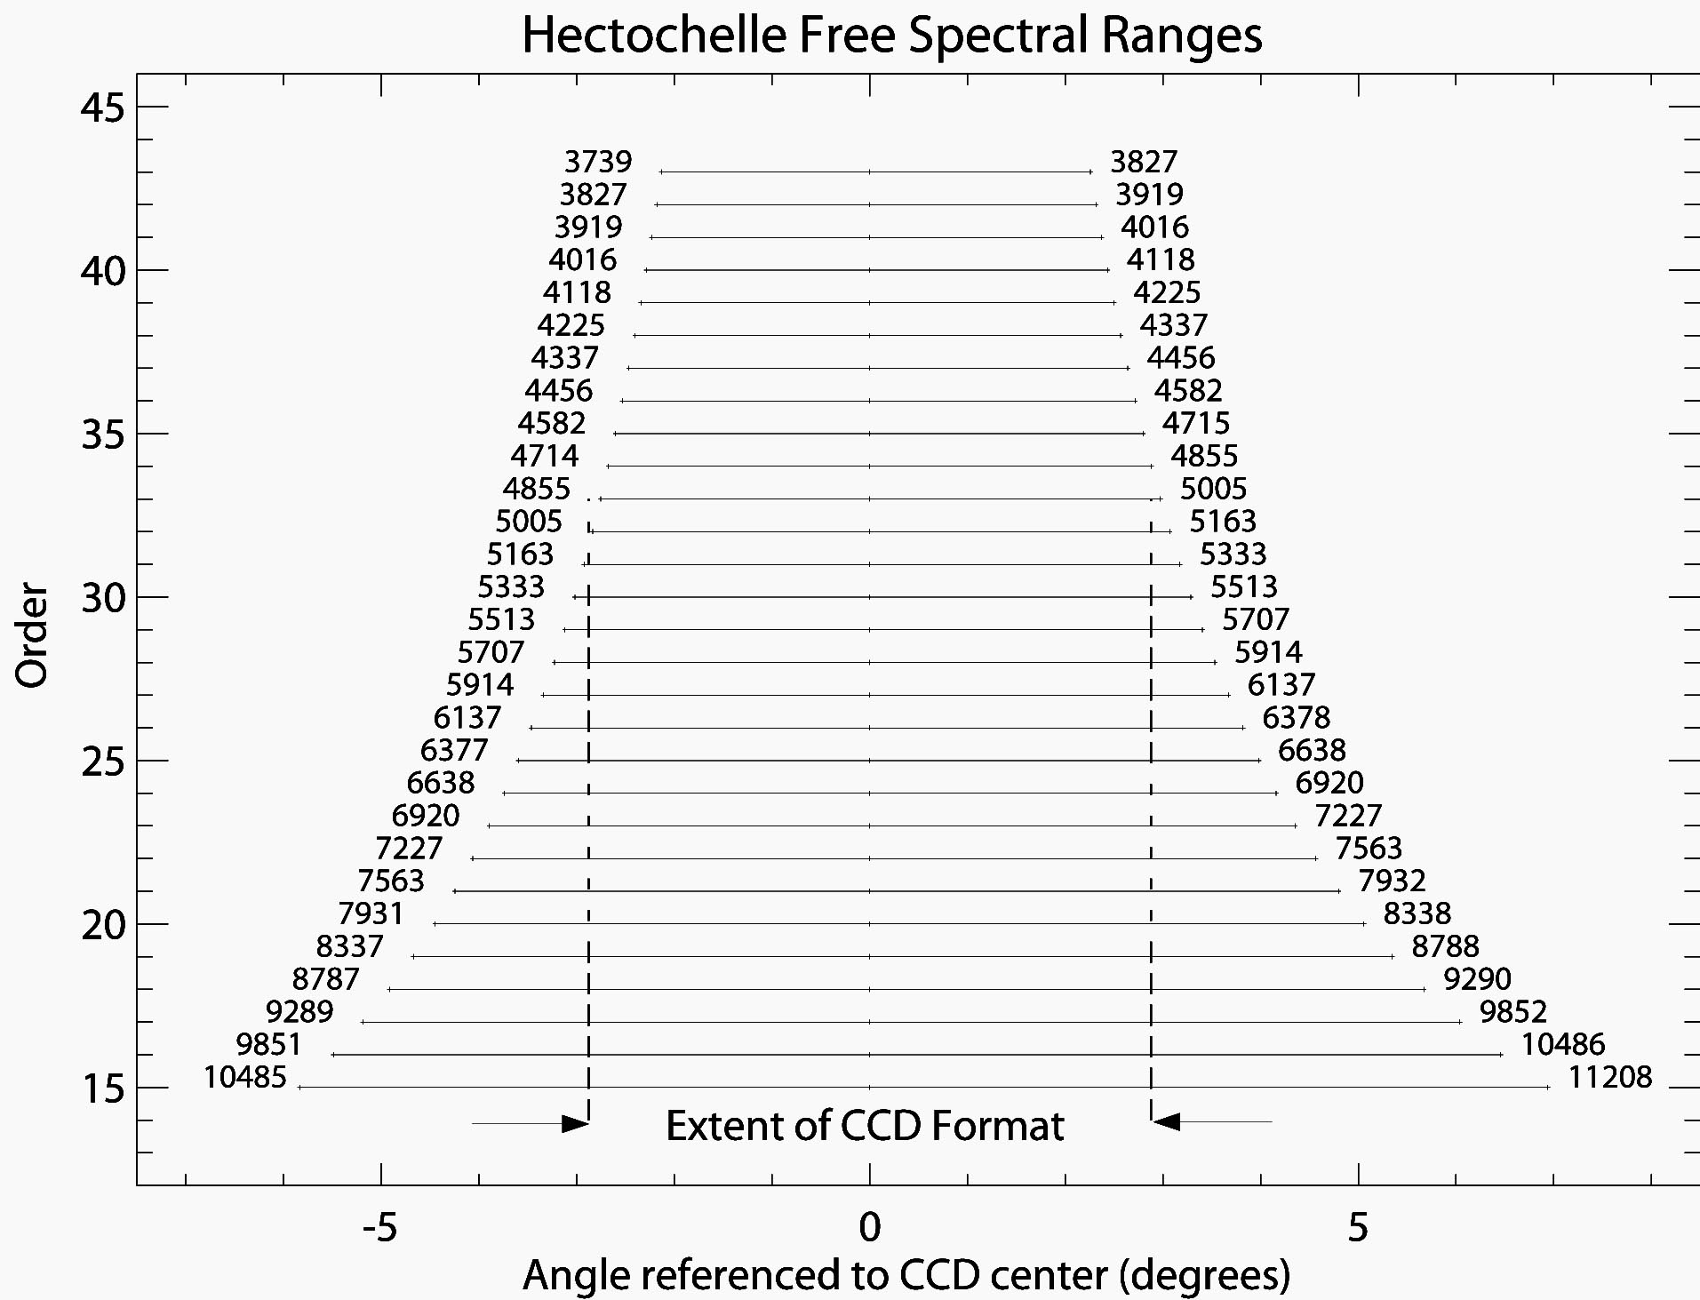
Figure 21: The diffractive orders of the Hectochelle. The dotted line indicates the extent of the CCD format when the grating is operated on blaze. The grating may be rotated, thus moving wavelengths that were lost onto the CCD format.

At present the Hectochelle has 11 order separating filters. Their relevant parameters are tabulated in Table 4 and their transmission curves appear in Figs 22 – 38. Both the narrow band transmission curve and the broad band out of band blocking performance at shown. While the efficiency of the Hectochelle as a function of wavelength can be calculated with other information in the Hectochelle Manual (in prep.), a good figure of merit for system efficiency is the filter transmission-CCD quantum efficiency product, also tabulated in Table tbd.

The FSR of order 31 (~510 nm) is the same size as the CCD format. Orders blueward of order 31 are smaller than the CCD format; order redward overfill the focal plane. It is possible that lines redward of 510 nm will require a special tilt of the grating to move them onto the focal plane, a feature that is not currently implemented on Hectochelle. Consultation with the PI is advised if you are planning on working at line that is not reasonably well centered in the filter transmission curve. You may, however, calculate the position on the focal plane with the grating equation and the following parameters of the Hectochelle:

Grating pitch: ρ = 110 lines/mm
Blaze angle of incidence: α = 72°
Blaze diffraction angle: β = 57°
Camera focal length: 25.3 inches
Pixel size: 13.5µ
Size of detector, dispersion direction: 2304 pixels, half width.

The filters with “OB” designators have been designed to match the FSR at blaze with minor adjustment to center scientifically important wavelengths. Na D, Ca H&K the infrared Ca triplet, and a Cu setting required a significant recentering, so they have special designators. The RV filter has been designed explicitly for radial velocity studies.

The CJ26 filter replaces the original OB26 filter, the latter being made out of spec.
The original OB24 was also made out of spec, and is being replaced as of Jan 2016. We do not recommend using either the old OB24 or the old OB26 filters. An additional filter, Cu28 is also being added in April 2016.

The Na28 order is contaminated with light from a different order shortward of 586 nm.

Filter | CWL | FWHM | Trans | Trans∙CCD QE | Vendor | Included Features
Ca 19 | 858.0 | 45.0 | 0.96 | 0.38 | Omega | Ca Triplet
OB 21 | 774.8 | 36.9 | 0.92 | 0.53 | Omega
Old OB 24 | 670.7 | 28.2 | 0.92 | 0.71 | Omega | Li, [S II], He II
New OB24 | 677.5 | 21 | 0.90 | - | Asahi | Li, [SII], He II
OB 25 | 656.3 | 26.0 | 0.89 | 0.71 | Omega | Hα, [N II]
CJ 26 | 626 | 25.0 | 0.90 | 0.71 | Asahi | [O I],
OB 26 | 670 | 22 | 0.89 | 0.71 | Omega | Hα at edge, but order overlap occurs
Na 28 | 589.2 | 20.8 | 0.87 | 0.73 | Omega | Na D, He I
Cu 28 | 581.5 | 20 | 0.93 | - | Asahi | Cu, Na D
RV 31 | 523.0 | 16.0 | 0.94 | 0.78 | Barr | Radial velocity
OB 32 | 500.7 | 15.9 | 0.87 | 0.73 | Barr | [O III]
OB 33 | 486.1 | 14.9 | 0.93 | 0.78 | Barr | Hβ
OB 37 | 435.1 | 11.9 | 0.98 | 0.79 | Barr | [O III], Hγ
Ca 41 | 395.0 | 9.6 | 0.96 | 0.72 | Barr | Ca H&K
An additional filter that is used in conjunction with an iodine vapor cell for precision radial velocity studies was made, but is unavailable.

Table 4: Order separating filter properties

Figure 22 All filters (except Ca41)
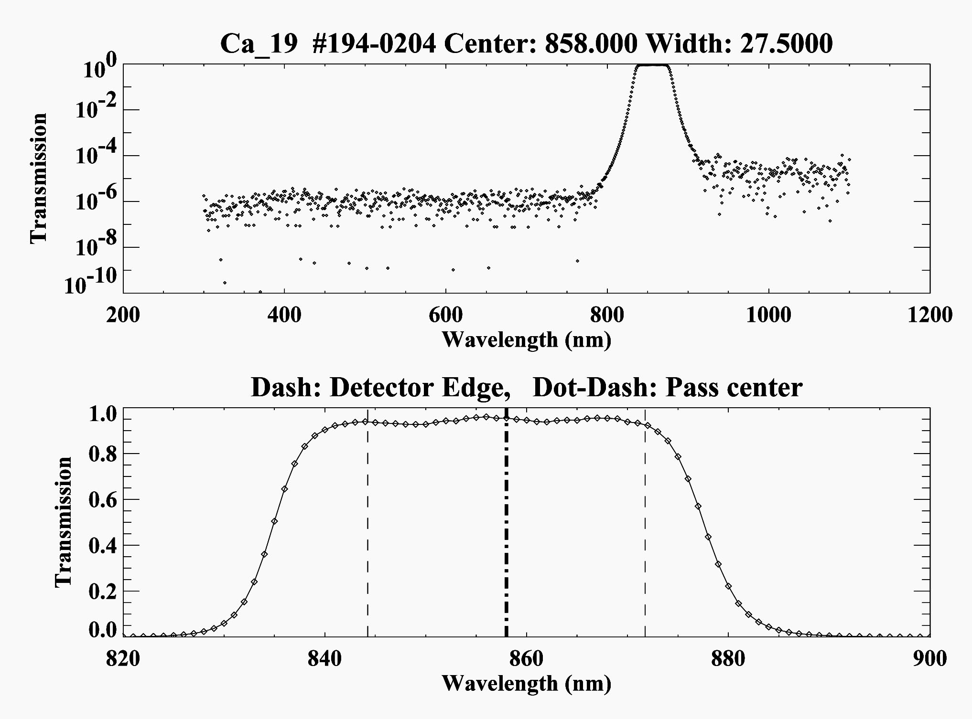
Figure 23: Ca 19 filter Transmission.
Upper panel shows out of band blocking, whilst lower panel shows detailed characteristics of this filter near pass center.

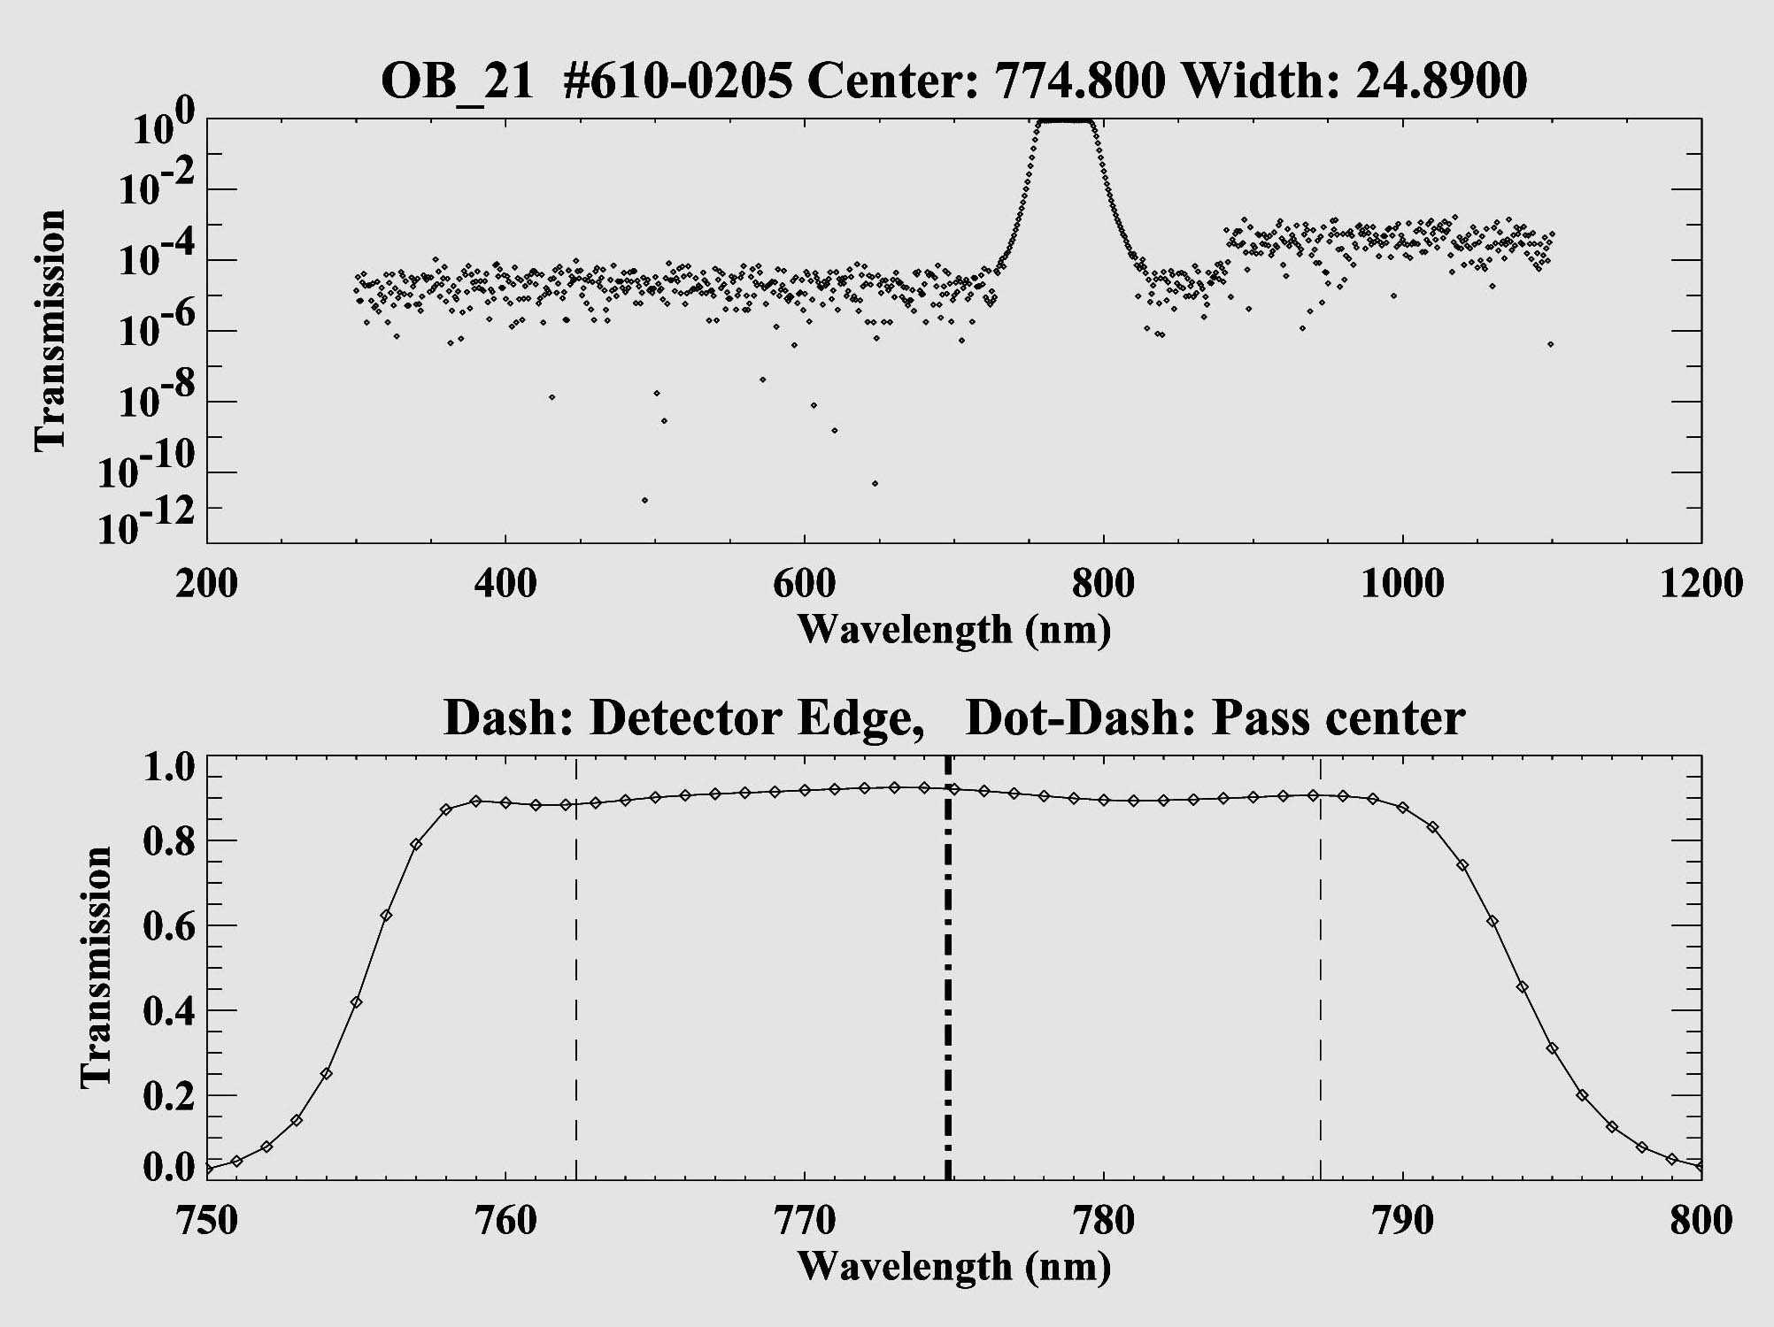
Figure 24: OB 21 filter transmission.

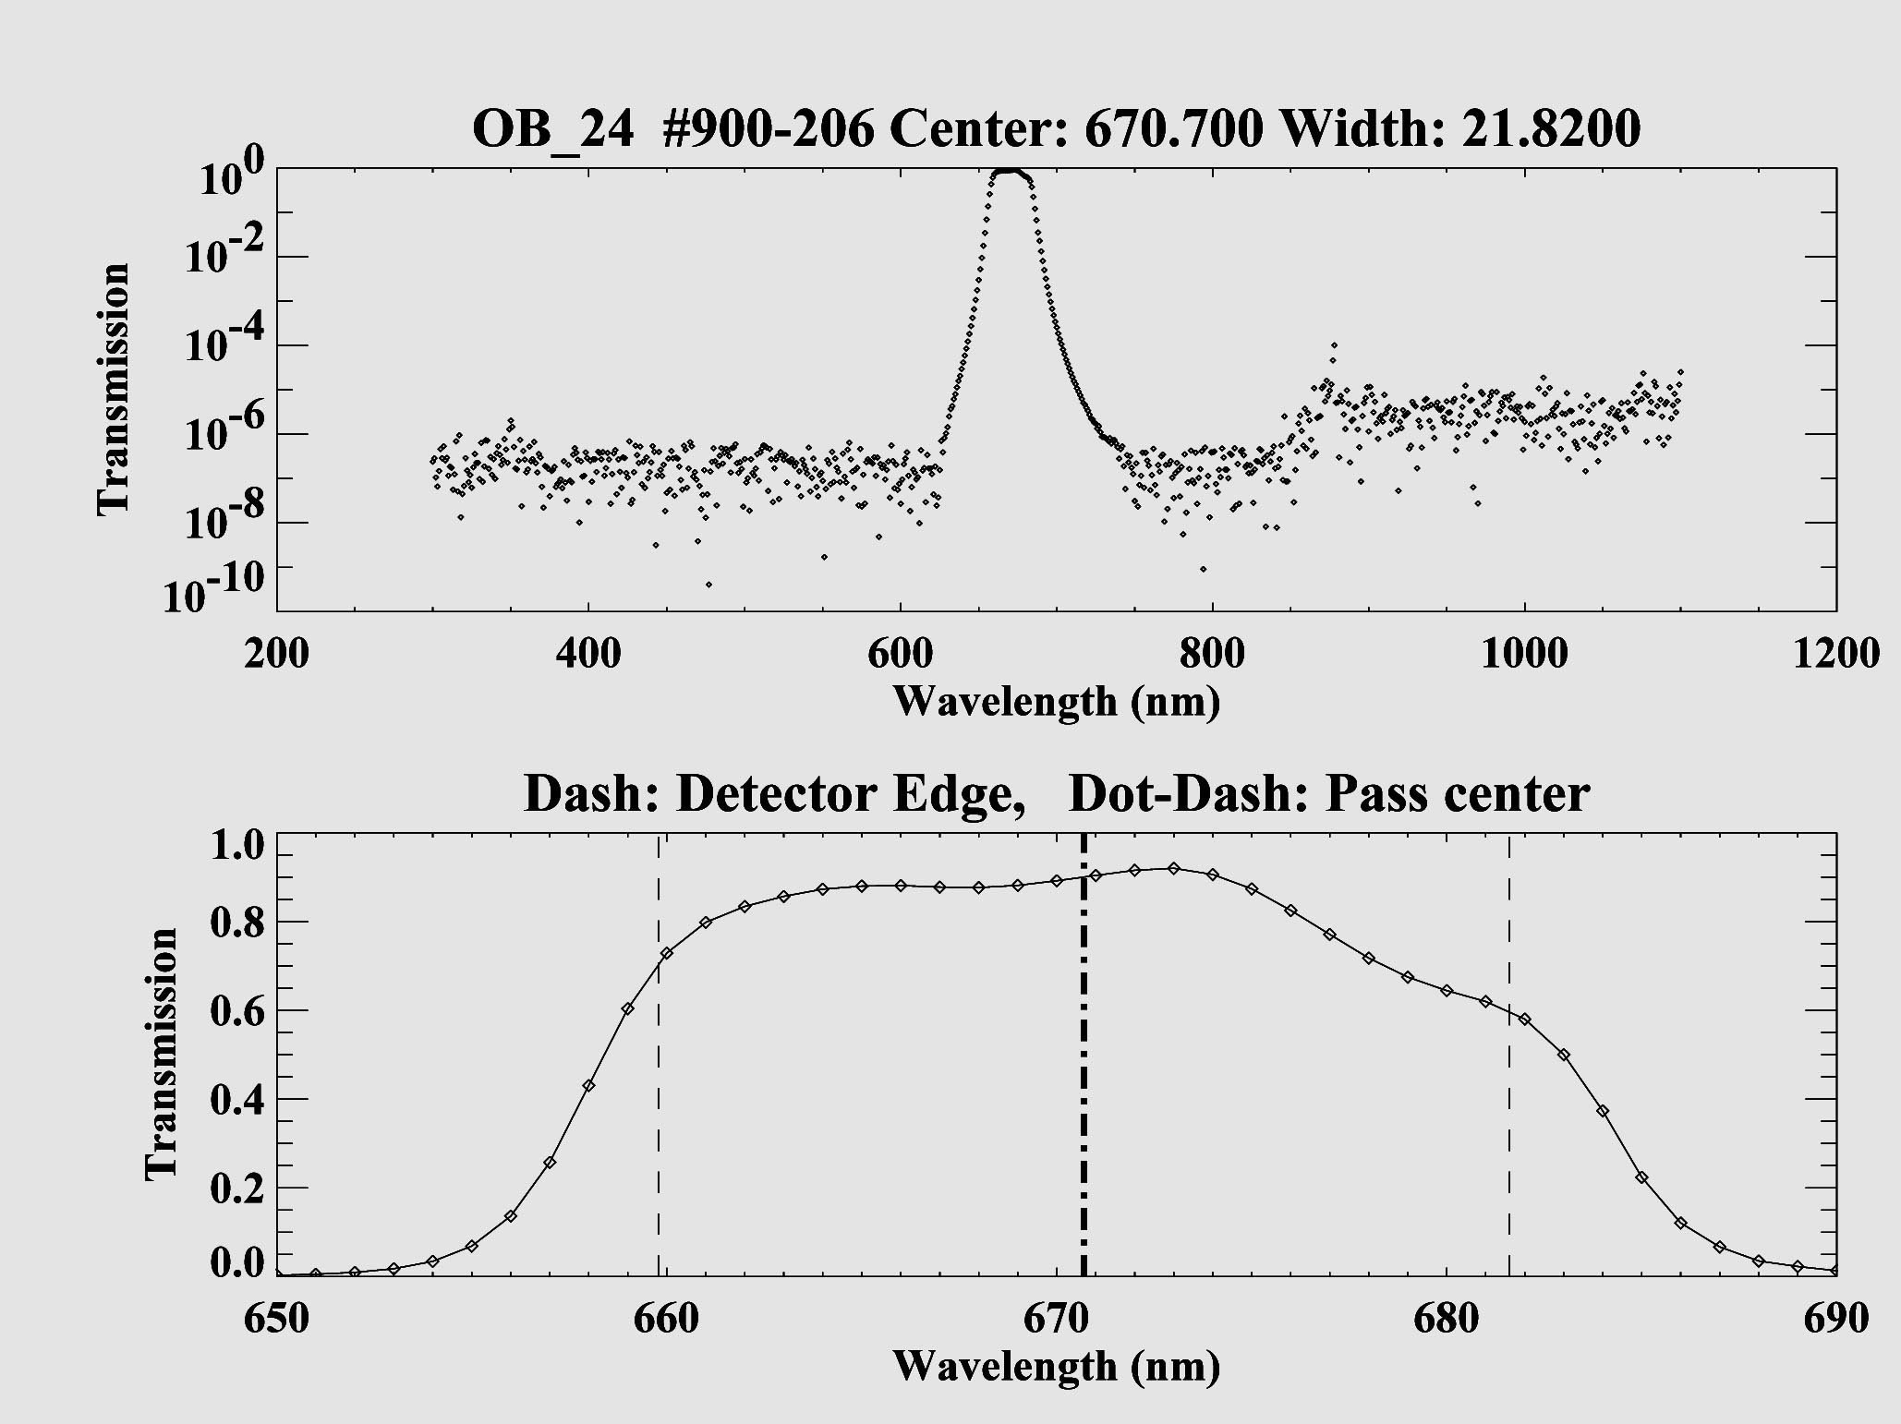
Figure 25: old OB 24 filter transmission, according to Mfgr.
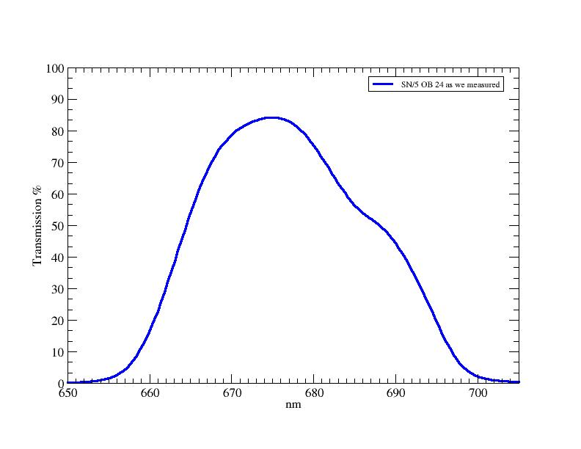
Figure 26 old OB24 as measured (note scale change, and vast difference between Mfgr and reality)

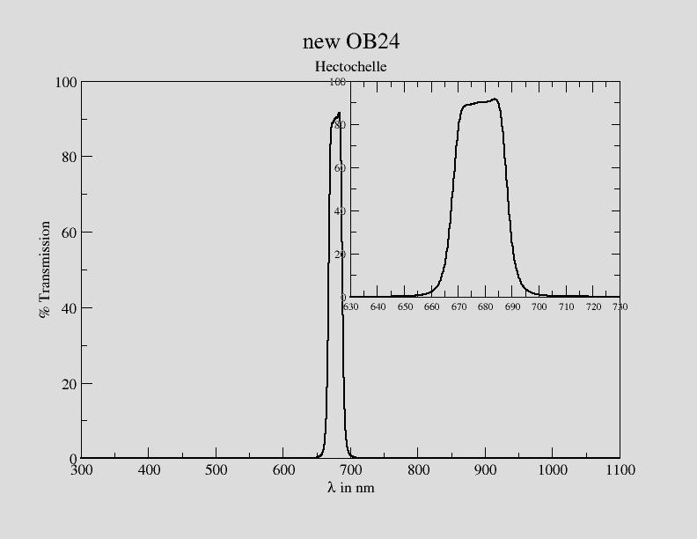
Figure 27 new OB24, as of April, 2016

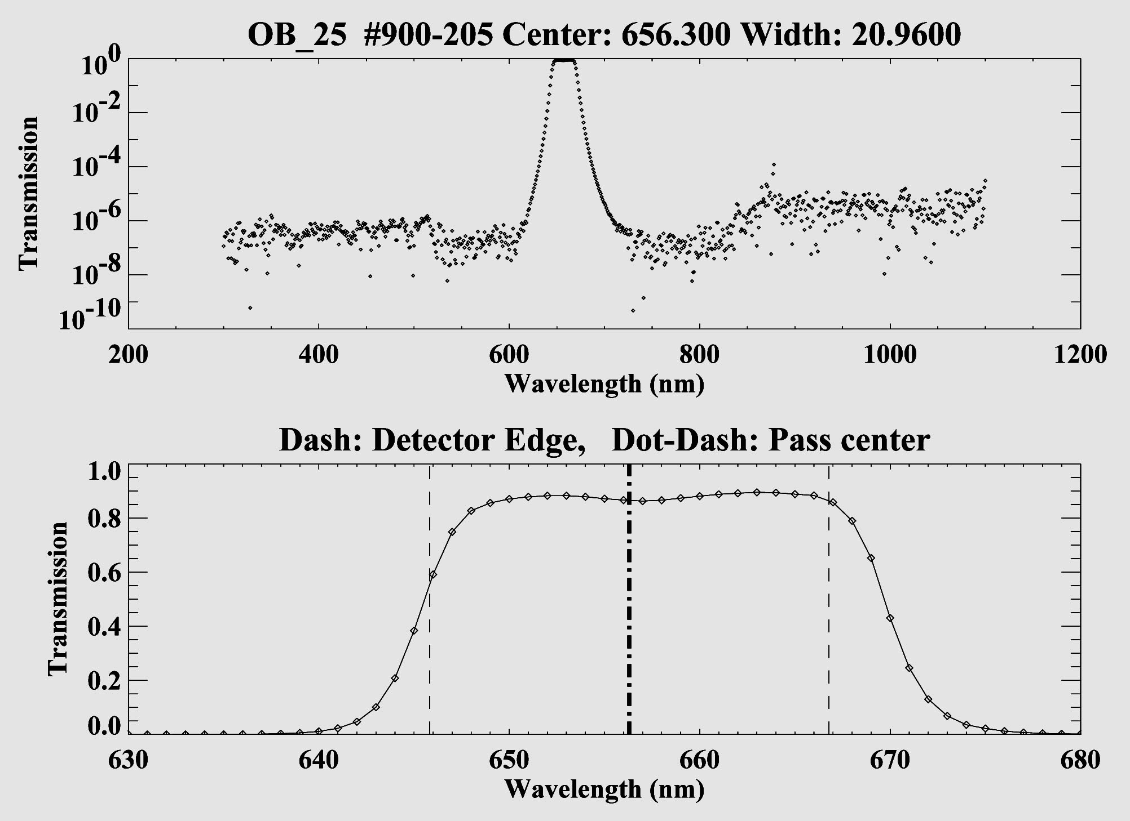
Figure 28: OB 25 filter transmission.

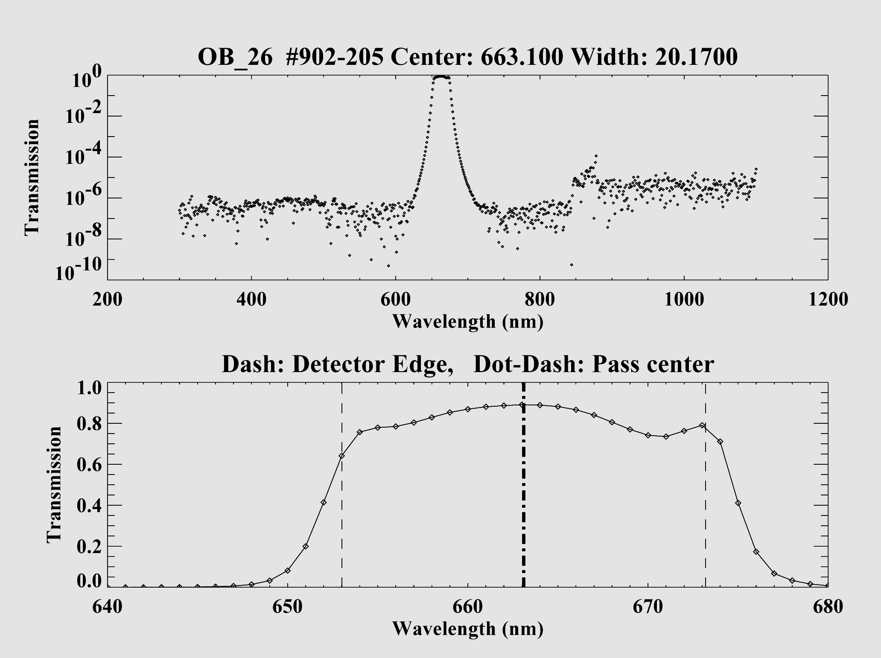
Figure 29: OB 26 filter transmission from Mfgr.

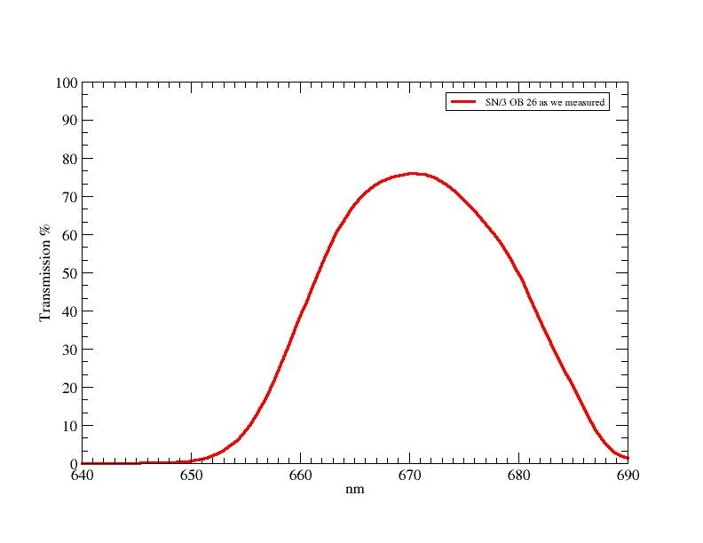
Figure 30 OB26 as measured (note scale change, and vast difference between Mfgr and reality)

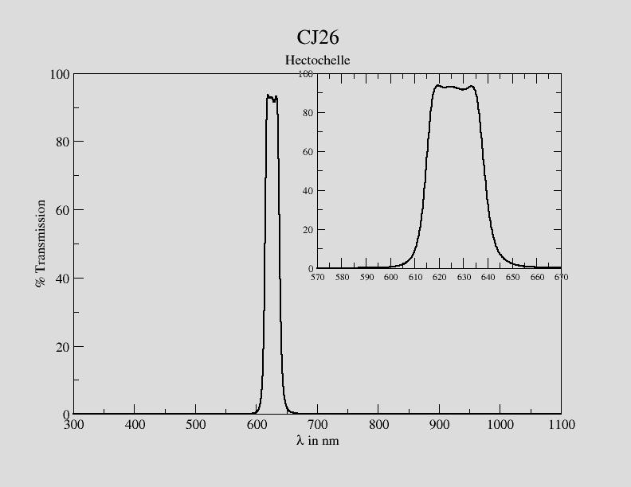
Figure 31 CJ26 filter

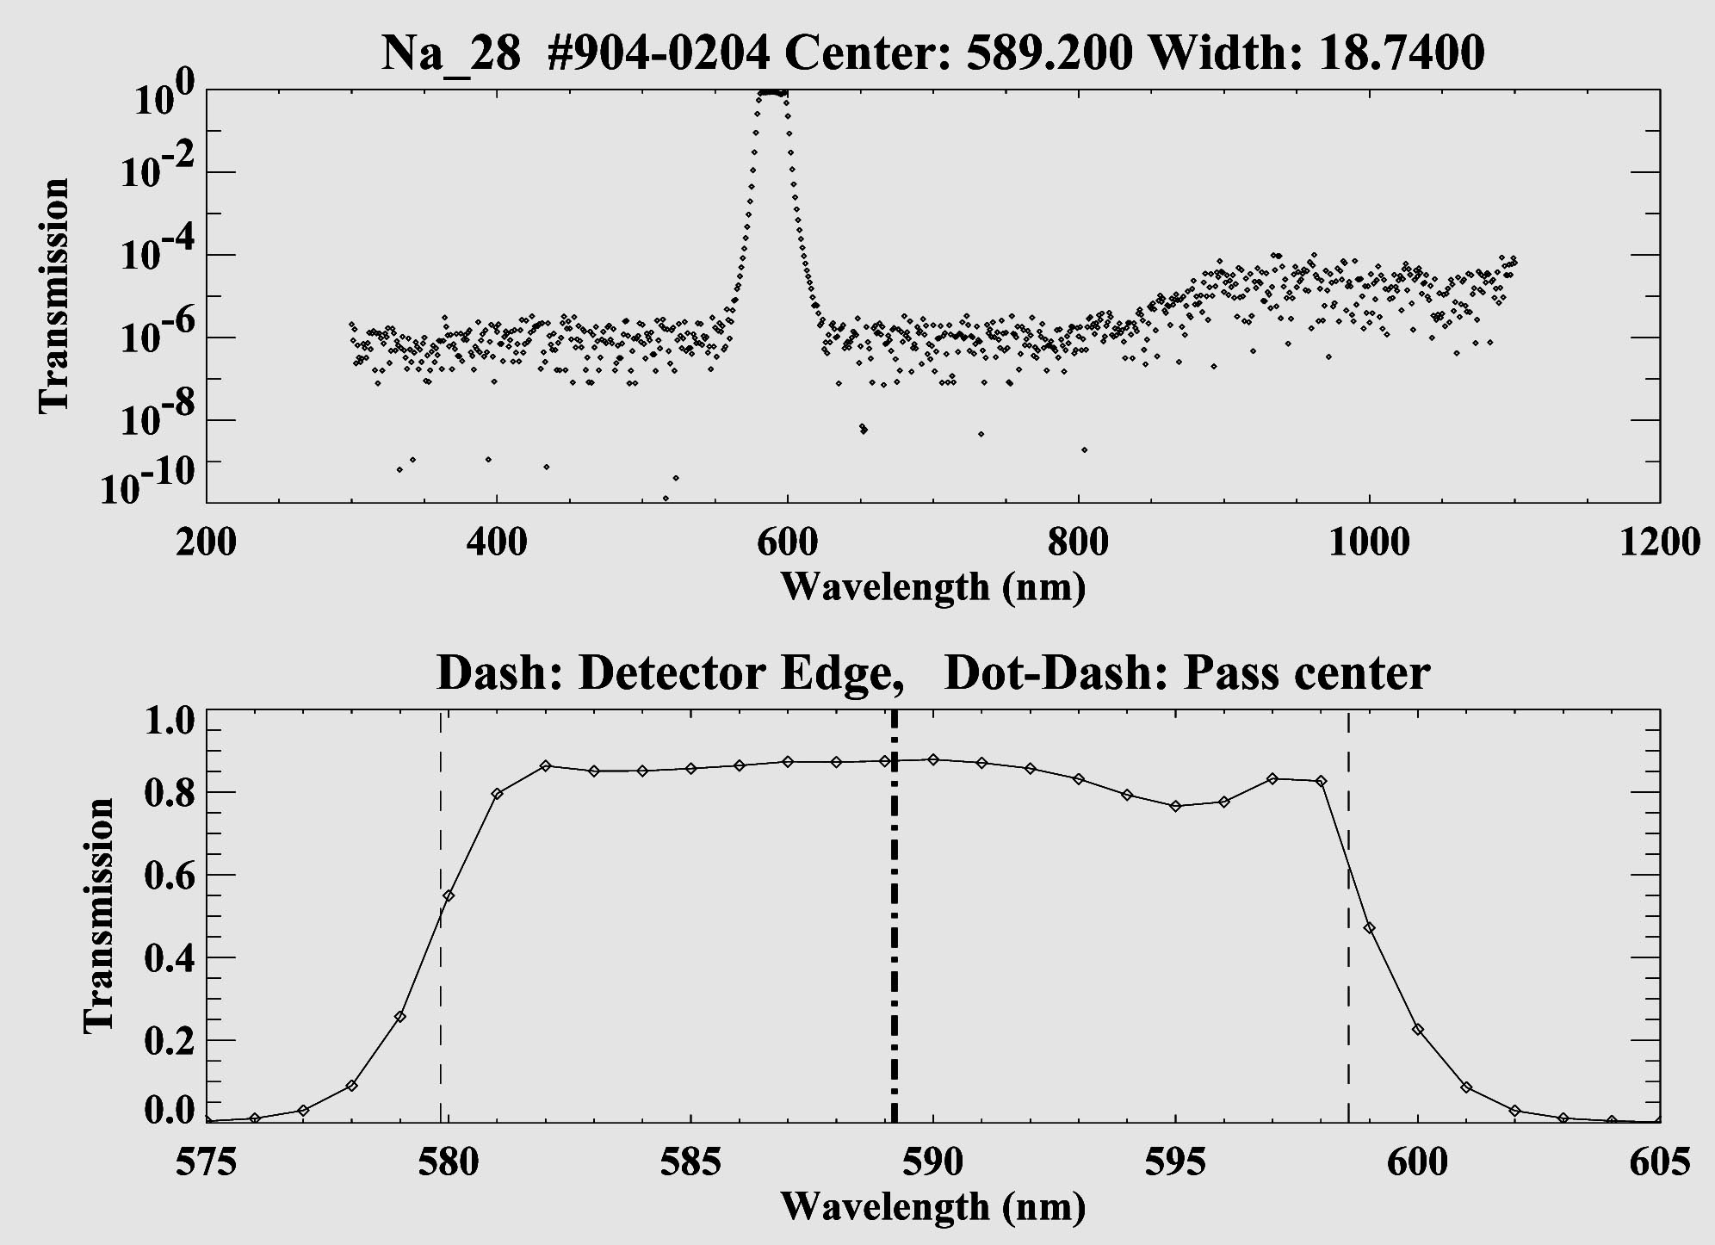
Figure 32: Na 28 filter transmission. Note that this order is contaminated with light from a different order shortward of 586 nm

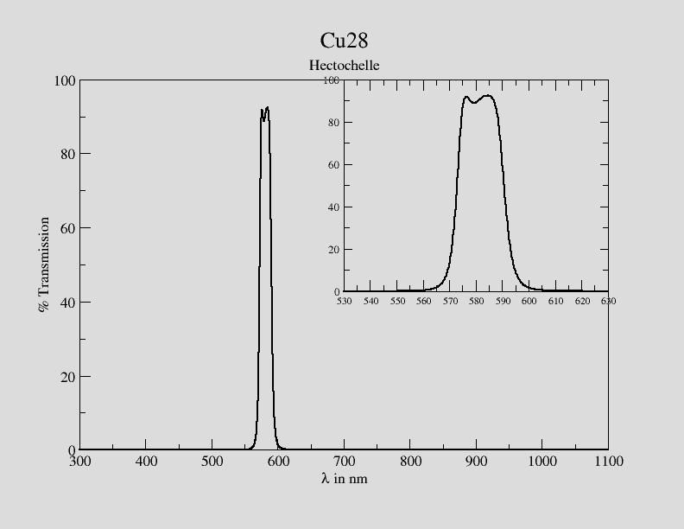
Figure 33 new Cu28, as of April 2016

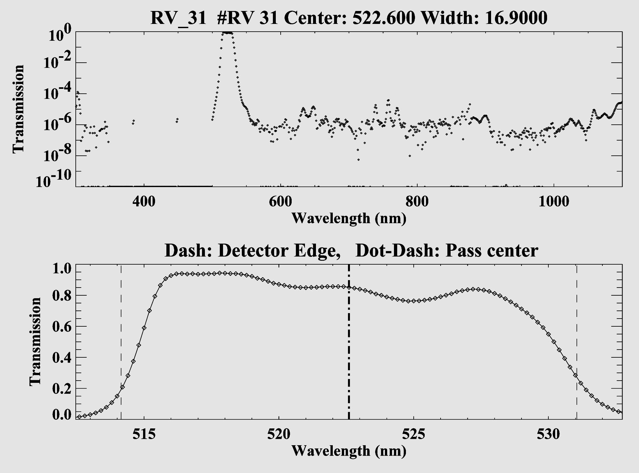
Figure 34: RV31 filter transmission.

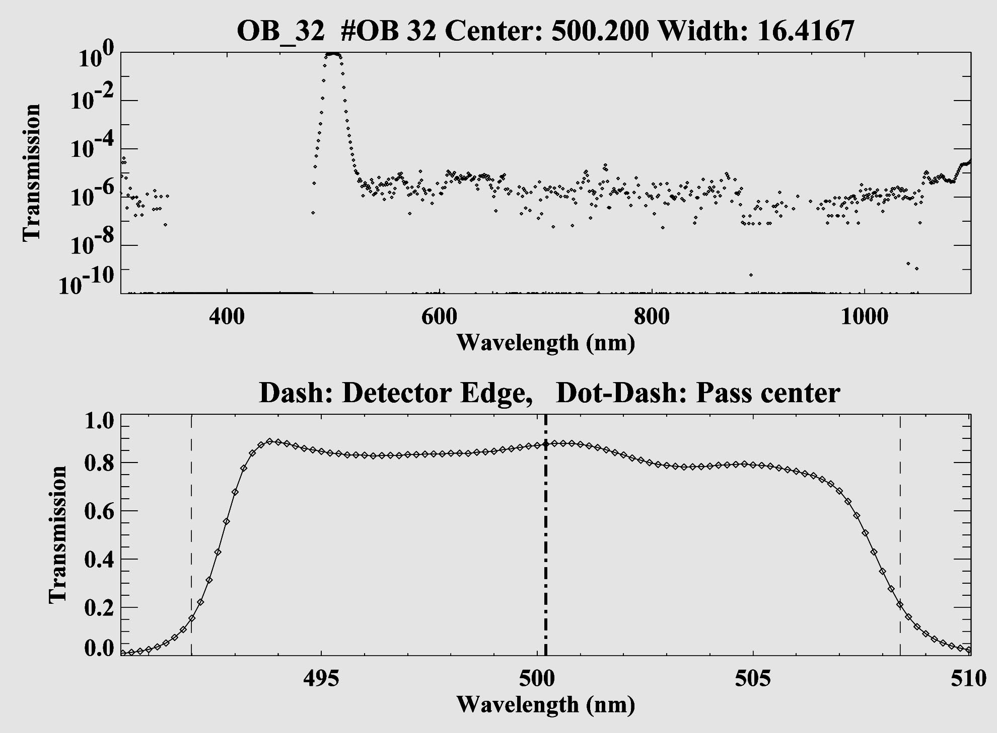
Figure 35: OB 32 filter transmission.

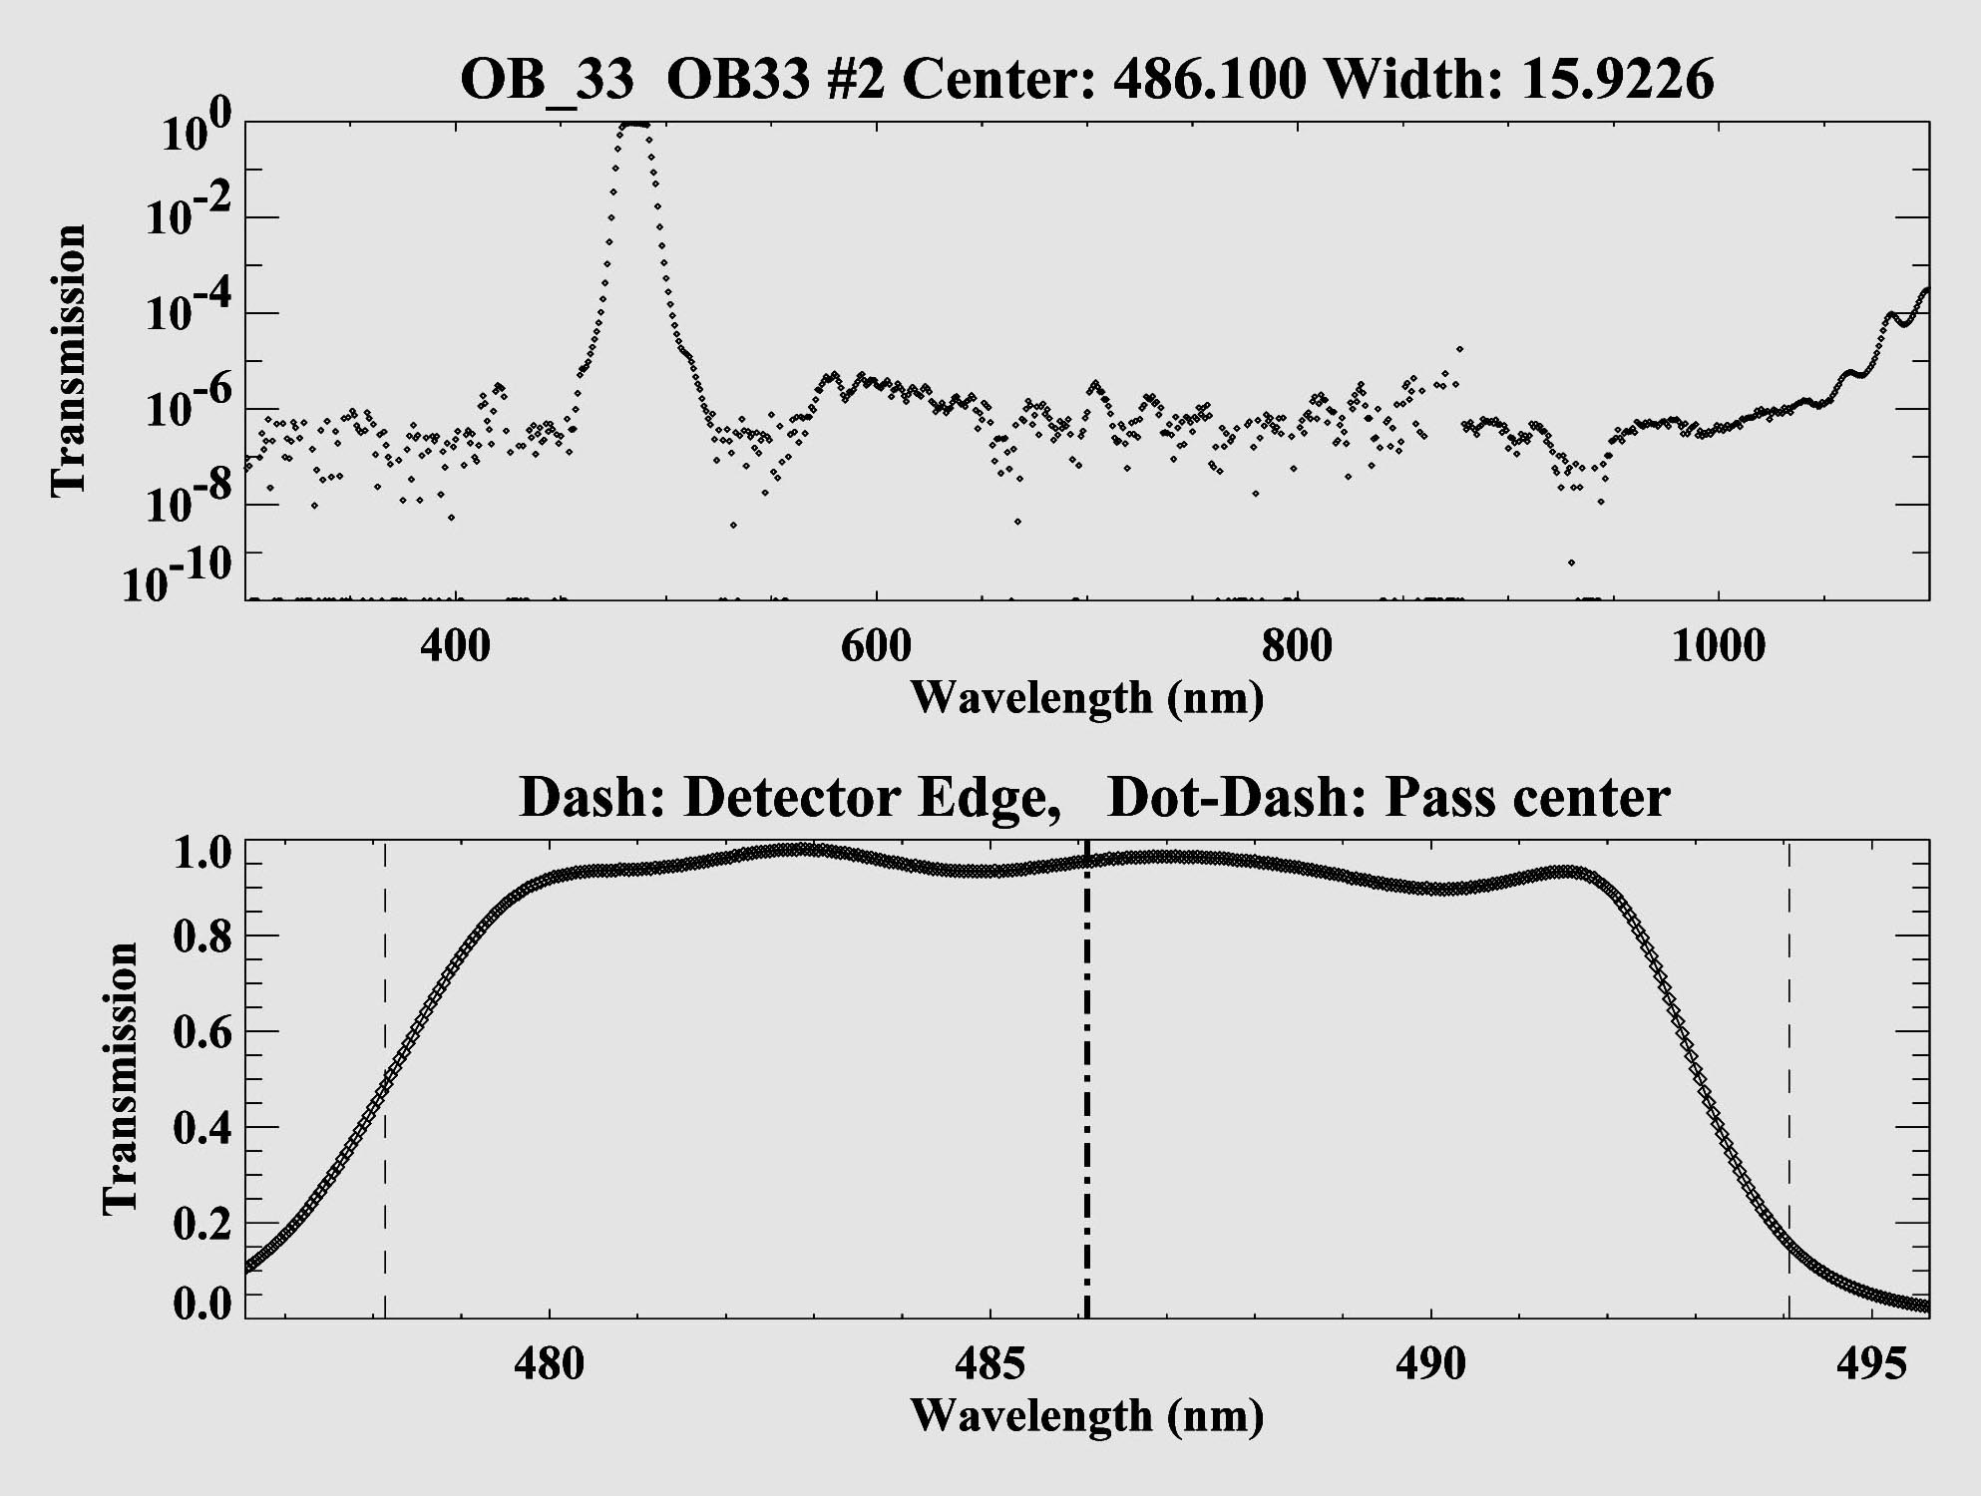
Figure 36: OB33 filter tranmission.

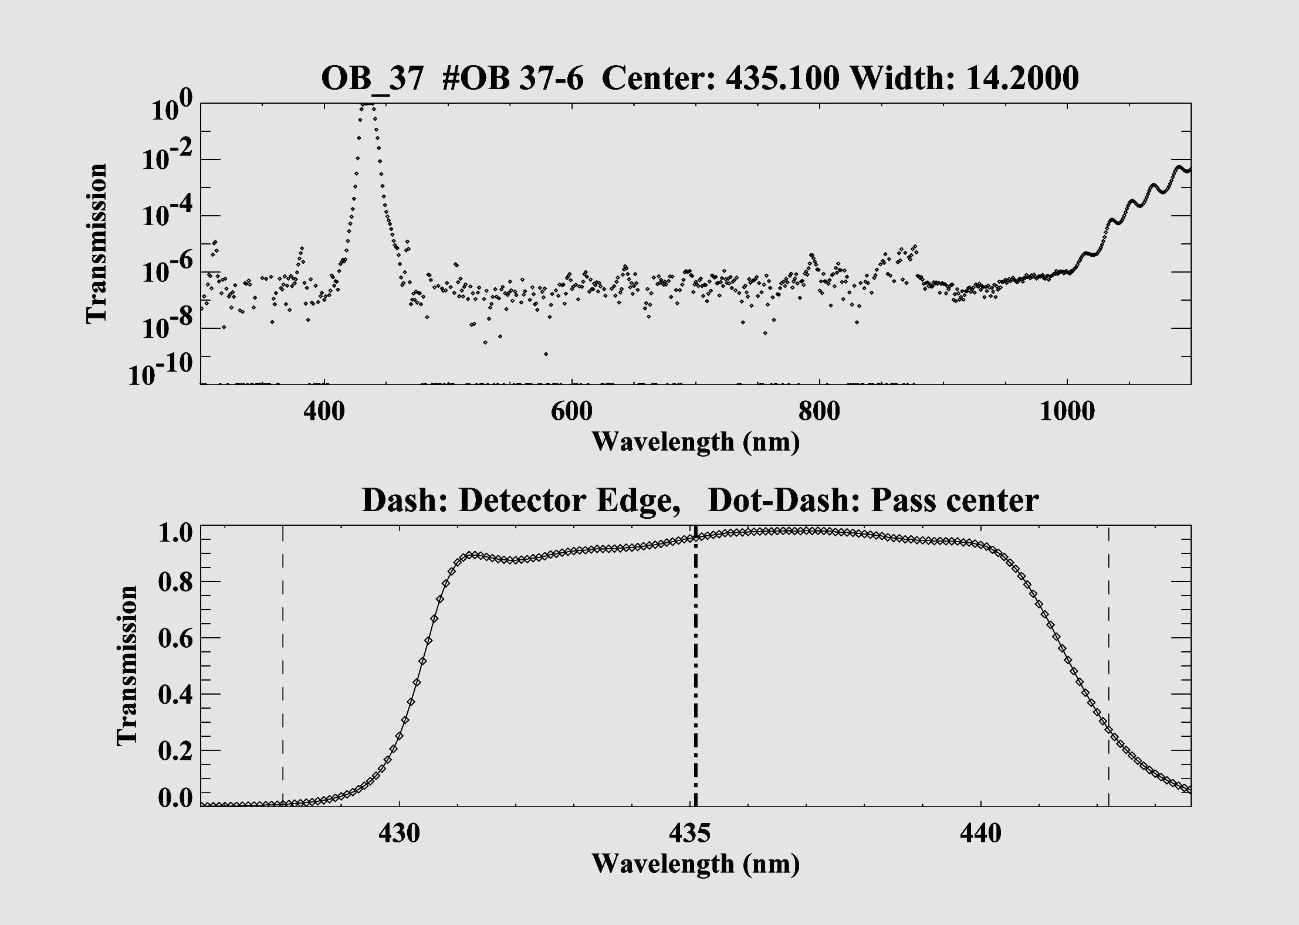
Figure 37: OB 37 filter transmission.

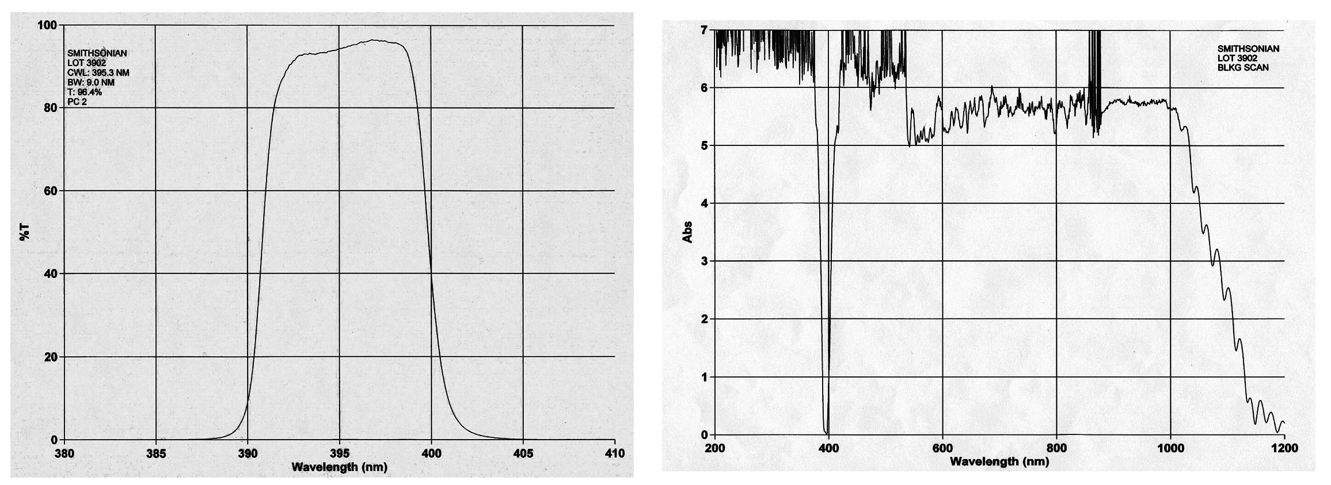
Figure 38: Ca 41 filter transmission.

Figure 39 Location of filters in the Chelle spectrograph

C. Signal to Noise of Example Observations
We don’t have an exposure time calculator, but here is a figure giving count rates for some real data. The magnitude is SDSS g’. The same stars were observed on three different nights, giving some idea of the variation in count rates above sky for different conditions. The S/N per pixel includes the noise from the moonlight, whose level also differed on the three nights. The cross correlation coefficient is shown for one of the nights. Generally, velocities can be believed for coefficients greater than 4.

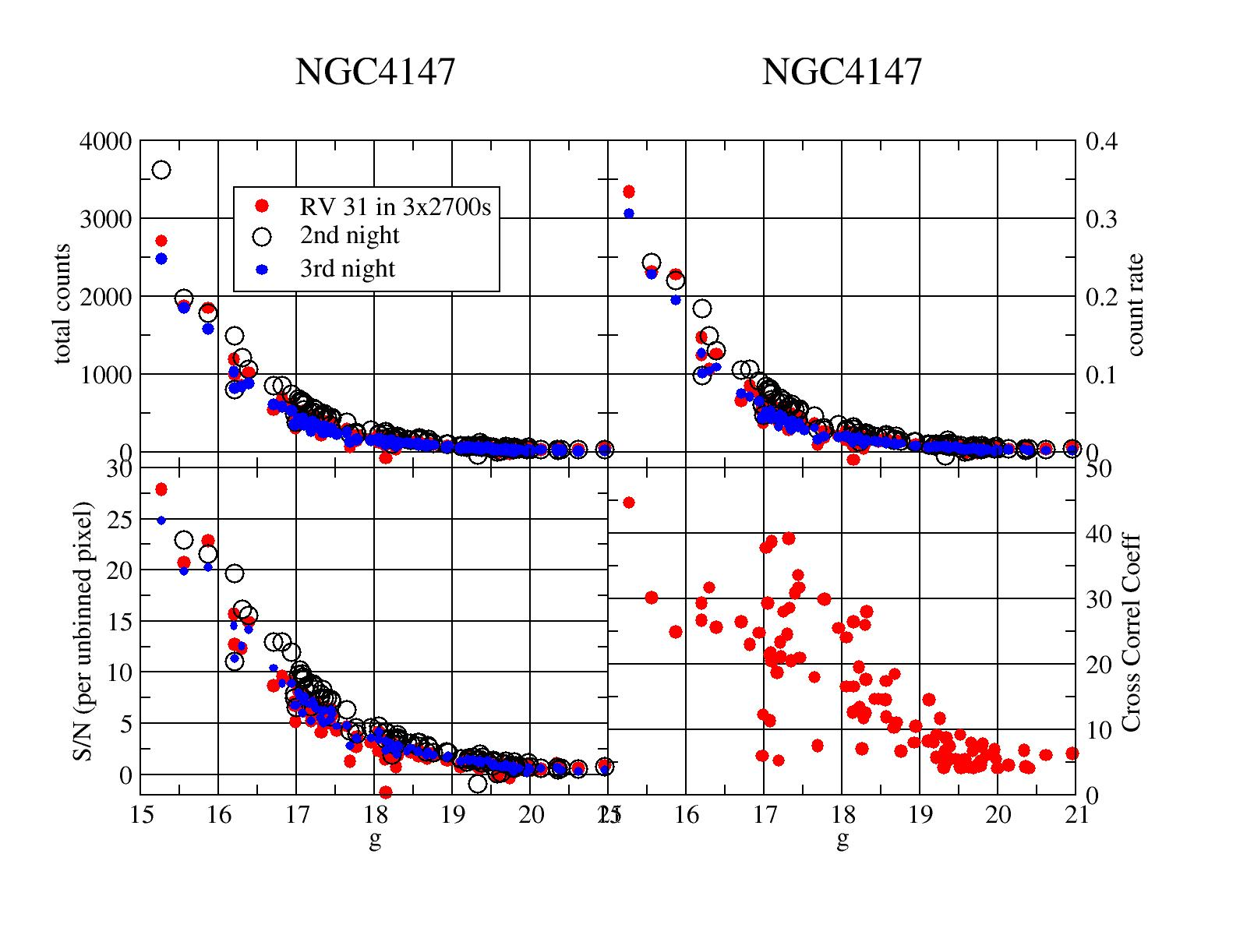

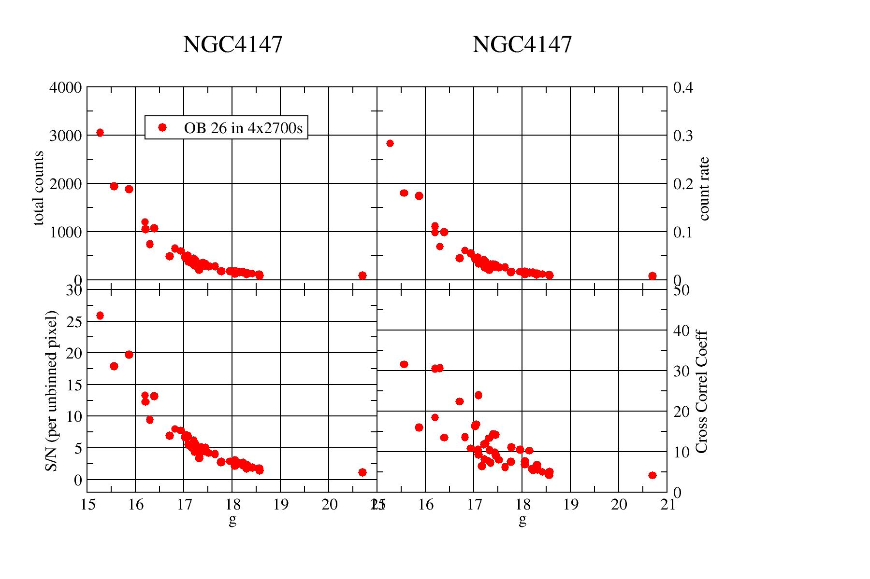
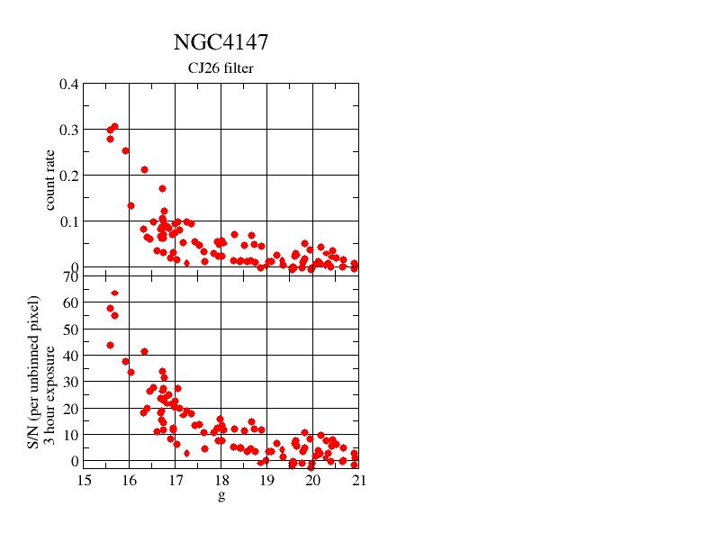

Here the data was taken in the RV31filter, with 2x3 binning.

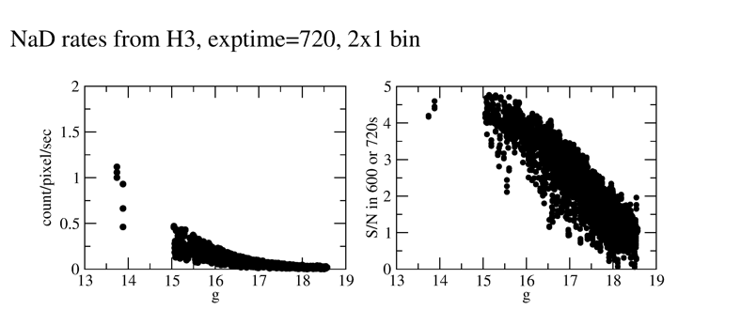

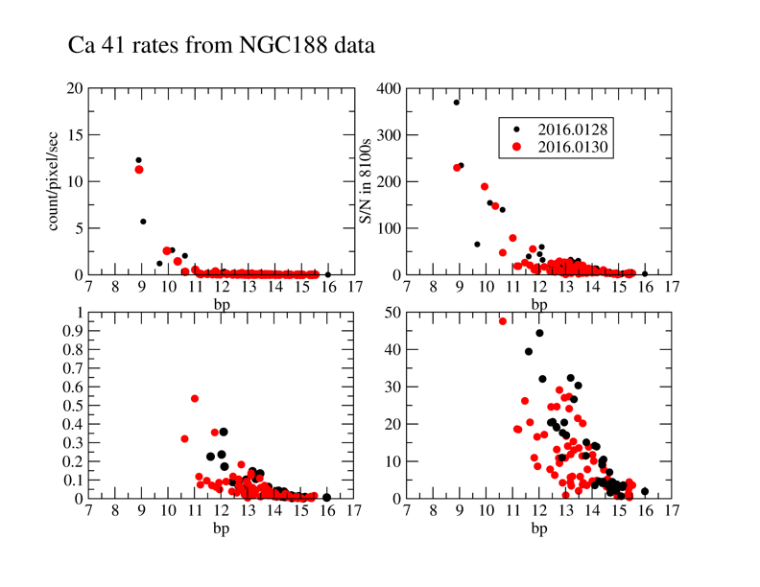
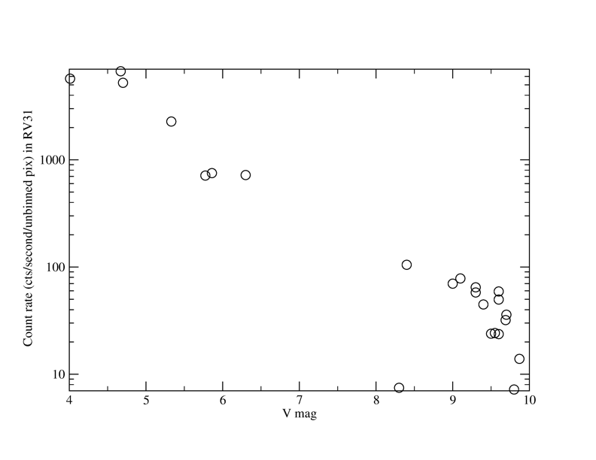
40 Count rate in RV31 from Bright Stars, counts/unbinned pixel/second

D. Hectochelle Cheat Sheet

This list is meant for the attending astronomers.
If the equipment is all ready, or if the run is underway, skip to item 8.
- Login to lewis as chelle. Have the robot operator login to clark and hudson as well. In an xterm on lewis , type go.go
- When the spice window is up, select the startup tab, and press Start Pulizzis (wait until the button turns blue).
- then Start Rack (wait).
- then Start Bench (wait),
- then Home Bench (wait),
- then Start CCD, and finally
- Start DomeCal.
- Now go to the Configure tab, enter the observers' names, select the correct telname (mmt_f5_adc), the correct instrument ( "hectochelle"), and the correct detector ("chelles").
- Insure the binning and grating are correct.
- At the start of the run, or if a new order has been selected, press ConfigBench, and wait about 10 seconds.
- Insure that the CCD temperatures are within 0.1 degree of -120. If not call an expert.
- Go to the StandardOps tab. Select bias for the exposure type, and take ~10 frames. Inspect these on ds9, and insure there is no pattern noise. The first image or two may be saturated - ignore these.
- Take a 300s dark exposure, 2 or three if there is time. Use iraf implot to inspect these for excess counts. A line plot where several hundred lines have been averaged is the best way (e.g., implot filesname.fits[im2], then :l 4000 4200, that's letter l, not number 1). The pixels beyond 1075 are overscan. The dark level should not be more than about 0.6 counts above the overscan in 300seconds. If it is, call an expert.
- Have the robot operator configure the fibers to the calibration setup. Have the telescope operator open the mirror covers.
- Bring up the schedule, by typing cd ; schedule chelle 2008c , for instance, but use the current trimester name ("a"=Jan-Apr, "b"=May-Jul; "c"=Sep-Dec". Select the current calendar day (not UT day) tab, and click on print. Review the program information from the proposals (these are kept in /home/spec/*.pdf , use gv to view). In particular note which orders are to be used for that night.
- Focus the spectrograph in the RV31 order, using 1x1 binning. To do this, in Spice, select the Standards Ops tab, and find "focus" in the pull down menu. Between 4 and 10 exposures will be needed, using a step size of 0.04. After those are taken, the script FOCUS.sh n executed in an xterm window will analyze n exposures, and provide a plot. Another script, display_focus n will display the n most recent focus frames on ds9 for inspection. Set the focus value in the Focus tab, save it, and then configure the bench in the Config tab.
- take domeflats in each order planned for the night, using 1x1 binning. For OB21 & Ca19 you should take spec box flats (these use the boxes mounted on the walls in the chamber, not the lights at the secondary mirror)
- Now turn off the continuum lamps, and select comps. Take comps in each order planned for the night in 1x1 binning.
- 10 - 15 minutes before sunset, start taking skyflats, in the RV31 order, and other orders if sky subtraction will be needed.
- It is always a good idea to configure for the first field early, and even move the telescope to the position, even if you have to wait a while to begin observing. Starting early will allow problems to be caught early.
- After the robot operator configures for a new field, SPICE will know about the exposure info and title. So most of the time you simply have to click "GO" to take the exposure. If the order has been changed, you'll need to "ConfigBench" in the Config tab before exposing (a warning will remind you of this).
- Before each science exposure, take a comp and a flat, using the requested order and binning. After each exposure, take an additional comp. During the night, monitor the time and try to keep to the schedule. Enter comments in to the logs about the conditions (seeing and clouds) and problems. qchelle is run automatically on the data; check these spectra to insure good data quality. The spectra are not sky-subtracted and only roughly wavelength calibrated, but still the extractions should be sufficient to assess data quality.

E. Spectrograph Optical Parameters

Beam Diameter | 254 mm
Fiber Output F/# | 5.0
Collimation Focal Length | 1371.6 mm
Corrected Camera Focal Length | 618.658 ,,
Grating Ruling Pitch | 110 lpm
Grating Angle of Incidence | 57º
Grating Diffraction Angle (Blaze) | 72º
Grating Blaze Angle | 64.5º (~R2)
Inc/Diffr. Opening Angle | 15 º
CCD Param | 2k x 4.5k, 15μ pixel
Focal Plane Format | 4k x 4,5 k (2 CCDs)
Number of Fibers Available | 240
Fiber Diameter | 250μm
Fiber Dia. on Sky | 1.5”
Peak Efficiency | 5%
Average Efficiency | TBD
Usable Passband | 3800-9000Ǻ
Table 5: Hectochelle Optical Parameters

Fabricant, D.G., et al., 2004, Proc.SPIE, 5492, 767
Szentgyorgyi, A.H., et al., 1998, Proc SPIE, 3355, 242
http://cfa-www.harvard.edu/cfa/oir/MMT/MMTI/hectochelle.html
Fabricant, D.G., et al., 2005, PASP, 117, 1411
http://www.cfa.harvard.edu/cfa/oir/MMT/MMTI/hectospec.html
http://www.eso.org/observing/bin/skycalcw/airmass
http://cfa-www.harvard.edu/cfa/oir/MMT/MMTI/hectospec/assign.html and http://www.cfa.harvard.edu/~john/xfitfibs/

