Subject: BMS CAT scope Eagan comments and Nick responses

Date: 15 April 2020

**From:** Alsis, Nick <nalsis@bmsmanagement.com>   
**Sent:** Thursday, April 2, 2020 1:53 PM  
**To:** Chris Eagan <ceagan@ipa.harvard.edu>  
**Cc:** Kris Broll <kbroll@ipa.harvard.edu>; Alsis, Nick <nalsis@bmsmanagement.com>  
**Subject:** RE: Scope of work and estimate - library protection

Chris,

The actual scope of work and price will all depend on what you want us to disinfect if/when you call us in. The original scope only included the a areas that are currently in use.

* The addition of three walls in the library would have a minimum cost, maybe $250.
* If needed I can give a detailed explanation of what will be fogged and what would be sprayed, but that would in part depend on which areas are to be done. Normally we would fog carpets, cloth chairs and areas around electronics. But we do allow for the crew leads to make determinations based on their expertize too.
* Yes, we will spray or fog chairs and wipe down the hard surfaces on them
* We can easily add the training room or any room the day of cleansing.

It will all boil down to the exact rooms you’d want sanitized, then the cost is based on Time and Material for those rooms. (if you decided to have the every room done, I would give you a budgetary figure of $25,000 and two days needed to complete).

If I haven’t answer your questions effectively, I’m always available for conference calls too.

Thanks again.

**Nick** **Alsis**  
General Manager   
BMS CAT   
265 Foster Street, Suite 1  
Littleton, MA 01460  
Mobile: 978.831.9728  
[nalsis@bmsmanagement.com](mailto:nalsis@bmsmanagement.com)  
  
**24-HOUR EMERGENCY RESPONSE: 877.730.1948**

**From:** Chris Eagan [<mailto:ceagan@ipa.cfa.harvard.edu>]   
**Sent:** Wednesday, April 1, 2020 2:55 PM  
**To:** Alsis, Nick <[nalsis@bmsmanagement.com](mailto:nalsis@bmsmanagement.com)>  
**Cc:** Kris Broll <[kbroll@ipa.cfa.harvard.edu](mailto:kbroll@ipa.cfa.harvard.edu)>; Chris Eagan <[ceagan@ipa.cfa.harvard.edu](mailto:ceagan@ipa.cfa.harvard.edu)>  
**Subject:** Scope of work and estimate - library protection

Hello again Nick

The library wall that includes the door and the two islands contain anomaly response documents. The bookshelves on the other three walls do not. How much would it cost to cover the three walls?

Chris

**From:** Chris Eagan   
**Sent:** Wednesday, April 1, 2020 2:22 PM  
**To:** 'Alsis, Nick' <[nalsis@bmsmanagement.com](mailto:nalsis@bmsmanagement.com)>  
**Cc:** Kris Broll <[kbroll@ipa.harvard.edu](mailto:kbroll@ipa.harvard.edu)>; Chris Eagan <[ceagan@ipa.harvard.edu](mailto:ceagan@ipa.harvard.edu)>  
**Subject:** Scope of work and estimate - Eagan comments

Hello Nick

1. Fogging: thanks for clarifying that it is part of the plan and yet not documented. If we decide another version of the scope is need then add a fogging please
2. Copy the raised floor carpet tiles
3. Regarding 3 and 6, additional public spaces, SNOC, and Computer room, I expect if we call you in to do a cleanup, then we’ll talk about the actual space that needs to be cleaned and those that don’t. Therefore a bill for the actual work will be submitted based on the scope of work with certain additions and subtractions
4. Regarding my chairs question, are you saying that you’ll clean the chairs by spraying and wiping down hard surfaces?
5. Regarding library, under normal circumstances they will not go into the library however if Chandra has an anomaly, then people will use the room. I’ve asked for identification of what can be protected because they will not use those documents, areas of the room. Maybe you cover those items. Still working this

We will probably be able to have people stay away from the ASVT room’s simulator racks of equipment and stay out of the back side of the room. They will only work at the console.

A new item is I was unware that operators are routinely using the Training Room (room 352). Please add training to the plan. This would be cleaned after the control room.

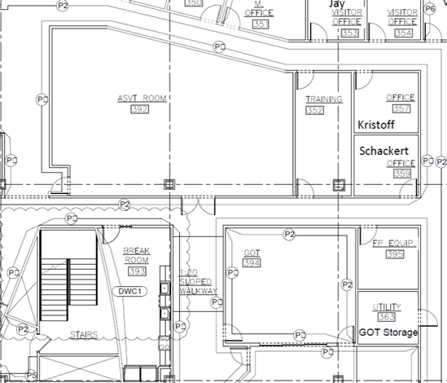

**From:** Alsis, Nick <[nalsis@bmsmanagement.com](mailto:nalsis@bmsmanagement.com)>   
**Sent:** Tuesday, March 31, 2020 9:25 PM  
**To:** Chris Eagan <[ceagan@ipa.harvard.edu](mailto:ceagan@ipa.harvard.edu)>  
**Cc:** Kris Broll <[kbroll@ipa.harvard.edu](mailto:kbroll@ipa.harvard.edu)>  
**Subject:** RE: Scope of work and estimate - Eagan comments

Hi Chris,

Hope you all are doing well over there! I’ve highlighted my responses below. Please let me know if we need to get on a call together.

Thanks,

Nick

**Nick** **Alsis**  
General Manager   
BMS CAT   
265 Foster Street, Suite 1  
Littleton, MA 01460  
Mobile: 978.831.9728  
[nalsis@bmsmanagement.com](mailto:nalsis@bmsmanagement.com)  
  
**24-HOUR EMERGENCY RESPONSE: 877.730.1948**

**From:** Chris Eagan [<mailto:ceagan@ipa.cfa.harvard.edu>]   
**Sent:** Tuesday, March 31, 2020 4:25 PM  
**To:** Alsis, Nick <[nalsis@bmsmanagement.com](mailto:nalsis@bmsmanagement.com)>  
**Cc:** Kris Broll <[kbroll@ipa.cfa.harvard.edu](mailto:kbroll@ipa.cfa.harvard.edu)>; Chris Eagan <[ceagan@ipa.cfa.harvard.edu](mailto:ceagan@ipa.cfa.harvard.edu)>  
**Subject:** Scope of work and estimate - Eagan comments

Hello Nick

It took me until today to review the scope of work. Thanks for sending it. Some things came to mind that I wanted to ask about

1. We talked about fogging and I don’t recall whether you recommended using it. Either way I don’t see fogging in the scope. Should it be listed? I can list it if you’d like, normally I don’t list all material and equipment.
2. The scope does not address the raised floor carpet tiles that I recall we agreed to clean. I included them is the walkways.
3. The scope does not explicitly include Computer room (room 317) and SNOC (room 308). Are they included now or do you want to update to list them? I did not include these areas, I thought those were part of the second area that is current shut down. I will add them if they are to be done at the same time as the control room.
4. We did not discuss cleaning of chairs and the scope did not include them. The scope indicates that “upholstered fabric and soft goods are not part of this scope”. What do you suggest we do? Bag and dispose of them, then replace with new? Maybe I should proactively bullpen all chairs except the minimum so that they are not infected. We will spray with the disinfectant and wipe down any hard surfaces.
5. I have not answered the question about the library’s use and therefore preventative measures are not yet defined
6. For completeness wrt “common areas and public gathering spaces” these would include the viewing area and ramps (room 396), supply area (room 371), mail stop (room 386), sleep room (321). We did not talk about the lobby area with the large table (room 301) however we may want to add this. Those areas,  I believe would be done in the second scenario?

I shared the scope of work with Ryan Traynor the Piedmont building manager and he can enter into a relationship with us and you to get the work done

Thanks for working with us and tell me what you think

Chris